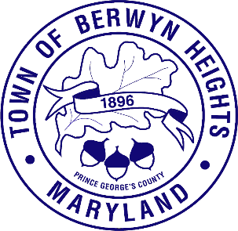

Town of Berwyn Heights

5700 Berwyn Road
Berwyn Heights, MD 20740
Tel. (301) 474-5000
Fax (301) 474-5002

MAYOR

Jodie Kulpa-Eddy

COUNCIL MEMBERS
Christopher Brittan-Powell (Mayor Pro Tem)
Shinita Hemby
Faustino Menjivar
Jason W. Papanikolas

Closed Session Agenda
July 6, 2023| 6:30 p.m.
Council Chambers

This meeting will be held in the Council Chamber, 5700 Berwyn Road.

The Berwyn Heights Town Council will be meeting in a special session on July 6, 2023 at 6:30 PM. The Council will meet briefly in open session in order to adopt the agenda and will then enter a closed session. The Council will return to open session for the regularly scheduled worksession. Residents are welcome at any open session, however the open session will not be recorded or broadcast.

The meeting will be meeting will be closed pursuant to Maryland Code Annotated, General Provisions Article, § 3-305(b)(1): To discuss the appointment, employment, assignment, promotion, discipline, demotion, compensation, removal, resignation, or performance evaluation of an appointee, employee, or official over whom this public body has jurisdiction; or any other personnel matter that affects one or more specific individuals” (specifically, to review residents' applications for appointment to the Town Manager Interview Panel).

- Call to Order

- Approval of the Agenda

- Vote to Enter Closed Session

- Adjourn from Closed Session

