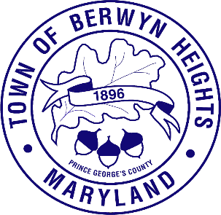

Town of Berwyn Heights

5700 Berwyn Road
Berwyn Heights, MD 20740
Tel. (301) 474-5000
Fax (301) 474-5002

MAYOR

Jodie Kulpa-Eddy

COUNCIL MEMBERS
Christopher Brittan-Powell (Mayor Pro Tem)
Shinita Hemby
Faustino Menjivar
Jason W. Papanikolas

Closed Session Agenda
July 22, 2023| 8:30 a.m.
Council Chambers

This meeting will be held in the Council Chamber, 5700 Berwyn Road.

The Berwyn Heights Town Council will be meeting in a special session on July 22, 2023 at 8:30am. The Council will meet briefly in open session in order to adopt the agenda and will then enter a closed session. The Council will break for lunch at 12:30pm and will resume the closed session at 1:30pm.

The meeting will be closed pursuant to Maryland Code Annotated, General Provisions Article, § 3-305(b)(1): To discuss the appointment, employment, assignment, promotion, discipline, demotion, compensation, removal, resignation, or performance evaluation of an appointee, employee, or official over whom this public body has jurisdiction; or any other personnel matter that affects one or more specific individuals” (specifically, to interview candidates for Town Manager and discussion).

- Call to Order

- Approval of the Agenda

- Vote to Enter Closed Session

- Adjourn from Closed Session

