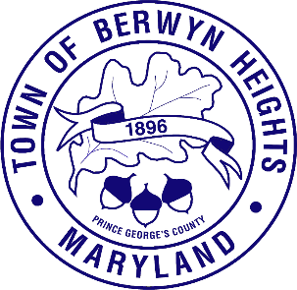

Town of Berwyn Heights

5700 Berwyn Road
Berwyn Heights, MD 20740
Tel. (301) 474-5000
Fax (301) 474-5002

MAYOR

Jodie Kulpa-Eddy

COUNCIL MEMBERS
Christopher Brittan-Powell (Mayor Pro Tem)
Shinita Hemby
Faustino Menjivar
Jason W. Papanikolas

Closed Session Agenda
January 16, 2024| 6:30 p.m.
Council Chambers

This meeting will be held in the Council Chamber, 5700 Berwyn Road.

The Berwyn Heights Town Council will be meeting in a closed session on December 18, 2023 at 6:30 PM. The Council will meet briefly in open session in order to adopt the agenda and will then enter a closed session. The Council will return to open session for the regularly scheduled worksession. Residents are welcome at any open session, however the open session at 6:30 will not be recorded or broadcast.

The meeting will be closed pursuant to Maryland Code Annotated, General Provisions Article, § 3-305
(b)(1) To discuss the appointment, employment, assignment, promotion, discipline, demotion, compensation, removal, resignation, or performance evaluation of appointees, employees, or officials over whom this public body has jurisdiction; any other personnel matter that affects one or more specific individuals [specifically, to discuss the performance of a Town staff member]; and
(b)(3): “To consider the acquisition of real property for a public purpose and matters directly related thereto” (specifically, to discuss the feasibility of purchasing a commercial property to use as space for public activities, the Town's Police Station and other Town services.)

- Call to Order

- Approval of the Agenda

- Vote to Enter Closed Session

- Adjourn from Closed Session

