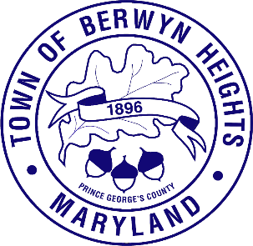

Town of Berwyn Heights

5700 Berwyn Road
Berwyn Heights, MD 20740
Tel. (301) 474-5000
Fax (301) 474-5002

MAYOR

Jodie Kulpa-Eddy

COUNCIL MEMBERS
Christopher Brittan-Powell (Mayor Pro Tem)
Shinita Hemby
Faustino Menjivar
Jason W. Papanikolas

Ethics Commission Agenda
March 6, 2024| 6:30 p.m.
Council Chambers

Call to Order
Approval of the Agenda
Approval of Minutes 2/8/24

- Review Draft Ethics Procedures
- Review Candidate Financial Disclosures
- Other Business

Adjournment

