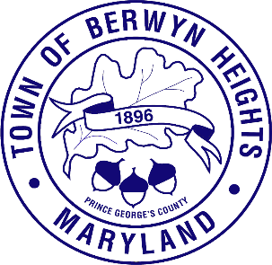

Town of Berwyn Heights

5700 Berwyn Road
Berwyn Heights, MD 20740
Tel. (301) 474-5000
Fax (301) 474-5002

MAYOR

Jodie Kulpa-Eddy

COUNCIL MEMBERS
Christopher Brittan-Powell (Mayor Pro Tem)
Shinita Hemby
Faustino Menjivar
Jason W. Papanikolas

Ethics Commission Agenda
February 8, 2024| 6:30 p.m.
Council Chambers

Call to Order
Approval of the Agenda

- Review Ethics Ordinance 110
  - Commission’s Responsibilities
  - Process for Reviewing Financial Disclosures
  - Complaint Procedures
- Review of Public Information Act
- Review of Open Meetings Act

Adjournment

