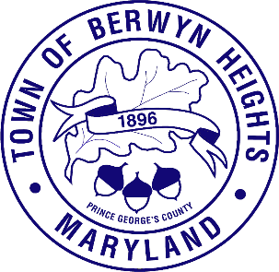

Town of Berwyn Heights

5700 Berwyn Road
Berwyn Heights, MD 20740
Tel. (301) 474-5000
Fax (301) 474-5002

MAYOR

Jodie Kulpa-Eddy

COUNCIL MEMBERS
Christopher Brittan-Powell (Mayor Pro Tem)
Shinita Hemby
Faustino Menjivar
Jason W. Papanikolas

Work Session Agenda
March 20, 2023| 7:00 p.m.
Council Chamber

This meeting will be held in the Council Chamber, 5700 Berwyn Road. Residents can comment by attending the meeting, by calling 301-474-9570, or emailing mfriesen@berwynheightsmd.gov . Resident comments may be limited to 3 minutes.

Call to Order
Approval of the Agenda

- Mayor
- Announcements (5 minutes)
- Calendar (5 minutes)
- DHCD Sustainable Communities Submission (10 minutes)
- Codification Project Update (15 minutes)
- Vehicle Reserve Fund (15 minutes)
- ARPA Budget Update (20 minutes)
- Resident Comments

- Code Compliance (5 minutes)

- Parks, Recreation, Education, and Civic Affairs (5 minutes)

- Public Safety (5 minutes)

- Public Works (5 minutes)

- Administration (5 minutes)
  - Residential Flood Gate Relief Program Application (5 minutes)

- Adjournment

To view an AI powered translation of this meeting visit:
https://attend.wordly.ai/join/VLRW-4987
or scan the QRcode

