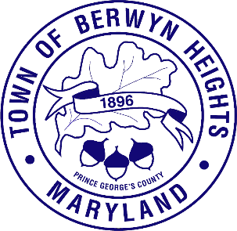

MAYOR

Jodie Kulpa-Eddy

COUNCIL MEMBERS
Christopher Brittan-Powell (Mayor Pro Tem)
Shinita Hemby
Faustino Menjivar
Jason W. Papanikolas

Town of Berwyn Heights

5700 Berwyn Road
Berwyn Heights, MD 20740
Tel. (301) 474-5000
Fax (301) 474-5002

Town Meeting Agenda
Town Council Chamber
October 12, 2022 | 7:00 p.m.

Call to order
Pledge of Allegiance

- Announcements

- Approval of Agenda

- Public Hearing Ordinance 185A- Budget Amendment for a Holistic Watershed Model
Resident comments may be limited to 3 minutes.

- Consent
Minutes
Department Reports
- Administration/ Treasurer
- Code Compliance
- Police
- Public Works

- Mayor & Councilmember Reports

- Committee Reports
- Education Advisory Committee
- Green Team
- Historical Committee
- Neighborhood Watch/ Emergency Preparedness
- Recreation Council

- Old Business
- Adoption of Ordinance 185A- Budget Amendment for a Holistic Watershed Model

- New Business
- Ordinance 185B Budget Amendment/UMD Agreement
- Council Meeting Calendar

9. Resident & Community Comments

Residents can comment by calling 301-474-9570 or e-mailing Clerk Friesen at mfriesen@berwynheightsmd.gov. Resident comments may be limited to 3 minutes.

10. Adjournment
To view an AI powered translation of this meeting visit:
https://attend.wordly.ai/join/VLRW-4987
or scan the QRcode below

