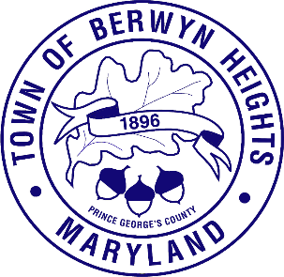

Town of Berwyn Heights

5700 Berwyn Road
Berwyn Heights, MD 20740
Tel. (301) 474-5000
Fax (301) 474-5002

MAYOR

Jodie Kulpa-Eddy

COUNCIL MEMBERS
Christopher Brittan-Powell (Mayor Pro Tem)
Shinita Hemby
Faustino Menjivar
Jason W. Papanikolas

Budget Work Session Agenda
March 13, 2023| 6:00 p.m.
Council Chamber

This meeting will be held in the Council Chamber, 5700 Berwyn Road. Residents can comment by attending the meeting, by calling 301-474-9570, or emailing mfriesen@berwynheightsmd.gov . Resident comments may be limited to 3 minutes.

Call to Order
Approval of the Agenda

- FY24 Public Safety Taxing District

- Revenue Forecast: CYTR (.5187), Current Tax Rate (.545), Refuse and Recycling Collection Fee

- Prioritizing Town Budget Needs

- FY23 ARPA Funding Allocations

- FY24 ARPA Funding Proposed Allocations

- Adjournment

To view an AI powered translation of this meeting visit:
https://attend.wordly.ai/join/VLRW-4987
or scan the QRcode

