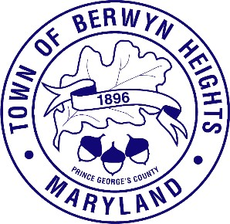
TOWN OF BERWYN HEIGHTS
5700 Berwyn Road Berwyn Heights, MD 20740
Tel. (301) 474-5000 Fax (301) 474-5002

Asian American, Native Hawaiian, and Pacific Islander Heritage Month

May 2023

WHEREAS, Asian American, Native Hawaiian, and Pacific Islander Heritage Month was first celebrated in 1979 as Asian/Pacific American Heritage Week and has been recognized since 1992 as a month long observance to celebrate and honor the contributions of Asian Americans, Native Hawaiians, and Pacific Islanders to American history, society, and culture; and

WHEREAS, the Town of Berwyn Heights recognizes this year’s theme for Asian American, Native Hawaiian, and Pacific Islander Heritage Month as “Advancing Leaders Through Collaboration”.
This year’s theme is a continuation of the “Advancing Leaders” theme which began in 2021 and will continue until 2024 to highlight the Federal Asian Pacific American Council’s efforts in advancing leaders in federal and local governments; and

WHEREAS, the month of May was chose to celebrate Asian American, Native Hawaiian, and Pacific Islander Heritage Month to commemorate the arrival of the first Japanese immigrants to the United States on May 7, 1843 and the completion of the first transcontinental railroad on May 10, 1869, which was built with significant contributions from Chinese workers; and

WHEREAS, the history and culture of our state and our nation have been significantly influenced by Asian Americans, Native Hawaiians, and Pacific Islanders. They have made significant contributions. at all levels of government, economy, education, the arts, law, science and technology, sports, and public service; and

WHEREAS, celebrating Asian American, Native Hawaiian, and Pacific Islander Heritage Month provides the residents of the Town of Berwyn Heights an opportunity to appreciate the achievements, contributions, history, and recognize the additional determination, hard work, and perseverance put forth to be heard and seen and that these additional efforts are a result of inequitable institutional and systemic injustices.

NOW THEREFORE, I, Jodie Kulpa-Eddy, Mayor of the Town of Berwyn Heights hereby proclaim May 2023 as Asian American, Native Hawaiian, and Pacific Islander Heritage Month in the Town of Berwyn Heights.

Jodie Kulpa-Eddy, Mayor

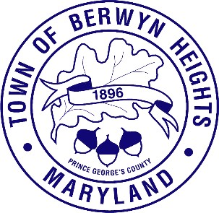
Town of Berwyn Heights
5700 Berwyn Road Berwyn Heights, MD 20740
Tel. (301) 474-5000
Fax (301) 474-5002

ORDINANCE 185-E
MAYOR
Jodie A. Kulpa-Eddy
COUNCIL MEMBERS
Christopher S. Brittan Powell (Mayor Pro Tem) Shinita Hemby
Faustino Menjivar Jason W. Papanikolas

AN ORDINANCE TO AMEND THE FISCAL YEAR 2023 BUDGET

WHEREAS, Section 602 of the Town Charter authorizes the Town Council to amend an adopted budget; and
WHEREAS, the budget for Fiscal Year 2023 was adopted on May 11, 2022 with the passage of Ordinance 185; and
WHEREAS, there is a need to amend the Fiscal Year 2023 Budget to:

- To cover severance pay of $44,076 for former Town Manager Laura Allen; and

- Pay for the services of a consultant to administer, manage and facilitate an executive search for a Town Manager for the Town at a cost of $25,300; and

WHEREAS, on July 8, 2020 the Town Council approved the appointment of Laura Allen as Berwyn Heights Interim Town Manager, and whose contract included a clause allowing six months of severance pay following two years of employment, with Ms. Allen leaving Town employment on November 11, 2022; and

WHEREAS, on March 8, 2023, the Council of the Town of Berwyn Heights approved the hiring of a consultant to administer, manage and facilitate an executive search for a Town Manager for the Town of Berwyn Heights;

NOW, THEREFORE, BE IT ORDAINED that the Council of the Town of Berwyn Heights, on this day of April, 2023, hereby amends the Fiscal Year 2023 Budget by authorizing the following:

- Transfer $44,076 from the Town of Berwyn Heights’ General Fund Reserve to the Town’s FY2023 General Fund, Town Administration, Salaries (#130-001), to pay for severance pay, and

- Transfer $25,300 from the Town of Berwyn Heights’ General Fund Reserve to the Town’s FY2023 General Fund, Town Administration, Miscellaneous (#130-021) account to pay for an executive search consultant.

 | EXPENDITURES:
 | Town Administration
130-001 | Salaries | $44,076
 | Subtotal: Salaries | $44,076
 | Town Administration
130-021 | Miscellaneous | $25,300
 | Subtotal: Miscellaneous | $25,300
 | TOTAL TRANSFERRED | $69,376

BE IT FURTHER ORDAINED that if any sections or provisions or parts of this Ordinance shall be adjudicated to be invalid or unconstitutional by a court of competent jurisdiction, such invalidity or unconstitutionality shall not affect the validity of this Ordinance as a whole or any other section or provision or part thereof; and
BE IT FURTHER ORDAINED by the Town Council of the Town of Berwyn Heights that this Ordinance shall become effective on May 30, 2023, which is twenty days after its passage, and after having been read at two (2) successive Public Meetings (at the April 26, 2023 Meeting and at the May 10, 2023 Town Meeting), pursuant to Section 311 of the Town Charter, if not petitioned to referendum. If a petition is filed, this Ordinance shall be held in abeyance pending the outcome of a special election.

Resolved by the Mayor and Town Council

Jodie Kulpa-Eddy, Mayor

ATTEST:

Melanie Friesen, Town Clerk

Town of Berwyn Heights
5700 Berwyn Road Berwyn Heights, MD 20740
Tel. (301) 474-5000
Fax (301) 474-5002
MAYOR
Jodie Kulpa-Eddy
COUNCIL MEMBERS
Christopher Brittan-Powell (Mayor Pro Tem) Shinita Hemby
Faustino Menjivar Jason W. Papanikolas

ORDINANCE 187 – FY 2024 TOWN BUDGET

FOR the purposes of adopting the Town Operating Budget, General Fund, Infrastructure Improvement Reserve Fund, Vehicle and Equipment Replacement Reserve Fund, Public Safety Reserve Fund, Cable Television Public, and Educational and Governmental (PEG) Access Reserve Fund, budgets for the Town of Berwyn Heights for Fiscal Year 2024; appropriating funds for the expenditures for Fiscal Year 2024; establishing appropriation limits at the fund level; defraying all expenses and liabilities of the Town of Berwyn Heights and levying same for the purposes specified; and establishing real estate and personal property tax rates for Fiscal Year 2024, beginning July 1, 2023, and ending June 30, 2024, inclusive, and specifying a rate of interest and penalty to be charged upon overdue-property taxes.

WHEREAS, pursuant to Section 602 of the Berwyn Heights Town Charter, the Fiscal Year 2024 General Fund Town Budget was presented at Council Work Sessions in February, March and April 2023, and

WHEREAS, pursuant to Section 602 of the Berwyn Heights Town Charter, the Fiscal Year 2024 General Fund Town Budget was presented and discussed at Public Meetings on April 26, 2023 and May 10, 2023, and

WHEREAS, pursuant to Section 602 of the Berwyn Heights Town Charter, the Fiscal Year 2023 Budget was made available to Town residents prior to and at Public Meetings on April 26, 2023 and May 10, 2023, and

WHEREAS, pursuant to Section 602 of the Berwyn Heights Town Charter, a properly advertised public hearing on the Fiscal Year 2023 General Fund Budget was held on April 12, 2023, and May 10, 2023.

NOW, THEREFORE:

SECTION 1. BE IT ESTABLISHED AND ORDAINED BY THE BERWYN HEIGHTS TOWN
COUNCIL that the following budgets and fund-level appropriation limits, as approved by the Council for the General Fund, Vehicle and Equipment Replacement Reserve Fund, Public Safety Reserve Fund, Cable Television Public, and Educational and Governmental (PEG) Access Reserve Fund, and the same are hereby adopted at the indicated fund levels for the Town of Berwyn Heights, Maryland, for Fiscal Year 2024, beginning July 1, 2023, and ending June 30, 2024, inclusive.

SECTION 2. GENERAL FUND:
  - AND BE IT FURTHER ESTABLISHED AND ORDAINED BY THE BERWYN
HEIGHTS TOWN COUNCIL that the following revenues are, in the considered

judgment of the Town Council, a fair appraisal and estimate of the revenues available to finance this budget and these appropriations for the fiscal year beginning July 1, 2023 and ending June 30, 2024, inclusive:

Source | Estimated Revenues
Real Estate Taxes | $2,083,639
Real Estate Taxes – Road Repair Fund | 127,916
Personal Property Taxes | 239,879
Personal Property Tax – Road Repair Fund | 14,393
Income Tax | 450,000
Refuse and Recycling Collection Fee | 97,945
Licenses and Permits | 131,600
Intergovernmental | 251,303
Service Charges | 100
Fines and Forfeitures | 160,000
Miscellaneous Revenues | 74,900
Fund Balance & Reserves | 1,164,306
TOTAL GENERAL FUND REVENUE: | $4,795,981

  - AND BE IT FURTHER ESTABLISHED AND ORDAINED BY THE BERWYN
HEIGHTS TOWN COUNCIL that the following sums and amounts shall be and hereby are appropriated for the fiscal year beginning July 1, 2023 and ending June 30, 2024, inclusive, the said revenues being used to defray expenses and operations of the Town of Berwyn Heights for the General Fund:
Account Name | Approved Budget  and Appropriation
General Government | $613,145
Public Safety | 982,582
Code Compliance | 197,796
Public Works | 1,071,859
Parks & Recreation | 51,150
Cable | 26,200
Miscellaneous | 739,300
Capital Projects Operating | 1,033,852
Capital Projects: Reserve | 80,097

TOTAL GENERAL FUND APPROPRATION $4,795,981 SECTION 3. RATE OF TAXATION ON REAL PROPERTY:
BE IT ESTABLISHED AND ORDAINED BY THE BERWYN HEIGHTS TOWN
COUNCIL that a tax rate of fifty one and eighty seven one hundredths cents ($0.5187) on each one hundred dollars ($100) of assessable property in the Town of Berwyn Heights be and the same is hereby imposed on all assessable property for the fiscal year beginning July 1, 2023 and ending June 30, 2024, to be collected pursuant to the provisions contained in Section 604 of the Charter of the Town of Berwyn Heights and all other provisions pertaining to tax levies

in said Charter, the said tax rate of ($0.5187) on each one hundred dollars ($100) shall be used for the operation of the General Fund Budget.

SECTION 4. RATE OF TAXATION ON PERSONAL PROPERTY:
BE IT FURTHER ESTABLISHED AND ORDAINED BY THE BERWYN HEIGHTS
TOWN COUNCIL that a tax rate of one dollar thirty-two and a half cents ($1.325) on each one hundred dollars ($100) of assessable personal property in the Town of Berwyn Heights be and the same is hereby imposed on all assessable property for the fiscal year beginning July 1, 2023 and ending June 30, 2024, to be collected pursuant to the provisions contained in Section 604 of the Charter of the Town of Berwyn Heights and all other provisions pertaining to tax levies in said Charter, the said tax rate of one dollar thirty-two and a half cents ($1.325) on each one hundred dollars ($100) shall be used for the operation of the General Fund Budget.

SECTION 5. INFRASTRUCTURE IMPROVEMENT RESERVE FUND ASSESSMENT: BE IT FURTHER ESTABLISHED AND ORDAINED BY THE BERWYN HEIGHTS
TOWN COUNCIL that three cents ($.03) of each one hundred dollars ($100) of assessed property in the Town of Berwyn Heights and seven and a half cents ($0.075) per one hundred dollars ($100) of assessed personal property valuation shall be appropriated to the Infrastructure Improvement Reserve to be used to install, improve, repair, or reconstruct roads, curbs, gutters, sidewalks, street signs, traffic control markings and devices and any other Town infrastructure; and

SECTION 6. REFUSE AND RECYCLING COLLECTION FEE:
BE IT FURTHER ESTABLISHED AND ORDAINED BY THE BERWYN HEIGHTS
TOWN COUNCIL that a fee of ninety dollars ($90) shall be assessed for each non- commercial residential dwelling unit, including each unit of rental property, in the Town of Berwyn Heights and same shall be appropriated to the General Fund and shall be used to defray the expenses related to refuse and recycling collection and disposal.

SECTION 7. INFRASTRUCTURE IMPROVEMENT RESERVE FUND:
BE IT FURTHER ESTABLISHED AND ORDAINED BY THE BERWYN HEIGHTS
TOWN COUNCIL that the following sums and amounts shall be and hereby are appropriated for the fiscal year beginning July 1, 2023 and ending June 30, 2024, inclusive, the said revenues being used to defray expenses and operations of the Town of Berwyn Heights for the Infrastructure Improvement Reserve Fund to be used to install, improve, repair, or reconstruct roads, curbs, gutters, sidewalks, street signs, traffic control markings and devices and any other Town infrastructure

Approved Budget and Appropriation

Real Estate Tax | 127,916
Personal Property Tax | 14,393
TOTAL FUNDS AVAILABLE | $142,309
Transfer from Infrastructure Improvement Reserve: | $80,097

SECTION 8. VEHICLE AND EQUIPMENT REPLACEMENT RESERVE FUND:
BE IT FURTHER ESTABLISHED AND ORDAINED BY THE BERWYN HEIGHTS
TOWN COUNCIL that the following sums and amounts shall be and hereby are appropriated for the fiscal year beginning July 1, 2023 and ending June 30, 2024, inclusive, the said revenues being used to purchase Town vehicles and equipment:

Approved Budget and Appropriation
For transfer from Vehicle & Equipment Reserve to General Fund Capital
Projects: Operating: $-0-

SECTION 9. VEHICLE AND EQUIPMENT REPLACEMENT RESERVE FUND:
BE IT FURTHER ESTABLISHED AND ORDAINED BY THE BERWYN HEIGHTS
TOWN COUNCIL that the following sums and amounts shall be and hereby are transferred from the General Fund for the fiscal year beginning July 1, 2023 and ending June 30, 2024, inclusive, to the Vehicle and Equipment Replacement and Reserve Fund, said fund to be used for the future purchase of Town vehicles and equipment:
Amount
For transfer from General Fund to the Vehicle
and Equipment Replacement Reserve Fund: $339,200

SECTION 10. BE IT FURTHER ORDAINED that the taxes levied by this Ordinance remaining unpaid on October 1, 2025 shall be overdue, and from and after that date shall bear interest, to be collected with said taxes, at the rate of two-thirds of one percent for each month or fraction of a month and a penalty of thirty dollars for each month or fraction of each month until paid. The Town may place a lien on the personal property and on the real property of the owners of the personal property to collect unpaid personal property tax and any applicable penalty and interest.

SECTION 11. BE IT FURTHER ORDAINED that this General Fund Town Budget ensures more than adequate funds are maintained in the Town’s Assigned and Unrestricted Fund Balances in a manner consistent with Resolution 5-2022 Reserve Policy.

NOW, THEREFORE, BE IT ORDAINED that the Town Council of the Town of Berwyn Heights does hereby adopt this budget with a supporting real property tax rate of rate of fifty one and seventh eighths cents ($0.5187) per one hundred dollars ($100) of assessed valuation of real property and one dollar and thirty-two point five cents ($1.325) per one hundred dollars ($100) of valuation of personal property for Fiscal Year 2024, beginning July 1, 2023, and ending June 30, 2024, inclusive.

AND BE IT FURTHER ORDAINED that if any section or provisions or parts of this Ordinance shall be adjudicated to be invalid or unconstitutional by a court of competent jurisdiction, such invalidity or unconstitutionality shall not affect the validity of this Ordinance as a whole or any other section or provision or part thereof.

AND BE IT FURTHER ORDAINED by the Town Council of the Town of Berwyn Heights, that this Ordinance shall become effective on the 1st day of June 2023, after having been read at two successive Public Meetings on April 26, 2023 and May 10, 2023, pursuant to Section 311 of the

Berwyn Heights Charter, unless within twenty days (20) after its passage a Referendum Petition is filed with the Town Manager. If such a Petition is filed, this Ordinance shall be held in abeyance pending the outcome of a special election.

By the Order of Mayor and Town Council

Mayor Jodie Kulpa-Eddy Town of Berwyn Heights

ATTEST:

Melanie Friesen, Town Clerk Date
Adopted:
Effective:

FY 2024 PROPOSED BUDGET GENERAL FUND
at $.5187 Real Estate Tax Rate
ACCT# | ACCOUNT NAME | FY22 Actuals | FY2023  Adopted | Actuals as of 3/31/2023 | FY2024  Proposed | % Change  from FY23 to FY24 | $ Change from FY23 to FY24 | Notes

REVENUES
TAXES AND FEES TAX RATE $.5187
310-100 | Real Estate (RE) Taxes - Current Year | $1,984,781 | $2,108,400 | $2,053,012 | $2,083,639 | -1.17% | ($24,761)
310-110 | RE Taxes - Prior Years | $2,680 |  | $32
310-115 | RE Taxes Penalty & Interest | $4,669 |  | $266
310-116 | RE Tax - Road Repair Fund - Current Year | $128,483 | $122,000 | $126,647 | $127,916 | 4.85% | $5,916
310-200 | Personal Property Tax - Current Year | $239,901 | $220,000 | $204,728 | $239,879 | 9.04% | $19,879
310-210 | Personal Property Tax - Prior Years | $19,022
310-300 | Personal Property Taxes Penalty & Interest | $1,482
310-301 | Personal Property Taxes - Road Repair Fund | $14,385 | $12,320 | $1,992 | $14,393 | 16.83% | $2,073
310-302 | PPT - Road Repair Fund- Prior Years | $1,261
310-400 | Income Tax | $538,074 | $400,000 | $285,459 | $450,000 | 12.50% | $50,000
310-500 | Refuse and Recycling Collection Fee | $97,945 | $0 |  | $97,945
310-700 | Admission & Amusement Tax

LICENSES AND PERMITS
TOTAL: TAXES AND FEES $3,032,683 $2,862,720 $2,672,136 $3,013,772 5.28% $151,052
323-100 | Business Licenses | $19,360 | $17,000 | $14,287 | $18,500 | 8.82% | $1,500
323-115 | Business Licenses - Late Fee | $913 | $500 | $1,300 |  | -100.00% | ($500)
323-150 | Business Licenses - Prior Years | $940 |  | $825
323-200 | Traders Licenses | $0 | $2,000 | $25 | $500 | -75.00% | ($1,500)
323-300 | Building Permits | $9,045 | $10,000 | $12,187 | $12,000 | 20.00% | $2,000
323-400 | Cable TV Fees - Comcast | $12,592 | $12,600 | $6,064 | $12,300 | -2.38% | ($300)
323-401 | Cable TV Fees - Verizon | $21,855 | $22,500 | $10,193 | $20,000 | -11.11% | ($2,500)
323-500 | Rental Licenses | $48,560 | $63,000 | $40,150 | $67,000 | 6.35% | $4,000
323-600 | Dumpster Permits | $975 | $1,000 | $465 | $1,000 | 0.00% | $0
323-800 | Portable Storage Permits | $315 | $300 | $150 | $300 | 0.00% | $0

see Tab #3 for allocation

see Tab #3 for allocation see Tab #3 for allocation

see Tab #3 for allocation

on track for $480,000 in FY23

estimate based on average over the last couple of y

estimate based on FY23 1/31/23 actuals estimate based on FY23 1/31/23 actuals estimate based on FY23 1/31/23 actuals estimate based on FY23 1/31/23 actuals estimate based on FY23 1/31/23 actuals

TOTAL — LICENSES & PERMITS $114,555 $128,900 $85,646 $131,600 2.09% $2,700

FY 2024 PROPOSED BUDGET GENERAL FUND
at $.5187 Real Estate Tax Rate
ACCT# | ACCOUNT NAME | FY22 Actuals | FY2023  Adopted | Actuals as of 3/31/2023 | FY2024  Proposed | % Change  from FY23 to FY24 | $ Change from FY23 to FY24 | Notes

INTERGOVERNMENTAL/ GRANTS
335-100 | Police Aid | $45,760 | $48,000 | $29,476 | $59,000 | 22.92% | $11,000
335-200 | Disposal Fee Rebate | $8,232 | $8,000 | $4,116 | $8,000 | 0.00% | $0
335-350 | Police Protection Grants
335-500 | Highway User Fee | $154,113 | $148,900 | $64,838 | $184,303 | 23.78% | $35,403
335-976 | Bond Bill | $0 | $0 |  |  |  | $0

SERVICE CHARGES
TOTAL: SERVICE CHARGES $0 $100 $0 $100 0.00% $0
TOTAL: INTERGOVERNMENTAL $208,105 $204,900 $98,430 $251,303 22.65% $46,403
361-100 | Pedestrian Bridge Reimbursement |  | $100 |  | $100 | 0.00% | $0

FINES AND FORFEITURES
362-100 | Police Department | $35,299 | $55,000 | $33,280 | $30,000 | -45.45% | ($25,000)
362-110 | Speed Camera | $69,019 | $45,000 | $35,880 | $80,000 | 77.78% | $35,000
362-111 | Red Light Camera |  |  |  | $45,000
362-200 | Code Compliance Fines | $900 | $5,000 | $5,048 | $5,000 | 0.00% | $0
362-211 | Code Lien Paid- Prior Year
362-212 | Code Lien Interest

estimate based on FY23 1/31/23 actuals estimate based on FY23 1/31/23 actuals

Based on estimates provided by the State FY23 and

estimate based on FY23 1/31/23 actuals 70 months = $47,440 $80k is reasonable

estimate based on FY23 1/31/23 actuals

TOTAL: FINES & FORFEITURES $105,218 $105,000 $74,208 $160,000 52.38% $55,000

FY 2024 PROPOSED BUDGET GENERAL FUND
at $.5187 Real Estate Tax Rate
ACCT# | ACCOUNT NAME | FY22 Actuals | FY2023  Adopted | Actuals as of 3/31/2023 | FY2024  Proposed | % Change  from FY23 to FY24 | $ Change from FY23 to FY24 | Notes
MISCELLANEOUS
370-110 | Interest & Dividend Income Old Line Bank | $2,532 | $5,000 | $15,360 | $30,000 | 500.00% | $25,000 | Interest rates increasing
370-200 | Town Center Rental | $0 | $2,500 | $4,050 | $10,000 | 300.00% | $7,500 | estimate based on FY23 1/31/23 actuals estimate based on FY23 1/31/23 actuals  $71,000 was for the refund of the forfeiture accoun estimate based on FY23 1/31/23 actuals  estimate based on FY23 1/31/23 actuals  estimate based on FY23 1/31/23 actuals estimate based on FY23 1/31/23 actuals  Reimbursement by MNCPPC
370-300 | Recycling | $1,464 | $1,000 | $655 | $1,000 | 0.00% | $0
370-301 | Appliance Pick-up | $630 | $300 | $200 | $300 | 0.00% | $0
370-303 | Bulk Trash Pick up | $285 | $0 |  | $300 | 100.00% | $300
370-400 | Notary & copying service | $144 | $100 | $76 | $100 | 0.00% | $0
370-500 | Other | $10,454 | $71,000 | $2,924 | $5,000 | -92.96% | ($66,000)
370-550 | Police Dept. - Miscellaneous | $6,874 | $3,000 | $2,400 | $2,500 | -16.67% | ($500)
370-555 | CARES Act Grant
370-600 | Advertising in Bulletin | $662 | $1,000 | $212 | $500 | -50.00% | ($500)
370-700 | Sale of Assets |  | $0
370-800 | Cable TV PEG Grant - Comcast | $7,449 | $7,500 | $3,638 | $7,500 | 0.00% | $0
370-801 | Cable TV PEG Grant - Verizon | $13,900 | $14,300 | $6,483 | $12,700 | -11.19% | ($1,600)
370-912 | Insurance Recovery Proceeds | $3,172 |  | $1,932 |  |  | $0
370-XXX | Men's League Reimbursement |  | $0 |  | $5,000 | 5000.00% | $5,000
TOTAL: MISCELLANEOUS |  | $47,566 | $105,700 | $37,930 | $74,900 | -29.14% ($30,800)
 | TOTAL RECEIPTS | $3,508,127 | $3,407,320 | $2,968,350 | $3,631,675 | 6.58% | $224,355

GENERAL FUND BALANCE (Transfer from Reserves)
301-100 | Fund Balance - Operating Budget |  | $135,445 |  | $1,059,209 | 682.02% | $923,764
301-100 | Fund Balance -Police Vehicles |  | $0 |  | $0 | 0.00% | $0
301-300 | Fund Balance - Capital Projects & Purchases |  | $0 |  | $0 | 0.00% | $0
301-401 | Reserve - Vehicle Replacement |  | $139,000 |  | $0 | -100.00% | ($139,000)
301-402 | Reserve - Infrastructure Improvement |  | $30,000 |  | $80,097 | 166.99% | $50,097
301-403 | Reserve - PEG Cable TV |  | $108,300 |  | $0 | -100.00% | ($108,300)
301-405 | Reserve - NW Trailer
301-405 | Transfer from Metroland bank account |  | $0 |  | $25,000 | 100.00% | $0

This line item if using General Fund Reserves to Bala

this is for road repair minus HUR money

TOTAL: FUND BALANCE & RESERVE TRANS. | $0 | $412,745 | $0 | $1,164,306 | 182.09% | $751,561
TOTAL REVENUES | $3,508,127 | $3,820,065 | $2,968,350 | $4,795,981 | 25.55% | $975,916

FY 2024 PROPOSED BUDGET GENERAL FUND
at $.5187 Real Estate Tax Rate
ACCT# | ACCOUNT NAME | FY22 Actuals | FY2023  Adopted | Actuals as of 3/31/2023 | FY2024  Proposed | % Change  from FY23 to FY24 | $ Change from FY23 to FY24 | Notes

GENERAL GOVERNMENT MAYOR and COUNCIL
110-015 | Council Conventions & Training | $8,409 | $8,500 | $1,362 | $8,500 | 0.00% | $0
110-016 | Council Public Relations | $6,158 | $1,000 |  | $1,000 | 0.00% | $0
110-017 | Education | $4,000 | $4,000 |  | $4,000 | 0.00% | $0
110-019 | Council Stipends | $12,500 | $12,000 | $9,000 | $12,000 | 0.00% | $0
110-020 | Network Software Support | $5,775 | $3,000 | $3,229 | $9,000 | 200.00% | $6,000
110-021 | Miscellaneous | $860 | $500 | $470 | $1,976 | 295.20% | $1,476
110-029 | Council Communications | $1,080 | $500 | $779 | $500 | 0.00% | $0
110-078 | Spay and Neuter Program | $0 | $600 |  | $300 | -50.00% | ($300)

TOWN ADMINISTRATION
FY23 YTD actuals are lower than anticipated
TOTAL: MAYOR and COUNCIL
$38,782
$30,100
$14,840
$37,276
23.84%
$7,176
130-001 | Salaries | $216,979 | $220,000 | $180,996 | $229,219 | 4.19% | $9,219
130-002 | Independent Contractor - Treasurer | $85,000 | $85,000 | $67,292 | $85,000 | 0.00% | $0
130-003 | Temporary Services | $0 | $0 | $0 | $0 | 0.00% | $0
130-004 | FICA | $17,140 | $17,000 | $15,950 | $17,600 | 3.53% | $600
130-027 | Vacation Attrition |  | $2,000 | $9,012 | $2,000 | 0.00% | $0
130-029 | Overtime |  | $300 | $0 | $500 | 66.67% | $200
130-007 | Office Supplies | $1,702 | $2,000 | $1,997 | $2,500 | 25.00% | $500
130-008 | Postage | $584 | $1,500 | $422 | $1,200 | -20.00% | ($300)
130-009 | Bulletin | $20,649 | $24,000 | $15,166 | $24,000 | 0.00% | $0
130-010 | Repairs & Maintenance | $74 | $1,000 | $209 | $500 | -50.00% | ($500)
130-011 | Audit Services | $18,728 | $20,000 | $9,287 | $20,000 | 0.00% | $0
130-012 | Legal Expenses | $6,066 | $7,000 | $11,327 | $20,000 | 185.71% | $13,000
130-014 | Elections- Ballots, Supplies and Stipends | $1,975 | $0 | $0 | $4,600 | 4600.00% | $4,600
130-015 | Dues and Conferences | $4,993 | $8,000 | $2,825 | $8,000 | 0.00% | $0
130-016 | Public Relations | $2,436 | $2,500 |  | $2,500 | 0.00% | $0
130-017 | Training and Seminars | $1,999 | $3,000 | $867 | $2,000 | -33.33% | ($1,000)
130-018 | Travel | $2,044 | $1,500 |  | $1,500 | 0.00% | $0
130-020 | Network/Software Support | $1,820 | $3,500 | $2,988 | $3,500 | 0.00% | $0
130-021 | Miscellaneous | $5,893 | $3,500 | $2,620 | $3,500 | 0.00% | $0
130-023 | Books & Periodicals | $0 | $0 |  | $0 | 0.00% | $0
130-024 | Copier Rental & Maintenance | $3,424 | $4,000 | $3,608 | $4,000 | 0.00% | $0
130-025 | Payroll Processing Fees | $4,918 | $5,000 | $5,025 | $6,000 | 20.00% | $1,000

FY23 YTD actuals are lower than anticipated

$750/mo. X 12/mos. (live translation service) Air Cards = $24.60/mo. x 5 x 12/mos. + $500

4% COLA $9,422

OT might be used during FY2024 Increase reflects FY23 YTD spending Decrease reflects FY23 YTD spending Publishing costs have increased

Increase reflects FY23 YTD actuals May 2024 Town elections

Increase reflects FY23 YTD spending

FY 2024 PROPOSED BUDGET GENERAL FUND
at $.5187 Real Estate Tax Rate
ACCT# | ACCOUNT NAME | FY22 Actuals | FY2023  Adopted | Actuals as of 3/31/2023 | FY2024  Proposed | % Change  from FY23 to FY24 | $ Change from FY23 to FY24 | Notes

Approx. $5,000 has been purchased but not receive
130-028 | Gasoline & Oil | $0 | $500 |  | $500 | 0.00% | $0
130-032 | Communications - phone bills, reimburs. | $3,501 | $2,000 | $1,142 | $2,000 | 0.00% | $0
130-031 | Code Supplementation | $0 | $0 |  | $0 | 0.00% | $0
130-035 | Capital Outlay > $5,000 | $3,467 | $0 |  | $0 | 0.00% | $0
130-036 | Equipment/Computers |  | $5,000 | $1,634 | $6,000 | 20.00% | $1,000
130-086 | Town Council Dues | $3,579 | $5,400 | $3,686 | $5,400 | 0.00% | $0
130-087 | Law Books Subscription | $1,844 | $2,000 | $1,908 | $2,000 | 0.00% | $0
130-088 | Translation |  |  |  | $5,000 | 100.00% | $5,000
130-089 | Emergency Assistance |  |  |  | $50,000 | 100.00% | $50,000
130-090 | BH Team Youth |  |  |  | $15,000 | 100.00% | $15,000

Mercy
resident & business assistance

TOTAL: ADMINISTRATION $408,815 $425,700 $337,961 $524,019 23.10% $98,319

MUNICIPAL BUILDING
Staff summary 3 F/T; Contractor 3 F/T; Contractor

Decrease reflects FY23 YTD spending Increase reflects FY23 YTD actuals Increase reflects FY23 YTD actuals Increase reflects FY23 YTD actuals
170-010 | Repairs & Maintenance | $3,679 | $5,000 | $4,234 | $4,000 | -20.00% | ($1,000)
170-026 | Electricity | $4,122 | $4,000 | $3,958 | $5,000 | 25.00% | $1,000
170-027 | Water & Sewer | $1,446 | $600 | $2,204 | $2,400 | 300.00% | $1,800
170-028 | Gas | $763 | $800 | $1,118 | $1,600 | 100.00% | $800
170-030 | Custodial Supplies | $0 | $500 |  | $500 | 0.00% | $0
170-031 | Improvements of Grounds | $335 | $500 | $484 | $750 | 50.00% | $250
170-032 | Telephone system | $2,884 | $3,000 | $1,493 | $2,500 | -16.67% | ($500)
170-033 | Capital Outlay - Building | $3,123 | $0 |  | $5,000 | 0.00% | $5,000
170-036 | Hospitality | $0 | $0 |  | $200 | 200.00% | $200
170-037 | Miscellaneous | $0 | $0 |  | $1,500 | 200.00% | $1,500

Increase reflects FY23 YTD actuals Decrease reflects FY23 YTD spending
new windows throughout municipal building
replace blackboard on municipal building
TOTAL: MUNICIPAL BUILDING
$16,352
$14,400
$13,491
$23,450
62.85%
$9,050

TOWN CENTER

190-007 Office Supplies/ Love Room $619 $500 $359 $300 -40.00% ($200) FY23 YTD spending yet to be attributed to this line 190-010 Repairs & Maintenance $16,068 $8,500 $8,135 $8,500 0.00% $0 purchasing keyless entry to Town Ctr & Love conf ro 190-013 Elevator Repairs & Maintenance $5,632 $6,500 $290 $6,500 0.00% $0 Need to purchase new warranty; antic. other expen 190-021 Miscellaneous $4,005 $500 $132 $500 0.00% $0
190-026 Electricity $5,873 $6,500 $4,729 $7,500 15.38% $1,000
190-027 Water & Sewer $2,069 $2,000 $888 $2,100 5.00% $100
190-028 Gas $1,918 $2,000 $2,135 $2,500 25.00% $500
190-030 Custodial Supplies $1,084 $500 $500 0.00% $0 190-032 Telephone $0 $0
190-035 Capital Outlay >$5,000 $2,238 $0
TOTAL: TOWN CENTER | $39,506 | $27,000 | $16,668 | $28,400 | 5.19% | $1,400
TOTAL: GENERAL GOVERNMENT | $503,455 | $497,200 | $382,960 | $613,145 | 23.32% | $115,945

FY 2024 PROPOSED BUDGET GENERAL FUND
at $.5187 Real Estate Tax Rate
ACCT# | ACCOUNT NAME | FY22 Actuals | FY2023  Adopted | Actuals as of 3/31/2023 | FY2024  Proposed | % Change  from FY23 to FY24 | $ Change from FY23 to FY24 | Notes

PUBLIC SAFETY POLICE DEPARTMENT
210-001 | Salaries & Wages | $530,033 | $601,000 | $400,770 | $637,882 | 6.14% | $36,882
210-002 | Overtime Wages | $50,531 | $30,000 | $48,365 | $30,000 | 0.00% | $0
210-003 | Shift Differential | $5,712 | $6,000 | $4,553 | $6,000 | 0.00% | $0
210-004 | FICA | $44,674 | $49,000 | $38,055 | $51,600 | 5.31% | $2,600
210-019 | Vacation Attrition |  | $3,000 |  | $3,000 | 0.00% | $0
210-007 | Supplies | $4,910 | $6,500 | $1,422 | $4,500 | -30.77% | ($2,000)
210-008 | Postage | $713 | $1,000 | $483 | $1,000 | 0.00% | $0
210-009 | Locality Pay | $6,243 | $7,200 | $3,969 | $7,200 | 0.00% | $0
210-010 | Vehicle Repairs | $29,746 | $20,000 | $9,231 | $20,000 | 0.00% | $0
210-011 | Vehicle Preventive Maintenance | $2,029 | $2,000 | $1,810 | $2,000 | 0.00% | $0
210-012 | Maintenance & Repairs | $4,457 | $2,000 | $841 | $2,000 | 0.00% | $0
210-013 | Language Pay | $4,944 | $5,000 | $4,134 | $7,500 | 50.00% | $2,500
210-014 | Hazard Pay | $0 | $0
210-015 | Dues & Conferences | $7,849 | $4,000 | $1,240 | $4,000 | 0.00% | $0
210-016 | Public Relations | $5,954 | $5,000 | $800 | $5,000 | 0.00% | $0
210-017 | Training & Seminars | $4,186 | $6,000 | $1,325 | $6,000 | 0.00% | $0
210-020 | Network/Software Support | $609 | $2,000 | $2,359 | $12,000 | 500.00% | $10,000
210-021 | Miscellaneous | $6,973 | $1,500 | $1,119 | $1,500 | 0.00% | $0
210-023 | Books & Periodicals | $184 | $500 | $34 | $500 | 0.00% | $0
210-024 | Copier Rental & Maintenance | $1,289 | $3,000 | $2,064 | $2,000 | -33.33% | ($1,000)
210-026 | Electricity | $3,882 | $4,000 | $2,581 | $5,000 | 25.00% | $1,000
210-028 | Gasoline & Oil | $24,117 | $22,000 | $16,425 | $22,000 | 0.00% | $0
210-029 | Communications | $14,573 | $13,000 | $8,809 | $13,000 | 0.00% | $0
210-032 | Telephone | $2,653 | $2,000 | $2,336 | $4,000 | 100.00% | $2,000
210-035 | Capital Outlay >$5,000 | $26,353 | $0
210-036 | Police Station Rent | $20,935 | $24,000 | $15,701 | $24,000 | 0.00% | $0
210-037 | Ammunition | $95 | $3,000 |  | $3,000 | 0.00% | $0
210-038 | Uniforms | $19,663 | $17,000 | $8,258 | $17,000 | 0.00% | $0
210-025 | Equipment and Equipment Rental |  | $10,000 | $10,633 | $10,000 | 0.00% | $0
210-050 | National Night Out | $0 | $4,000 | $300 | $7,000 | 75.00% | $3,000
210-052 | Secret Service Reimbursement | $1,218 | $1,500 |  | $1,500 | 0.00% | $0
210-053 | Speed Camera Administration | $45,404 | $35,000 | $27,581 | $40,500 | 15.71% | $5,500
210-054 | Red Light Camera Administration |  |  |  | $18,000

One promotion; COLA 4% = $29,519 Translation work transferred to General Govt.

Remains the same just in case it's needed Reduction reflects FY23 YTD spending

Reduction reflects FY23 YTD spending Start-up: Lexipol

Reduction reflects FY23 YTD spending

Increase reflects FY23 YTD spending

Reduction reflects FY23 YTD spending increased by $5k from decibel readers

NEW ITEM
TOTAL: POLICE DEPARTMENT
$869,929
$890,200
$615,198
$968,682
6.79%
$60,482

FY 2024 PROPOSED BUDGET GENERAL FUND
at $.5187 Real Estate Tax Rate
ACCT# | ACCOUNT NAME | FY22 Actuals | FY2023  Adopted | Actuals as of 3/31/2023 | FY2024  Proposed | % Change  from FY23 to FY24 | $ Change from FY23 to FY24 | Notes
Staff summary 9 F/T; 1 P/T 9 F/T; 1 P/T
PUBLIC SAFETY MISCELLANEOUS
TOTAL: PUBLIC SAFETY MISC. $13,483 $13,900 $10,750 $13,900 0.00% $0
211-076 | Neighborhood Watch | $3,483 | $3,900 | $750 | $3,900 | 0.00% | $0
211-090 | BH VFD | $10,000 | $10,000 | $10,000 | $10,000 | 0.00% | $0

TOTAL: PUBLIC SAFETY | $883,412 | $904,100 | $625,948 | $982,582 | 8.68% | $78,482

CODE COMPLIANCE DEPARTMENT CODE COMPLIANCE

4% COLA = $4,998
4% COLA = $948
Percentage ascribed by the ITM

Increase reflects FY23 YTD spending

$800 to ARPA budget

$400 increase in cost of software/licensing No spending during FY23, therefore decrease

TOTAL: CODE COMPLIANCE

Staff summary

$178,328 2 F/T; 1 P/T

$190,100 2 F/T; 1 P/T

$138,989

$197,796

4.05%

$7,696
NEED TO $$$ INTO DPW CAP./RES. FUND
No spending during FY23, therefore decrease includes 2 noise decibel readers
220-001 | Salaries | $120,621 | $126,000 | $92,260 | $130,998 | 3.97% | $4,998
220-003 | Wages - Part Time | $22,994 | $24,000 | $16,582 | $24,948 | 3.95% | $948
220-004 | FICA | $10,765 | $11,500 | $9,136 | $12,000 | 4.35% | $500
220-041 | Vacation Attrition |  | $1,000 | $0 | $1,000 | 0.00% | $0
220-007 | Supplies | $1,055 | $1,000 | $1,693 | $1,500 | 50.00% | $500
220-008 | Postage | $784 | $1,000 | $672 | $1,000 | 0.00% | $0
220-010 | Vehicle Repairs | $2,927 | $1,000 | $1,605 | $2,000 | 100.00% | $1,000
220-011 | Vehicle Preventive Maintenance | $771 | $500 | $387 | $500 | 0.00% | $0
220-015 | Dues & Conferences | $635 | $1,500 | $919 | $1,500 | 0.00% | $0
220-016 | Public Relations | $23 | $0 |  | $0 |  | $0
220-017 | Training & Seminars | $803 | $2,800 | $755 | $2,000 | -28.57% | ($800)
340-018 | Travel | $0 | $550 | $64 | $550 | 0.00% | $0
220-020 | Network/Software Support | $10,286 | $11,000 | $11,333 | $11,400 | 3.64% | $400
220-021 | Miscellaneous | $332 | $1,000 | $1,375 | $1,000 | 0.00% | $0
220-023 | Books & Periodicals | $0 | $200 | $52 | $100 | -50.00% | ($100)
220-028 | Gasoline & Oil | $737 | $1,300 | $581 | $1,300 | 0.00% | $0
220-029 | Communication | $2,892 | $3,000 | $1,575 | $3,000 | 0.00% | $0
220-035 | Capital Outlay >$5,000 | $2,126 | $0 |  | $0 |  | $0
220-038 | Uniforms | $577 | $750 |  | $1,000 | 33.33% | $250
220-042 | Equipment |  | $2,000 |  | $2,000 | 0.00% | $0

TOTAL: CODE COMPLIANCE | $178,328 | $190,100 | $138,989 | $197,796 | 4.05% | $7,696

FY 2024 PROPOSED BUDGET GENERAL FUND
at $.5187 Real Estate Tax Rate
ACCT# | ACCOUNT NAME | FY22 Actuals | FY2023  Adopted | Actuals as of 3/31/2023 | FY2024  Proposed | % Change  from FY23 to FY24 | $ Change from FY23 to FY24 | Notes
PUBLIC WORKS DEPARTMENT PUBLIC WORKS BUILDING
310-007 | Supplies | $3,129 | $3,000 | $1,789 | $3,300 | 10.00% | $300 | Inflation adjustment
310-010 | Building Maintenance & Repairs | $2,238 | $5,000 | $5,625 | $7,500 | 50.00% | $2,500
310-026 | Electricity | $3,220 | $3,000 | $2,542 | $4,000 | 33.33% | $1,000
310-027 | Water & Sewer | $1,039 | $1,000 | $549 | $1,100 | 10.00% | $100
310-028 | Gas | $1,695 | $1,500 | $1,418 | $2,800 | 86.67% | $1,300
310-029 | Communications | $2,931 | $1,000 | $1,496 | $2,500 | 150.00% | $1,500 | Increase reflects FY23 YTD spending
310-032 | Telephone | $2,267 | $2,000 | $1,864 | $2,000 | 0.00% | $0
310-033 | Capital Outlay Building | $3,434 | $0 | $0 | $25,000 | 0.00% | $25,000 | roof repair funded by Metroland $
310-035 | Capital Outlay >$5,000 | $7,000 | $5,000 | $1,353 | $5,000 | 0.00% | $0 | Expense(s) anticipated during FY2024
310-041 | Equipment | $2,261 | $2,500 | $929 | $2,500 | 0.00% | $0
310-042 | Tools | $2,788 | $1,500 | $610 | $1,500 | 0.00% | $0 | FY23 actuals might be higher; increase by $1K
 | TOTAL: PUBLIC WORKS BLDG | $32,002 | $25,500 | $18,175 | $57,200 | 124.31% | $31,700
 | STREETS & SANITATION
340-001 | Salaries - Full-Time | $303,988 | $385,000 | $247,865 | $404,501 | 5.07% | $19,501 | 4% COLA
340-002 | Overtime Wages | $7,516 | $10,000 | $2,491 | $7,500 | -25.00% | ($2,500) | Reduction = FY23 spend & accommodates BHD
340-003 | Wages - Part-Time | $14,962 | $35,000 |  | $59,158 | 69.02% | $24,158 | Eddie Stewart FY23 limit was $12,000 but he can w
340-004 | FICA | $24,585 | $33,000 | $21,343 | $38,500 | 16.67% | $5,500
340-061 | Vacation Attrition |  | $1,000 |  | $0 | -100.00% | ($1,000) | Not anticipating FY24 spending from this line
340-007 | Supplies | $2,771 | $3,000 | $141 | $2,000 | -33.33% | ($1,000)
340-008 | Postage | $0 | $100 |  | $100 | 0.00% | $0
340-009 | Temporary Help Service | $90,499 | $30,000 | $64,280 | $30,000 | 0.00% | $0 | Seasonal leaf crew+; backfill open positions
340-010 | Vehicle Repairs | $39,720 | $49,000 | $50,780 | $57,000 | 16.33% | $8,000 | Higher anticipated maintenance costs
340-011 | Vehicle Preventive Maintenance | $13,734 | $15,000 | $18,147 | $22,500 | 50.00% | $7,500 | Higher service costs
340-014 | Hazard Pay | $0 | $0 | $0 | $0 |  | $0
340-015 | Dues & Conferences | $122 | $3,000 | $867 | $2,000 | -33.33% | ($1,000) | Reduction reflects FY2023 YTD spending
340-017 | Training & Seminars | $3,365 | $6,000 | $3,750 | $6,000 | 0.00% | $0 | CDL + safety training anticipated during FY24
340-018 | Travel | $0 | $500 | $0 | $500 | 0.00% | $0
340-021 | Miscellaneous | $3,336 | $1,200 | $875 | $1,200 | 0.00% | $0
340-022 | Employee Recognition Incentives | $699 | $500 | $0 | $1,200 | 140.00% | $700 | Actuals = per Brad; team-building/apprec./etc
340-023 | Books & Periodicals | $0 | $0 |  | $0 |  | $0
340-028 | Gasoline & Oil | $34,271 | $25,000 | $25,918 | $40,000 | 60.00% | $15,000 | Increased fuel costs
340-035 | Capital Outlay >$5,000 | $2,806 | $0 |  | $0 |  | $0
340-038 | Uniforms | $12,074 | $12,000 | $8,337 | $12,000 | 0.00% | $0
340-041 | Equipment & Equipment Rental | $10,309 | $14,000 | $0 | $10,000 | -28.57% | ($4,000) | Antic. purchase mower; poss. dump truck rental
340-042 | Compost Collection | $3,051 | $3,500 | $1,361 | $4,200 | 20.00% | $700
340-044 | Solid Waste Disposal Fees | $94,332 | $112,700 | $76,346 | $112,700 | 0.00% | $0
340-045 | Leaf Collection | $6,750 | $8,000 | $8,400 | $8,000 | 0.00% | $0
340-046 | Mosquito Control | $0 | $0 |  | $0 |  | $0
340-047 | Snow & Ice Removal | $3,525 | $7,000 | $4,808 | $7,000 | 0.00% | $0 | Will maintain FY2023 amount

FY 2024 PROPOSED BUDGET GENERAL FUND
at $.5187 Real Estate Tax Rate
ACCT# | ACCOUNT NAME | FY22 Actuals | FY2023  Adopted | Actuals as of 3/31/2023 | FY2024  Proposed | % Change  from FY23 to FY24 | $ Change from FY23 to FY24 | Notes

HUR
340-048 | Street Materials | $4,983 | $7,000 | $3,567 | $7,000 | 0.00% | $0
340-049 | Street Repairs | $1,016 | $20,000 | $7,800 | $20,000 | 0.00% | $0
340-050 | Street Signs & Traffic Control | $635 | $5,000 | $2,385 | $5,000 | 0.00% | $0
340-053 | Pedestrian Bridge | $5,419 | $2,000 | $1,230 | $2,000 | 0.00% | $0
340-054 | Urban Forest | $15,949 | $16,000 | $58,600 | $44,500 | 178.13% | $28,500
340-055 | Recycling Supplies | $1,619 | $2,000 |  | $2,000 | 0.00% | $0
340-090 | Recreation Council Events | $2,215 | $1,800 |  | $4,000 | 122.22% | $2,200
340-XXX | Safety Personal Protection Equipment |  |  |  | $3,600 | 720.00% | $3,600
340-XXX | Pet Waste/Litter Station Supplies |  |  |  | $3,000 | 500.00% | $3,000
340-XXX | CDL Raise Incentive |  |  |  | $30,000 | 3000.00% | $30,000
340-XXX | Staff Reorganization Plan |  |  |  | $27,000 | 384.00% | $27,000

TOTAL: STREET & SANITATION STREET LIGHTING
342-055 | Street Lighting | $36,163 | $39,000 | $26,751 | $39,000 | 0.00% | $0
342-056 | School Flashing Safety Light | $199 | $700 | $1,344 | $1,500 | 114.29% | $800

Staff summary

$704,251 7 F/T; 2 P/T

$808,300 7 F/T; 2 P/T

$609,291

$974,159

20.52%

$165,859

Tree maintenance + arborist inventory Spending anticipated this spring
Increased DPW involvement w/ Special Events New Item: NEED PRICING ESTIMATES
New Item: $96/wk. reduced to $60/wk. New Item: Incentive for staff to earn CDL New Staff reorganization plan

TOTAL: STREET LIGHTING $36,362 $39,700 $28,095 $40,500 2.02% $800
$198,359
22.71%
$1,071,859
$655,561
$873,500
$772,615
TOTAL: PUBLIC WORKS

FY 2024 PROPOSED BUDGET GENERAL FUND
at $.5187 Real Estate Tax Rate
ACCT# | ACCOUNT NAME | FY22 Actuals | FY2023  Adopted | Actuals as of 3/31/2023 | FY2024  Proposed | % Change  from FY23 to FY24 | $ Change from FY23 to FY24 | Notes

RECREATION
540-007 | Pop's Park Supplies | $6,750 | $1,700 | $1,480 | $1,700 | 0.00% | $0 | $1700 (Pops park renewal $22878.75 down in Capit  block parties (5 @ $500 each)  + $4,500 Community Garden  To be reimbursed by MNCPPC
540-010 | Pop's Park Maintenance & Repairs | $2,817 | $1,550 | $105 | $1,550 | 0.00% | $0
540-019 | Volunteer Appreciation Dinner | $1,098 | $1,500 |  | $1,500 | 0.00% | $0
540-021 | Miscellaneous | $0 | $500 |  | $3,000 | 500.00% | $2,500
540-053 | Berwyn Heights Historical Committee | $597 | $3,000 | $114 | $3,000 | 0.00% | $0
540-058 | Recreation Council & Special Events | $10,554 | $18,400 | $3,270 | $18,400 | 0.00% | $0
540-060 | Playground Supplies | $0 | $0 | $0 | $0 |  | $0
540-061 | Playground Utilities | $359 | $500 | $79 | $500 | 0.00% | $0
540-062 | Sports Park | $2,617 | $1,500 | $2,685 | $1,500 | 0.00% | $0
540-064 | Pontiac Field | $0 | $1,500 |  | $1,500 | 0.00% | $0
540-065 | Green Team | $7,633 | $3,000 |  | $7,500 | 150.00% | $4,500
540-066 | Boys & Girls Club | $2,600 | $2,600 | $2,600 | $2,600 | 0.00% | $0
540-067 | Education Advisory Committee | $0 | $400 |  | $400 | 0.00% | $0
540-071 | Immigrant Resident Committee | $0 | $4,000 |  | $3,000 | -25.00% | ($1,000)
540-XXX | Men's League |  |  |  | $5,000 | 500.00% | $5,000
 | TOTAL: PARKS & RECREATION | $35,025 | $40,150 | $10,333 | $51,150 | 27.40% | $11,000

CABLE
550-010 | Repairs & Maintenance | $3,198 | $500 |  | $500 | 0.00% | $0 | New AV equipment under warranty
550-015 | I-Net Participation Fee | $3,342 | $3,500 | $65 | $3,500 | 0.00% | $0 | Part of Clerk's salary goes to this line
550-021 | Miscellaneous | $0 | $0 |  | $0 | 0.00% | $0
550-035 | Capital Outlay - Equipment >$5,000 | $0 | $0 |  | $0 | 0.00% | $0
550-043 | Wages for Operators/Programmers | $16,250 | $16,200 | $12,625 | $16,200 | 0.00% | $0
550-044 | Video Live Streaming - Granicus | $5,814 | $6,000 |  | $6,000 | 0.00% | $0
 | TOTAL: CABLE | $28,604 | $26,200 | $12,690 | $26,200 | 0.00% | $0

FY 2024 PROPOSED BUDGET GENERAL FUND
at $.5187 Real Estate Tax Rate
ACCT# | ACCOUNT NAME | FY22 Actuals | FY2023  Adopted | Actuals as of 3/31/2023 | FY2024  Proposed | % Change  from FY23 to FY24 | $ Change from FY23 to FY24 | Notes
MISCELLANEOUS
560-020 | Network/Software Support | $39,599 | $30,000 | $23,082 | $40,000 | 33.33% | $10,000 | Increase reflects YTD actuals
560-025 | Credit Card Acceptance Fees & Equipment | $0 | $0 |  | $0 |  | $0 | Increase reflects YTD actuals Increase due to 4% COLA  One-time allocation to staff from 401K closure Increase reflects YTD actuals  Increase reflects YTD actuals Increase reflects YTD actuals  Increase reflects YTD actuals Increase reflects YTD actuals Increase reflects YTD actuals  WHY ISN'T BH BEING INVOICED?
560-061 | Unemployment Compensation | $8,602 | $10,000 | $6,308 | $10,000 | 0.00% | $0
560-062 | General Liability and Property | $34,983 | $37,800 | $37,489 | $40,000 | 5.82% | $2,200
560-064 | Worker's Compensation | $54,633 | $60,000 | $44,288 | $66,500 | 10.83% | $6,500
560-065 | Public Officials Bond | $375 | $500 | $375 | $500 | 0.00% | $0
560-066 | Employee Recognition Award | $2,436 | $3,000 | $217 | $3,000 | 0.00% | $0
560-067 | Miscellaneous Benefits | $0 | $54,215 | $54,215 | $10,000 | -81.55% | ($44,215)
560-068 | Employee Merit Increases | $0 | $0 |  | $0 |  | $0
560-071 | Health Insurance | $273,413 | $300,000 | $228,340 | $330,000 | 10.00% | $30,000
560-072 | 4-Cities Street Sweeper | $25,549 | $26,000 |  | $26,000 | 0.00% | $0
560-075 | MD State Pension Plan Annual Contribution | $115,234 | $130,000 | $130,984 | $140,000 | 7.69% | $10,000
560-080 | MD State Pension Administration Fee | $2,572 | $3,800 | $2,731 | $3,800 | 0.00% | $0
560-081 | Dental Insurance | $11,114 | $10,500 | $10,155 | $15,000 | 42.86% | $4,500
560-082 | Vision Insurance | $2,406 | $2,500 | $1,948 | $2,500 | 0.00% | $0
560-083 | Custodial Services (4 Town Facilities) | $12,947 | $12,000 | $9,462 | $12,000 | 0.00% | $0
560-084 | Life Insurance | $9,366 | $5,500 | $7,352 | $10,000 | 81.82% | $4,500
560-092 | Health Insurance Offset | $5,164 | $4,000 | $5,254 | $6,000 | 50.00% | $2,000
560-095 | Website Services | $4,154 | $3,000 | $4,236 | $6,000 | 100.00% | $3,000
560-098 | Consultant Services | $0 | $18,800 |  | $10,000 | -46.81% | ($8,800)
560-099 | Employee Wellness Initiative | $0 | $0 |  | $0 |  | $0
560-100 | Digitalization of Documents | $0 | $0 |  | $0 |  | $0
560-101 | Vacation Attrition | $0 | $0 |  | $0 |  | $0
560-102 | Welcome Sign | $0 | $2,000 |  | $2,000 | 0.00% | $0
560-103 | Short Term Disability Insurance | $0 | $6,000 |  | $6,000 | 0.00% | $0
 | TOTAL: MISCELLANEOUS | $602,547 | $719,615 | $566,436 | $739,300 | 2.74% | $19,685

FY 2024 PROPOSED BUDGET GENERAL FUND
at $.5187 Real Estate Tax Rate
ACCT# | ACCOUNT NAME | FY22 Actuals | FY2023  Adopted | Actuals as of 3/31/2023 | FY2024  Proposed | % Change  from FY23 to FY24 | $ Change from FY23 to FY24 | Notes
CAPITAL EXPENSES: OPERATING
570-002 | Road Repairs | $206,072 | $244,400 | $183,606 | $164,303 | 23.00% | ($80,097) | $164,303 HUR & $80,097 transfer from Infrastructu purchae 2 vehicles @ $60,800 each  FY23 pickup truck $80k, Dingo $50k, FY24 pickup tr  IS $37,000 @ FY22 BEING APPROP. APPLIED?  MNCPPC Grant  Work has been completed new equipment  $400k less 1 PD vehicle of $60,800  This is road repair revenue (Account #'s 310-116 &
570-006 | Purchase Police Vehicles | $48,813 | $59,000 | $57,965 | $121,600 | 0.00% | $62,600
570-009 | Purchase Public Works Equipment/vehicles | $4,174 | $80,000 | $205,066 | $210,000 | 162.50% | $130,000
570-011 | Purchase Police Equipment | $0 | $0 | $0 | $0 | 0.00% | $0
570-027 | Codification | $0 | $10,000 | $6,460 | $3,540 | 0.00% | ($6,460)
570-030 | Town Center Improvements | $203,958 |  |  | $0 | 0.00% | $0
570-031 | Audio Visual/PEG Equipment Replacement | $37,000 | 108,300 | 110,328 | $0 | 0.00% | ($108,300)
 | Infrastructure Improvements: Walkable Bikeable
570-032 | Communities |  | 30,000 |  | $30,000 | 0.00% | $0
 | Architecture and Engineering of Town Office
570-033 | Improvements |  | 37,500 |  | $0 | 0.00% | ($37,500)
570-034 | Pops Park Renewal |  |  |  | $22,900 | 100.00% | $22,900
570-008 | Transfer to Vehicle Replacement Fund | $0 | $0 |  | $339,200 | 100.00% | $339,200
570-033 | Transfer to Infrastructure Reserve Fund |  |  |  | $142,309 | 100.00% | $142,309
 | TOTAL CAPITAL PROJECTS: OPERATING | $500,017 | $569,200 | $563,425 | $1,033,852 | 81.63% | $464,652

$895,819
23.45%
$4,715,884
$2,956,342
$3,820,065
$3,504,003
TOTAL OPERATING BUDGET

CAPITAL EXPENSES: RESERVE
571-002 | Infrastructure Improvements: Walkable Bikeable  Communities |  | $0 |  | $0 | 0.00% | $0
571-005 | Purchase Public Works Vehicles | $107,326 | $0 |  | $0 | 0.00% | $0
571-008 | Architecture and Engineering of Town Office  Improvements | $0 | $0 |  | $0 | 0.00% | $0
571-011 | Purchase Police Vehicles and Equipment | $0 | $0 |  | $0 | 0.00% | $0
New | Road Repair expenditures | $0 | $0 |  | $80,097 | 0.00% | $80,097
571-025 | NW Trailer | $4,982 | $0 |  | $0 | 0.00% | $0
TOTAL CAPITAL PROJECTS: FUND BALANCE &
RESERVE
$112,308
$0
$0
$80,097
18.75%
$80,097

TOTAL EXPENDITURES OPERATING BUDGET &  CAPITAL PROJECTS | $3,616,311 | $3,820,065 | $2,956,342 | $4,795,981 | 25.55% | $975,916

REVENUES OVER EXPENDITURES = Net Total
($108,184) $0 $12,008 $0
$1,059,209 <= Deficit - see Account #301-100 Fund Balance - Operating Budget above

Town of Berwyn Heights
5700 Berwyn Road Berwyn Heights, MD 20740
Tel. (301) 474-5000
Fax (301) 474-5002

MAYOR
Jodie Kulpa-Eddy
COUNCIL MEMBERS
Christopher Brittan-Powell (Mayor Pro Tem) Shinita Hemby
Faustino Menjivar Jason W. Papanikolas

ORDINANCE 188 – FY 2024 PUBLIC SAFETY TAXING DISTRICT BUDGET
FOR the purposes of adopting the Public Safety Taxing District Budget for Fiscal Year 2024, to be collected by and transferred from the General Fund to be appropriated for the expenditures for Fiscal Year 2024; defraying public safety expenses and liabilities of the Town of Berwyn Heights and levying same for the purposes specified; and establishing real estate and personal property tax rates for Fiscal Year 2024, beginning July 1, 2023, and ending June 30, 2024, inclusive, and specifying a rate of interest and penalty to be charged upon overdue-property taxes.

WHEREAS, the Public Safety Taxing District (PSTD), created under the authority granted by the State of Maryland to finance public safety projects, systems, facilities, programs, or activities of special benefit to the district, through an ad valorem tax levied on real and/or personal property, encompasses the commercial and industrial properties within the Commercial District Management Authority Commercial District as defined in Ordinance 123.

WHEREAS, the PSTD provides the Berwyn Heights Police Department with resources to finance capital and operating costs for a police officer to strengthen public safety in the commercial district. This additional officer augments existing policing and community outreach efforts within the PSTD.

WHEREAS, pursuant to Section 602 of the Berwyn Heights Town Charter, the Fiscal Year 2024 PSTD budget was presented and discussed at the April 26, 2023 and May 10, 2023 Council meetings, and

WHEREAS, pursuant to Section 604 of the Town of Berwyn Heights Charter, properly advertised public hearings on the Fiscal Year 2024 PSTD Budget were held on April 12, 2023 and May 10, 2023; and

WHEREAS, pursuant to Section 602 of the Berwyn Heights Town Charter, the Fiscal Year 2024 PSTD Budget was made available to Town residents prior to and at the Town Meetings on April 26, 2023 and May 10, 2023; and

NOW, THEREFORE:

SECTION 1. BE IT ESTABLISHED AND ORDAINED BY THE BERWYN HEIGHTS TOWN
COUNCIL that the following budget, as approved by Council for the PSTD, is hereby adopted at the indicated funding level for the Town of Berwyn Heights, Maryland for Fiscal Year 2024, beginning July 1, 2023, and ending June 30, 2024, inclusive; and

SECTION 2. PSTD:

- AND BE IT FURTHER ESTABLISHED AND ORDAINED BY THE BERWYN
HEIGHTS TOWN COUNCIL that the following revenues are, in the considered judgment of the Town Council, a fair appraisal and estimate of the revenues available to finance this budget and these appropriations for the fiscal year beginning July 1, 2023 and ending June 30, 2024, inclusive:

Source | Estimated Revenues
Real Estate Taxes | $70,295
Personal Property Taxes | 30,500
TOTAL PSTD FUND REVENUE: | $100,795

- AND BE IT FURTHER ESTABLISHED AND ORDAINED BY THE BERWYN
HEIGHTS TOWN COUNCIL that the following sums and amounts shall be and hereby are appropriated for the fiscal year beginning July 1, 2023 and ending June 30, 2024, inclusive, the said revenues being transferred from the General Fund to be used to finance public safety projects, systems, facilities, programs, or activities Public Safety Police Department Fund:
Approved Budget,
Account Name Appropriation Transfer

General Fund General Government
Budget: | $96,115
General Fund: Capital Projects Fund
Balance & Reserve: | 4,680
TOTAL PSTD APPROPRATION: | $100,795

SECTION 3. RATE OF TAXATION ON REAL PROPERTY:
BE IT ESTABLISHED AND ORDAINED BY THE BERWYN HEIGHTS TOWN COUNCIL
that a tax rate of thirteen cents ($0.13) on each one hundred dollars ($100) of assessable property in the Town of Berwyn Heights be and the same is hereby imposed on all assessable property for the fiscal year beginning July 1, 2023, and ending June 30, 2024, inclusive, to be collected pursuant to the provisions contained in Section 604 of the Charter of the Town of Berwyn Heights and all other provisions pertaining to tax levies in said Charter, the said tax rate of ($0.13) on each one hundred dollars ($100) shall be transferred from the General Fund to finance public safety projects, systems, facilities, programs or activities of special benefit to the district; and

SECTION 4. RATE OF TAXATION ON PERSONAL PROPERTY:
BE IT FURTHER ESTABLISHED AND ORDAINED BY THE BERWYN HEIGHTS TOWN
COUNCIL that a tax rate of fifteen cents ($0.15) on each one hundred dollars ($100) of assessable personal property in the Town of Berwyn Heights be and the same is hereby imposed on all assessable property for the fiscal year beginning July 1, 2023 and ending June 30, 2024, inclusive, to be collected pursuant to the provisions contained in Section 604 of the Charter of the Town of Berwyn Heights and all other provisions pertaining to tax levies in said Charter, the said tax rate of fifteen cents ($0.15) on each one hundred dollars ($100) shall be shall be transferred from the General Fund to finance public safety projects, systems, facilities, programs or activities of special benefit to the district; and

SECTION 5. BE IT FURTHER ORDAINED that the taxes levied by this Ordinance remaining unpaid on October 1, 2025 shall be overdue, and from and after that date shall bear interest, to be collected with said taxes, at the rate of two-thirds of one percent for each month or fraction of a month and a penalty of thirty dollars for each month or fraction of each month until paid. The Town may place a lien on the personal property and on the real property of the owners of the personal property to collect unpaid personal property tax and any applicable penalty and
interest.

NOW, THEREFORE, BE IT ORDAINED that the Town Council of the Town of Berwyn Heights does hereby adopt this budget with a supporting real property tax rate of thirteen cents ($0.13) per one hundred dollars ($100) of assessed valuation of real property and fifteen cents ($0.15) per one hundred dollars ($100) of assessed valuation of personal property for FY 2023 beginning July 1, 2023, and ending June 30, 2024, inclusive

BE IT FURTHER ORDAINED that if any sections or provisions in this Ordinance shall be adjudicated to be invalid or unconstitutional by a court of competent jurisdiction, such invalidity or unconstitutionality shall not affect the validity of this Ordinance as a whole or any other section or provision or part thereof.

AND BE IT FURTHER ORDAINED by the Mayor and Town Council of the Town of Berwyn Heights, Maryland that this Ordinance shall become effective on the 1st day of June 2023, after having been read at two successive Town Meetings on April 26, 2023 and May 10, 2023, pursuant to the Berwyn Heights Charter, Section 311, unless within twenty (20) days after its passage a Referendum Petition is filed with the Town Manager. If such a Petition is filed, this Ordinance shall be held in abeyance pending the outcome of a special election.

By the Order of Mayor and Town Council

Jodie Kulpa-Eddy
Mayor, Town of Berwyn Heights
ATTEST:

Melanie Friesen, Town Clerk

Date

Adopted:
Effective:

FY 2024
Public Safety Taxing District Proposed Budget

ACCT# | ACCOUNT NAME | FY 2021  Actual | FY 2022  Adopted | FY22 Actuals | FY 2023  Adopted | FY23 Actuals as of 1/31/2023 | FY24 Proposed | % Change from FY23 to FY24 | $ Change from FY23 to FY24

 | REVENUES
 | TAXES AND FEES
310-600 | PSTD- (Real Estate) RE Taxes | $51,261 | $58,000 | $55,359 | $61,000 | $58,373 | $70,295 | 15.24% | $9,295
310-601 | PSTD Personal Property Taxes - Current Yr. | $30,256 | $30,000 | $28,770 | $30,500 | $14,870 | $30,500 | 0.00% | $0
310-611 | PSTD Personal Property Taxes - Prior Yrs. | $205 |  | $2,358 | $0 | $0 | $0 |  | $0
310-616 | PSTD Personal Property Taxes Penalty & Interest |  |  | $173 |  |  |  |  | $0
 | TOTAL: TAXES AND FEES | $81,722 | $88,000 | $86,660 | $91,500 | $73,243 | $100,795 | 10.16% | $9,295

FUND BALANCE
301-100 | Fund Balance - Adopted Budget | $0 | $0 | $0 | $0 |  | $0 | 100.00% | $0
301-200 | Fund Balance - Budget Amendment | $0 |  |  |  |  |  |  | $0
 | Total: Fund Balance | $0 |  |  |  |  |  |  | $0
 | TOTAL REVENUES | $81,722 | $88,000 | $86,660 | $91,500 | $73,243 | $100,795 | 10.16% | $9,295

 | EXPENDITURES:
 | Personnel
210-071 | Salaries & Wages | $54,246 | $63,108 | $65,284 | $70,300 | $39,574 | $73,815 | 5.00% | $3,515
210-072 | Overtime Wages | $127 | $2,000 | $6,284 | $4,000 | $5,494 | $4,000 | 0.00% | $0
210-073 | Shift Differential | $0 | $250 | $161 | $200 | $0 | $200 | 0.00% | $0
210-075 | FICA | $3,928 | $5,000 | $5,413 | $5,400 | $3,875 | $6,000 | 11.11% | $600
 | Subtotal: Personnel | $58,301 | $70,358 | $77,142 | $79,900 | $48,943 | $84,015 | 5.15% | $4,115

Expenses
210-077 | Uniforms | $697 | $1,500 | $1,107 | $700 | $350 | $700 | 0.00% | $0
210-078 | Supplies | $1,906 |  | $56
210-079 | Repairs & Maintenance | $440 |  | $349
210-081 | Training & Seminars | $79 | $1,000 | $532 | $1,000 | $0 | $1,000 | 0.00% | $0
210-082 | Gasoline & Oil | $1,922 | $4,500 | $4,420 | $3,700 | $2,121 | $4,000 | 8.11% | $300
210-083 | Miscellaneous | $45 |  | $823

FY 2024
Public Safety Taxing District Proposed Budget

ACCT# | ACCOUNT NAME | FY 2021  Actual | FY 2022  Adopted | FY22 Actuals | FY 2023  Adopted | FY23 Actuals as of 1/31/2023 | FY24 Proposed | % Change from FY23 to FY24 | $ Change from FY23 to FY24

210-084 | Ammunition | $148 |  |  | $0 | $0 | $0 | 0.00% | $0
210-085 | Dues & Conventions |  | $1,000
210-086 | Vehicle Repairs | $670 |  |  | $0 | $0 | $0 | 0.00% | $0
210-087 | Communications |  | $1,000 | $0
210-088 | Public Relations | $151
210-090 | Capital Outlay <$500 | $1,799 | $1,300 |  | $0 | $0 | $0 | 0.00% | $0

 | Subtotal: Expenses  Benefits | $7,857 | $10,300 | $7,287 | $5,400 | $2,471 | $5,700 | 2.91% | $300
560-068 | Employee Merit Increases | $0 | $0 |  | $0 | $0 | $0 | 0.00% | $0
560-075 | MD State Pension Plan Annual Contribution | $0 | $6,000 | $6,200 | $6,200 | $6,200 | $6,400 | 3.33% | $200
 | Subtotal: Benefits | $0 | $6,000 | $6,200 | $6,200 | $6,200 | $6,400 | 3.33% | $200
 | TOTAL: Police Services | $66,158 | $86,658 | $90,629 | $91,500 | $57,614 | $96,115 | 5.04% | $4,615
 | CAPITAL PROJECTS
570-006 | Trans. Dedicated to Police Vehicles | $0 | $0 |  | $0 | $0 | $4,680 | 0.00% | $4,680
 | TOTAL: CAPITAL PROJECTS | $0 | $0 | $0 |  | $0 | $4,680 | 0.00% | $4,680
 | Staff Summary | 1 F/T | 1 F/T | 1 F/T | 1 F/T | 1 F/T | 1 F/T
 | TOTAL EXPENDITURES | $66,158 | $86,658 | $90,629 | $91,500 | $57,614 | $100,795 | 10.16% | $9,295
 | Revenue over Expenditures = Net Total | $15,564 | $1,342 | -$3,969 | $0 | $15,629 | $0 | 0.00% | $0

50th Council Project Tracking
Project # | Goal | Project Name and Brief Description | Council Lead | Town Organizations/ Residents Assisting | Town Department | Projected Completion  Date | Completion Status | Next Milestone | Comments (Hide)
1 | 3 | Community needs inventory | Brittan-Powell |  |  |  |  |  | Part of SPH project
2 | 2 | Establish a relationship with UMD School of Public Health | Brittan-Powell |  |  | Sep-22 | Completed |  | New Project - Explore next steps with SPH
3 | 5 | Establish committee on enhancing community life | Brittan-Powell |  |  |  | Cancelled | TBD by Mayor | Cancelled by Mayor's request - Mayor wishes to subsitute revised 'Quality of Life' Committee in its stead. Which will be the Mayor's project.  Note: Mayor suggested this Committee be created similar to the original QoL Committee and provided a process at the 10/17/2022 WS. The Mayor did not "cancel" this project.
4 | 3 | Establish committee on space needs and considerations | Brittan-Powell |  |  | Summer 22 | Completed |  | "Discussion in Council suggests that this is not a serious concern."
5 | 1 | Establish committee on Town street parking issues | Brittan-Powell |  |  |  | On Hold |  | "Conversations with key residential areas  suggest not a serious problem"
6 | 1 | Establish committee on townwide voter registration drive | Brittan-Powell |  |  |  | On Hold | Target Date - 2024
7 | 2 | Establish cross-community committee on Indian Creek | Brittan-Powell |  |  |  | In Progress |  | "Collecting info and contacts"
8 | A | Holistic Watershed Model | Brittan-Powell |  |  |  | In Progress |  | Budget approved at 10/12 TM ($80,000)
9 | O | Residential Flooding Resiliency (Home Retrofit) Program | Brittan-Powell |  |  |  | In Progress | Nov. 7 WS: MPT asked to make changes to application and bring back to TC for review
10 | O | Support CP efforts at restorative justice for Lakeland community | Brittan-Powell |  |  |  | In Progress | This is an ongoing project largely whose pacing is largely determined by the Lakeland Community org | "Possibilities being explored"
11 | S | Council-run listening sessions | Entire Council |  |  |  | In Progress |  | First listening session held 11/17/22; Topic = SPH ask: what is needed for the health and well- being of the Town's residents? Budget listening sessions held 2/24/23, 2/25/23, 3/21/23, 3/23/23  and 4/12/23
12 | O | Greenbelt Road Corridor Plan | Entire Council/Brittan- Powell lead (CM Sweep was co-lead in 49th Council) |  |  |  | In Progress | This is an ongoing project controlled by Greenbelt Gov. No new action has been taken. (Any update from Greenbelt?) | Council Discussed at 6/21/22 Wksession
13 | S | Storm Damage Survey | Hemby |  |  |  | In Progress | Start Phase 2 | Phase 1 - Distribution of Cards Complete
14 | S | Storm Floodgates | Hemby |  |  | 3/20/2023 | Completed | Presentation at April 2023 Town Meeting | ITM will implement.
15 | O | Town Welcome Packet - Create a Welcome Packet that can be given to  new Town residents | Hemby
16 | 1 | Teen Volunteer Program | Hemby/Menjivar
17 | 5 | Berwyn Heights Emergency Assistance Fund | Hemby/Papanikolas |  |  | Jan-23 | Completed |  | Council approved Ord. 185-C and Berwyn Heights Emergency Assistance Fund at  1/11/2023 Town Meeting
18 | A | 2022 ARPA Resident Relief Application | Kulpa-Eddy | INC-BH |  | Sep-22 | Completed |  | New Project - Application Reviews
19 | 1 | Community Bulletin Boards | Kulpa-Eddy |  |  |  | In Progress | Discuss intstallation process with Public Works | Council selected option at 11/07/2022 WS.
20 | 2 | Establish a permanent BHPD location | Kulpa-Eddy |  |  |  | In Progress | Looking for funding opportunities | Council has considered two possible properties  as of 4/12/2023, however Letters of Interest were not accepted by buyers
21 | O | Explore next steps with SPH | Kulpa-Eddy |  |  |  | In Progress | Discuss proposal with Council | UMD-SPH submitted proposal to Council on 5/1/23
22 | A | Grants Administrator position | Kulpa-Eddy |  |  |  | In Progress | Council decided to revise  position in February 2023 | Drafting a "Community Outreach Manager"  position advertisement with ITM
23 | 4 | Interim Town Manager search | Kulpa-Eddy |  |  | 23-Jan | Completed |  | Council approved Resolution 01-2023 at  01/11/2023 Town Meeting appointing an Interim Town Manager
24 | O | IT Services Contract | Kulpa-Eddy |  |  |  | On Hold | ITM stated contract ends in June 2023 | Review options when contract ends
25 | 5 | Mens Basketball League Use Agreement Renewal | Kulpa-Eddy | Men's League | Administration/PRECA | Dec-22 | Completed |  | Signed December 2022
26 | 1 | Review and update Town organizations policy | Kulpa-Eddy |  |  |  | On Hold
27 | O | Seniors Club Use Agreement Renewal | Kulpa-Eddy | Seniors Club | Administration/PRECA | Aug-22 | Completed |  | Approved at 8/10 Town Meeting
28 | A | 2022 ARPA Resident Relief Application Review | Kulpa-Eddy/Menjivar |  |  |  | In Progress |  | Six applications approved as of 5/8/2023
29 | O | Food Compost Bins/Containers | Menjivar |  | Public Works
30 | 3 | Councilmember office hours | Papanikolas
31 | 3 | Create a tracking spreadsheet for Council projects | Papanikolas |  | Administration |  | In Progress | First consent agenda inclusion - January 2023
32 | O | Amending Ordinance 106 (Cable Television) | TM/Staff |  | Administration |  | Completed |  | Council approved at 12/14/2022 TM
33 | O | Amending Ordinance 110 (Ethics) | TM/Staff | Ethics Commission | Administration |  | Completed |  | Council adopted updated Ord. 110 at 1/11/2023  Town Meeting

34 | 1 | Codification of Town ordinances | TM/Staff |  | Administration |  | In Progress | Finalize draft, submit to Town  Attorney for review | Draft reviewed in March and April 2023
35 | 2 | MOU - Hyattsville - Playground Inspector | TM/Staff |  | Administration/Public Works |  | Cancelled |  | Alternative solution found
36 | A | Sustainable Communities Workgroup | TM/Staff | Green Team, Seniors Club, Historical Committee |  |  | Completed | Awaiting acceptance by DHCD | Council approved application at April 2023 Town Meeting
37 | O | Amend Ordinance 109 (Election Procedures) |  | Board of Election  Supervisors | Administration |  | On Hold |  | 9/19: BoES offered to conduct an initial review  and report findings back to Council
38 | 5 | Establish committee on parks and recreation facilities
39 | S | Staffing and service inventory
 |  | Project numbering for reference purposes only
 | Legend - Goal Codes
 | 1 | The Town of Berwyn Heights will increase community engagement and outreach efforts
 | 2 | The Town of Berwyn Heights will work with community partners to address community health and vibrancy concerns
 | 3 | The Town of Berwyn Heights commits to increase transparency in government
 | 4 | The Town of Berwyn Heights seeks to enhance volunteerism in our community
 | 5 | The Town of Berwyn Heights will ensure the long-term stability of Town government
 | A | Project proposed or implemented using ARPA funding
 | O | Ordinary business - Town business that arises through the normal operations of government
 | S | Special initiative of Council

Town of Berwyn Heights
5700 Berwyn Road Berwyn Heights, MD 20740
Tel. (301) 474-5000
Fax (301) 474-5002

Work Session Minutes April 3, 2023| 7:00 p.m.
Council Chamber
MAYOR
Jodie Kulpa-Eddy
COUNCIL MEMBERS
Christopher Brittan-Powell (Mayor Pro Tem) Shinita Hemby
Faustino Menjivar Jason W. Papanikolas

Call to Order
Mayor Jodie Kulpa-Eddy called the meeting to order at 7:02PM. Present were Mayor Pro Tem Chris Brittan-Powell, Councilmember Shinita Hemby, Councilmember Faustino Menjivar and Councilmember Jason Papanikolas. Also present was Interim Town Manager Peter Jones, Town Treasurer Mike Lightfield, and Town Clerk Melanie Friesen.

Approval of the Agenda
CM Papanikolas moved to approve the agenda. CM Hemby seconded. With no discussion, the motion passed unanimously.

Mayor
  - Announcements
MPT Brittan-Powell wished everyone a good Easter and Spring Break. Mayor Kulpa- Eddy also mentioned that we are in the middle of Ramadan. CM Papanikolas asked for residents to be careful as students are on Spring Break and will be out during the day.

Calendar
Mayor Kulpa-Eddy reviewed the calendar for April, highlighting the Committee meetings and the budget listening session prior to the April Town Meeting.

Quantum Companies discussion on new tenant at the old Staples property:
Mayor Kulpa-Eddy shared that the discussion with Quantum Companies will need to be rescheduled. ITM Jones added that they did make contact regarding the renovations and stated that they seemed open to enacting some green practices.

DHCD Sustainable Communities Council Review
Mayor Kulpa-Eddy introduced that this is the application the Town will be voting on during the April Town Meeting. The Council reviewed the document and made requests for some changes. In particular, the demographic information will be checked and some corrections made. In the Environment Action Plan section, additional strengths such as being a Bee City USA and the installation of pet waste stations will be noted. Additional requested action items for Environment were to make the “drainage problem areas” strategy more robust, including to work with State and community partners to implement projects. Under Economic Development, there was a request for more
M. Friesen 4/20/23 pg. 1

specificity on grant funding opportunities, as well as to highlight the Urban Land Institute Technical Assistance Program report from 2018. Mayor Kulpa-Eddy also asked for clarification on the call-a-bus program, stating that it was the Town-sponsored program run by Code Compliance that had been cancelled, not the County’s call-a-bus which is still available to residents. Discussion of the Transportation portion of the application did not result in any requested changes to the application, but CM Papanikolas asked about the status of the Dragon handheld camera for police officers.
CM Hemby asked about “local traffic only” signs and if they should be larger and at more entrances to Town. CM Papanikolas added that “local traffic only” signs signal Google Maps to avoid routing traffic through Town as a bypass route. Mayor Kulpa- Eddy expressed some concern that when there are too many signs they get ignored. There was also discussion asking for follow-up with the police department on the status of temporary speed bumps and LED stop signs.
CM Papanikolas stated that he does not care for the action items for improving communication with Town residents and businesses, stating that surveys have been conducted in the past. CM Hemby added that she is distressed by the weaknesses in the Quality-of-Life portion of the application, especially a lack of after school activities.
There was discussion on options to improve this area, including possible collaboration with the Community Center and Boys and Girls Club. Both Parks and Planning and the Boys and Girls Club will be invited to a future worksession to discuss options to improve this area.
There was discussion on the comprehensive assessment with some edits to be made on the order of items as well as some additions and modifications. Examples include focus on the improvements in the commercial district and adjusting crime data to reflect the size of the community.
MPT Brittan-Powell asked about CM Papanikolas’ idea of adopting this as an interim strategic plan. CM Papanikolas added that there would also need to be an implementation plan. Council discussed reviewing the Strategic Plan that was developed in 2016, but due to turnover did not have the implementation plan developed to keep it active. The strategic plan and the possibility of using this application as part of an updated strategic plan will be part of a future agenda.

Codification Project: Code and Police
Mayor Kulpa-Eddy discussed that the Town has received an extension until April 24th, but that there are still pending responses from Code Compliance and the Police Department. ITM Jones will set a deadline for those departments to respond so that all items can be sent to the Town Attorney for review. TC Friesen will ask American Legal about additional response time.

  - Updated FY 24 Budget Documents, ARPA (18 months), PSTD, General Fund ITM Jones introduced a budget draft that is still open for edits and highlighted that the draft discussed is based on the current tax rate of $.545 per $100 of assessed real property value. MPT Brittan-Powell stated that keeping the current tax rate will result in additional funds that help the Town keep up with the growing cost of maintaining a
government. CM Papanikolas added that the Town’s sources of revenue are limited and that the largest source of income is from real estate taxes. He also asked for Council confirmation that they understand that this proposed tax rate is provisional until after there has been a public hearing on the subject. Mayor Kulpa-Eddy informed Council

that they will be responsible for presenting their department’s budget during the Town Meeting. ITM Jones added that this budget has been balanced based on moving many of the requested budget enhancements to the proposed ARPA budget. Mayor Kulpa- Eddy asked about the considerable increase in proposed income from Town Center rentals. ITM Jones replied that staff is proposing expanding the rental opportunities in order to maximize the income opportunities. There was concern expressed about expanding this beyond Berwyn Heights residents where the perceived lack of community ownership could result in damage and noise issues associated with the rental.
Mayor Kulpa-Eddy asked for confirmation about the proposed income tax revenue, expressing concern that it seems high. TT Lightfield explained that more revenue will come in after April 15th and explained how he projects income for the coming fiscal year. Mayor Kulpa-Eddy asked to have this item reviewed for several years, beyond what is shown on the current spreadsheet. She also asked about the transfer to infrastructure reserves, which resulted in discussion on dedicated funding and the need for an additional line item to show how funding is transferred into a reserve fund. TT Lightfield explained that changing that on this budget will result in a small deficit.
There was a discussion about best accounting practices. There was discussion on several smaller items, such as the AirCard costs and solid waste fees.
ITM Jones introduced a proposed APRA budget that captures the remaining 18 months until funding must be allocated. He reviewed his proposed expenditures. MPT Brittan- Powell asked why some items in proposed enhancements for the General Fund are coming from the ARPA fund instead out of reserves. He stated that there are several other projects that the Town has discussed that aren’t in the proposed spending plan.
ITM Jones advocated using the ARPA funds to make the enhancements for the departments viable without using Town Reserves. Council discussed the status of the Town’s dedicated reserves as well as continued discussion on the requested vehicles for Police and Public Works. ITM Jones advocated that the Council begin to actually spend ARPA funds. Council considered the purchase of a building for a community center, adding an executive session on April 6 at 6PM.
Mayor Kulpa-Eddy asked about the Emergency Assistance Fund. Council discussed stormwater funding and the County’s involvement. Additional conversation included articulating the priorities and processes of the budget process. CM Hemby advocated for a plain language explanation to be made available to residents.
TT Lightfield reviewed the proposed Public Safety Taxing District and the proposed tax increase for the PSTD which was initially calculated at a much higher rate but will only need to be increased about $0.0015 per $100 of assessed value.
CM Menjivar noted that the pickup truck that was allocated for this year in the General Fund will likely not be received and needs to be added to the budget for FY24. Council briefly addressed the requested Public Works reorganization and decided to add that to the next worksession.

FY24 Fees and Fines Schedule
Council determined to wait to address this at the next worksession.

Vehicle Reserve Fund Update
Council addressed out of order as part of agenda item 1.f.

Resident Comments
There were no resident comments.

Parks, Recreation, Education, and Civic Affairs
CM Papanikolas shared that there are two events coming up, an invasive plant pulling event with the Green Team and the BHHC is hosting a Meet the Author event with Dr. Richard Bell on his book “Stolen”. He highlighted attending the Rec Council meeting if you are involved in Berwyn Heights Day.

Public Safety
Mayor Kulpa-Eddy stated that she’d like to consider using the education grant that the Council has not allocated this year to sponsor attendees at STEAM summer camp programs at the Community Center. She also met with the School of Public Health, and they are working on a proposal to be sent within a few days. Berwyn Heights Elementary School is having a health and wellness fair and invited the Town to participate. CM Hemby offered to take point on that.

Public Works
CM Menjivar reviewed that Director Pudner has completed the road report and is looking to target areas where there were issues caused by water over the winter. He also mentioned the bathrooms at Sports Park are opening. Council reviewed who is responsible for maintaining the bathrooms throughout the season.

Administration
MPT Brittan-Powell thanked ITM Jones and TT Lightfield for all their work on the budget. He also thanked CM Hemby for volunteering during Berwyn Heights Day. He added that he and ITM Jones are meeting with Greenbelt to discuss possible opportunities to team up on some projects involving aging-in-place.

Code Compliance
CM Hemby reviewed the status of the residence that was the subject of a Code appeal, and that the decision was made to not fine the residents as they had completed the requested work. She added that she would like to review the appeal process. There was discussion on refining the language in the ordinance so that appeals could be made in closed session.

TT Lightfield inquired about the approval status of checks for the ARPA business relief grants.

Adjournment
CM Papanikolas moved to adjourn the meeting. MPT Brittan-Powell seconded. With no discussion, the motion passed unanimously, and the meeting adjourned at 10:42pm.

Town of Berwyn Heights
5700 Berwyn Road Berwyn Heights, MD 20740
Tel. (301) 474-5000
Fax (301) 474-5002

Town Meeting Minutes Town Council Chamber April 12, 2023| 7:00 p.m.

MAYOR
Jodie Kulpa-Eddy
COUNCIL MEMBERS
Christopher Brittan-Powell (Mayor Pro Tem) Shinita Hemby
Faustino Menjivar Jason W. Papanikolas

Call to Order
Mayor Kulpa-Eddy called the meeting to order at 7:00 PM. Present were Mayor Pro Tem Chris Brittan-Powell, Councilmember Shinita Hemby and Councilmember Jason Papanikolas.
Councilmember Faustino Menjivar had an excused absence. Staff present were ITM Peter Jones and Town Clerk Melanie Friesen. Residents of the Town of Berwyn Heights were also present.

Pledge of Allegiance

Announcements
Mayor Kulpa-Eddy shared that longtime term resident Mia Rojas has passed away at the age of
98. Service details will be shared when they are known. She also reported out on the April 6, 2023 Executive session that was held under General Provision Article §3-305(b)(3) to consider the acquisition of real property for a public purpose. Specifically, the acquisition of a space for public gathering as well as to provide a permanent location for the Berwyn Heights Police Department. All Councilmembers were present and voted to close the meeting. Also present was ITM Jones. All Councilmembers voted to send a letter of intent on a property.
CM Hemby thanked residents who came to speak on tonight’s agenda.

Approval of Agenda
CM Papanikolas stated that he would like to make a motion to amend the agenda, to hold the public hearings that were scheduled, but to recess after that in order to provide the Council more time to understand the budget that was scheduled for introduction. The most recent version of the budget was sent to Council less than a full day before the meeting. CM Hemby seconded. In discussion, Mayor Kulpa-Eddy advocated to respond to several other areas of the agenda that are time sensitive and to recess only on budget related issues. Council discussed adding an additional worksession on the 20th at 6PM and to reconvene the Town Meeting on April 26th. MPT Brittan- Powell asked about the proposed subject on traditional funding for a police department. CM Papanikolas commented that until there have been full discussions on how ARPA is to be allocated, he believes holding off on measures regarding funding of the police department makes sense. Council voted unanimously to approve the agenda as amended by Mayor Kulpa-Eddy.

Public Hearing: Constant Yield Tax Rate
Mayor Kulpa-Eddy introduced the Constant Yield Tax Rate (CYTR) Hearing and reviewed that Council is considering exceeding the CYTR by maintaining the current tax rate of $.545 per $100 of assessed real property value which, due to the rise of assessments, will generate $112, 309 in

additional property tax revenues. She opened the public hearing at 7:18PM.
Resident Paul Kavanaugh of Berwyn Rd stated that inflation has affected everyone, including the Town and he believes the Town Council really has no choice but to do what it needs to do to increase revenues. He has benefited from taxes on a personal level. He stated that Town employees are facing inflation and that the Town is facing inflated pricing on goods and services as well.
Shira Francis of Berwyn Rd stated that she has been seeing people leave Berwyn Heights due to the high cost of living in the community and does not believe the Town should raise taxes making the burden greater. She commented that real people have had to leave due to increased rents.
With no further comments, Mayor Kulpa-Eddy closed the hearing at 7:22PM.

Public Hearing: General Fund FY24
Mayor Kulpa-Eddy explained that the Town has two budgets, the General Fund and the Public Safety Taxing District. The General Fund provides for the public services the Town delivers and maintains adequate reserves and “rainy day” funds. She reviewed that the current budget has a deficit of about $230,000 and that the budget is required to be balanced and the Town is open to input on the ways to balance the budget.
Resident Paul Kavanaugh stated that he is not a budget expert but expressed concerns that he does not see Stormwater Management as a line item in the budget. He added that residents need a clearer understanding of what the Council has done on Stormwater Management. He believed that there was to be a Town Hall meeting on the subject and wanted to know what happened after the presentation from the County at a previous meeting. He added that he was glad to see the Sustainable Communities certification being renewed, but does not see that as a line item in the budget. Given that nothing is free, it should be accounted for. He appreciated CM Papanikolas’ comment at the last meeting regarding using this application as an implementation plan. He commented on grants the Town could pursue, including collaboration with larger municipalities.
He added that he did not see any tree canopy work in the budget and believes there should be an arborist on contract. He added he would like to see the Council speak at the Four Cities meetings to determine what kind of codes other municipalities have put forward to manage stormwater and rejuvenate their tree canopy.
Resident Michael Bloom of 63rd Ave added that he would like to support what Mr. Kavanaugh had said, adding that the ARPA funds provide a once in a lifetime opportunity to shore up the Town’s stormwater infrastructure. He made several suggestions including rainwater collection options, planting native species and the use of impervious pavement. He expressed his belief that this would cost about $1.3 million and the rest of the ARPA funds should be spent on enhancing the community, including a park for adults, by purchasing a vacant lot. He expressed frustration at the lack of action from the Council and an absence of effective leadership and an inability to prioritize Town needs.
Resident Pat Agee called in to say it was difficult to hear people speaking. The hearing was suspended for a short time while attempts were made to fix the problem.
The hearing then continued as resident Zach Francis stated that he owns a home at the bottom of Berwyn Rd and is concerned about stormwater, echoing previous statements. He added that his property lost three trees in the summer storms in 2022, and he has concerns about what their loss will mean in terms of stormwater management.
With no further community comment, Mayor Kulpa-Eddy closed the hearing at 7:46PM.

Public Hearing: PSTD FY24
Mayor Kulpa-Eddy stated that the Public Safety Taxing District is established around the Town’s
M. Friesen 4/13/23 pg. 2

33

commercial district for the purpose of financing one police officer. She stated that the proposed rate will increase Real Property taxes by $.01, to $0.13 per $100 of assessed real property value while maintaining the Personal Property tax rate at $.15 per $100 of assessed value. Mayor Kulpa-Eddy added that there will be a meeting with the CDMA later in the month as well. She opened the public hearing at 7:47PM.
Resident Paul Kavanaugh expressed support for taxes that bolster public safety but heard from a neighbor that the Police Department is not patrolling the Town between 11PM and 4AM. He expressed concerns if that was accurate.
Resident Michael Bloom asked for a response regarding the comment about lack of patrols. Mayor Kulpa-Eddy stated that Council does not typically respond during public hearings but will inquire with the Chief of Police on the matter. With no further community comment, Mayor Kulpa-Eddy closed the hearing at 7:51PM.

Consent
CM Papanikolas moved to approve the consent agenda. He also highlighted to residents that the Council Project Tracker is part of the consent agenda and encouraged them to keep an eye on it. CM Hemby seconded the motion. With no further discussion, the motion passed unanimously.

Mayor & Councilmember Reports
Mayor Kulpa-Eddy shared that there have been 5 budget listening sessions and reviewed priorities that she heard during those sessions. She highlighted that there will be overnight (9pm-5am, Sunday-Thursday) milling and paving on the I-495 Inner Loop at College Park that may affect traffic with three lane closures and to be prepared for heavier than normal traffic during those hours.
MPT Brittan-Powell stated that he has heard other residents expressing similar concerns as stated during the budget hearings, including on housing security. He is exploring programs that already exist and has met with the Town Manager in Greenbelt to explore possible collaboration on these services as well as aging in place programs for seniors.
CM Hemby thanked the residents who participated in the public hearings and for those who have reached out to her personally. She stated that some Councilmembers share the concern about stormwater management and good community spaces.
CM Papanikolas also thanked residents for speaking. He stated that he has also had frustration on the lack of progress and is happy to hear residents stating their priorities. He acknowledged that talk is cheap, and action is needed. He again invited residents to keep Council accountable via the project tracker.

Committee Reports
  - Education Advisory Committee- CM Papanikolas shared that the EAC is still not meeting.
  - Green Team- Paul Kavanaugh stated that the reports CM Papanikolas provides on the Green Team are 95% accurate. He added thanks to the Town Clerk on making the minutes understandable, and that he would like to see an executive summary of action items immediately following each meeting. CM Papanikolas added that the April Green Team meeting will be virtual and focusing on how to support the Town in Sustainable Maryland (Sustainable Communities) application items as well as brainstorming on stormwater solutions that are not tied up in County issues.
  - Historical Committee: Chair Debby Steele-Snyder highlighted the “Meet the Author” event with Dr. Richard Bell on Sunday, April 16 from 2-4PM. She added they are planning to
M. Friesen 4/13/23 pg. 3

34

participate in Berwyn Heights Day. They are also working on a project to organize their files.
  - Neighborhood Watch/ Emergency Preparedness: Mayor Kulpa-Eddy shared the NW/EP Committee will also be participating in Berwyn Heights Day, and they are working to get a CPR/AED class for residents in June or July.
  - Recreation Council: Mayor Kulpa-Eddy shared an email from Rec Council Chair Susan Jones that outlined the tentative schedule for the upcoming porch concerts on April 30th. She also stated that the rides and pancake breakfast on Berwyn Heights Day (May 6) will be free again this year. There will also be a parade at noon, and afterwards several food and craft vendors will be selling a variety of goods.

Old Business
  - DHCD Sustainable Communities Application Approval:
Mayor Kulpa-Eddy shared that she was glad to see the changes suggested in the last worksession have been incorporated. She reviewed the program, highlighting the advantages and grant opportunities that the designation will give the Town. MPT Brittan-Powell thanked all those who worked on the document. CM Papanikolas added that the application is pretty much laid out like a strategic plan and would like to see this adopted as the interim strategic plan with an implementation plan to be developed once the new Town Manager has been hired.
MPT Brittan-Powell moved to approve the Sustainable Communities Application. CM Papanikolas seconded. With no further discussion the motion passed 3:0:1 with Mayor Kulpa- Eddy, MPT Brittan-Powell, and CM Papanikolas in favor and CM Hemby abstaining.

New Business
  - Budget Ordinance Introduction- recessed
  - PSTD Budget Ordinance Introduction- recessed
  - ITM Jones PowerPoint Presentation on Floodgate Program
ITM Jones reviewed the application process for the floodgate program. Mayor Kulpa-Eddy emphasized that the program is only for property owners and for renters to ask their landlords to apply if they are in need of gates. CM Papanikolas stated that he was glad to see the program launched after 8 months. He asked about the status of the stormwater mitigation grant. MPT Brittan-Powell highlighted that the stormwater mitigation grant will be retroactive to the storm event of August 2022. Mayor Kulpa-Eddy stated that the application for the mitigation grant still needs to be reviewed by the Town Attorney.
  - Four Cities Agenda Items
Mayor Kulpa-Eddy shared that Greenbelt will be hosting the Four Cities meeting on April 27th and asked for agenda items. CM Hemby expressed concern about crime in the area around Berwyn Heights and would like to have Greenbelt share their plans for the apartments behind Beltway Plaza. MPT Brittan-Powell would like an update on the plastic bag ban legislation in Greenbelt and College Park. Stormwater management continued to be an area of joint concern.

Resident & Community Comments
Resident Claudia Barragan stated that she is speaking to represent INCbh on budget issues, expressing that she is against any increase on property taxes. She also will be starting a campaign because none of the budget information has been provided in Spanish and the Town will only respond to litigation. Ms. Barragan commented that there should be at least 10% of the population of Berwyn Heights attending Council meetings and providing comment. She expressed that she

was saddened that the Latino Councilmember was not present at this Town Meeting. She expressed gratitude to CM Hemby for not voting to approve the Sustainable Communities application. She commented that there was no representation from immigrants and that the application was done almost entirely by the Green Team with no representation from Brown or Black residents. She added that CM Papanikolas is correct in his comment that this is not just an environmental application, but one with equity and justice issues as well and that minority representation should have been included. Ms. Barragan commented on the Floodgate application, stating that it should not be in front of residents if it has not passed through legal review. She also commented negatively on the quality of the Spanish translation of the application. She expressed that property taxes should not be increased as the Town is not using what they are receiving well. She reiterated that Council is not receiving adequate participation from residents and that they will be held accountable come elections.
Shira Francis commented that she agreed with previous comments that the Town should not use ARPA funds for a police department, but rather stormwater management and for resident engagement.
Debby Steele-Snyder asked about what action will need to be taken to remove a member of the BHHC who is no longer able to participate due to health reasons. CM Papanikolas stated he will review the resolution that established the BHHC to see what needs to be done, and if there needs to be official action to have that done at a Town Meeting soon.

Adjournment
MPT Brittan-Powell moved to adjourn the meeting. CM Hemby seconded. With no discussion the motion passed unanimously, and the meeting adjourned at 8:39pm.

Town of Berwyn Heights
5700 Berwyn Road Berwyn Heights, MD 20740
Tel. (301) 474-5000
Fax (301) 474-5002

Work Session Minutes April 17, 2023| 7:00 p.m.
Council Chamber
MAYOR
Jodie Kulpa-Eddy
COUNCIL MEMBERS
Christopher Brittan-Powell (Mayor Pro Tem) Shinita Hemby
Faustino Menjivar Jason W. Papanikolas

Call to Order
Mayor Kulpa-Eddy called the meeting to order at 7:00PM.
Present were Mayor Pro Tem Chris Brittan-Powell, Councilmember Shinita Hemby, and Councilmember Jason Papanikolas. Councilmember Faustino Menjivar arrived at 7:04pm. Also present were Interim Town Manager Peter Jones, Town Treasurer Mike Lightfield, Town Clerk Melanie Friesen, Code Compliance Director Hollyce Goodwin, and Director of Public Works Brad Pudner as well as residents of the Town of Berwyn Heights.

Approval of the Agenda
CM Papanikolas moved to approve the agenda, MPT Brittan-Powell seconded with an amendment to move the resolution on the police department funding to earlier in the agenda. Council discussed the proposed amendment. The agenda, as amended was approved unanimously. The resolution will now fall after the ARPA Budget Development as item 1g.

Mayor
  - Announcements
Mayor Kulpa-Eddy stated that there had been a fire at the Paramount building near McDonalds on Greenbelt Road. There is likely only smoke damage but will keep residents informed if more information arises. She also wished her husband a happy birthday.
MPT Brittan-Powell wished everyone a happy Tax Day. CM Papanikolas shared condolences to former MPT James Wilkinson on the death of his father and shared the service details. CM Hemby stated that Code Compliance will be working with residents who wish to participate in “No Mow April”. She explained this activity is a national initiative to support pollinators. MPT Brittan-Powell stated that the Green Team is facing some difficulties and shared his high regard for former Mayor Amanda Dewey.

Calendar
Mayor Kulpa-Eddy highlighted the time change for the upcoming budget worksession and the continuation of the Town Meeting. She also reviewed the upcoming PGCMA meeting and Four Cities Meeting.

Codification Project: Code and Police Review
Mayor Kulpa-Eddy reviewed the purpose and function of the Codification process.

Council discussed proposed changes with Director Goodwin. The highlight was that many of the questions regarded the fees and fines schedule. Mayor Kulpa-Eddy reviewed the responses from the Police Department submitted by Lt. Unger as no representatives were available. She noted that they had provided some specific details that she does not believe should be in the ordinance, such as the size of the police force or how it is managed.. Mayor Kulpa-Eddy noted that due to changes in State legislation, the police department is no longer subject to the Law Enforcement Bill of Rights and there are changes for how a trial of an officer proceeds. Lt. Unger’s submitted document stated that the Police Department does not have a manual, but rather a set of General Orders and Policies and Procedures and the language should be updated to reflect that. He also responded to a question regarding the Nuisance Ordinance prohibiting vulgar language. He believed that this would be infringing on a person’s constitutional rights. The updates will be made. MPT Brittan-Powell asked about vulgar language directed at employees being considered “abuse” and would like to see if there is something that can be put into an ordinance that would prohibit that.
The Town Attorney will be asked about this possibility.

FY24 Fees and Fines Schedule
Mayor Kulpa-Eddy asked ITM Jones to review the Fees and Fines schedule. He shared that Code and Police Departments had updated a few amounts for fines and fees. CM Hemby stated that she has had residents reach out regarding noise issues in rental properties and would like to see if there is a way to address those and make fines stricter for landlords. There was discussion regarding how landlords have a responsibility to ensure their tenants abide by Town Ordinances, or they may lose their rental license.
MPT Brittan-Powell asked about the number of complaints or violations that must be substantiated before a license would be revoked. Director Goodwin reviewed the process for violations from a Code perspective. CM Hemby highlighted how families have been adversely affected by the noise. Council noted that noise violations have a two-pronged approach, one from the Police Department and the other from Code Compliance. Director Goodwin stated that Code is working with the Police to solve the problem. There was also discussion to ensure that both departments have certified decibel meters. CM Hemby was satisfied with the fine under Ordinance 120, Public Nuisance Violations but expressed that she would like to ensure that this does not happen to other residents.
ITM Jones reviewed that there are no changes to the fee schedule. These are the fees that cover the cost of doing the work or obtaining the license or permit. There was Council discussion on bulk refuse collection as there have been complaints about the amount of bulk refuse some residents set out. Director Pudner reviewed that residents are allowed to put out 3 cubic yards of trash and explained how much that really is. He also stated that there are a few incidents where residents have been charged for excessive pick up. He highlighted that Public Works cannot take waste from a major renovation, only minor renovations, and is unable to accept bricks or concrete.

FY23 Budget Amendments
ITM Jones reviewed that there are three proposed budget amendments for FY23. These are to cover the costs for the severance pay for the former Town Manager, for the cost of a consultant to search for a permanent Town Manager, and to cover the $10,000 for floodgates that will not be funded by APRA. There was discussion on where the
M. Friesen 4/21/23 pg. 2

38

funding for these amendments will come from. Consensus was to reallocate money currently approved in the FY23 budget for the floodgates, negating the need for an amendment. As an aside, it was determined that ITM Jones will review the floodgate applications. There was discussion about the dollar amounts needed for the amendments for the consultant and severance pay. There was also discussion if an amendment would be needed for the forthcoming teen and young adult volunteer program. It was determined that this money could also be reprogrammed from the same line item being utilized to fund the floodgates.

FY24 Employee Compensation, Department Reorganization, Merit and COLA Increases
ITM Jones reviewed that there were several different recommendations and requests for employee compensation. He stated that he was proposing a 2% COLA for all employees. He noted that separate compensation packages (3% and 6%) were requested by the Police Department. He also reviewed the proposed reorganization for Public Works employees with the purpose of ensuring that employees are compensated for skill sets that are not accounted for in the current personnel structure. MPT Brittan-Powell expressed concern about remaining competitive and keeping employees. CM Hemby asked if there was a way to use ARPA funding to award employees who performed well during the summer emergencies. ITM Jones stated it is his understanding that once ARPA money has been used for this designated purpose it cannot be reused for that again and premium pay has already been given to staff. There was discussion regarding the additional expectations for Code and Public Works for stormwater management.
There was discussion about the need to set a COLA so that the budget can reflect accurate salaries. There was discussion about merit increases, however without a permanent Town Manager, neither Administration nor Department Directors have received evaluations, making them ineligible to receive a merit increase. CM Hemby disagreed with the assessment that Administration or Department Directors should be ineligible for merit increases. ITM Jones reviewed several salary scenarios and how the tax rates will affect the funding for salaries. Without merit increases, a 4% COLA was proposed to be more equitable for all employees. CM Menjivar spoke regarding the proposed reorganization; several employees have been with the Town for a long time and have skill sets that should be recognized. Director Pudner was invited to explain his proposal. With the departure of the Foreman, several employees have filled that role in various ways. He reviewed the ways that Public Works was out of compliance when he came on board, and they have been working to get the department in compliance. He believes that the proposal would move the department out of survival stage. There was not consensus to move forward with the reorganization at this time as it was felt there was not enough data, including what other municipalities are paying for these skill sets. Staff will do some preliminary research, and this will be added to the special worksession agenda later in the week.

18 Month ARPA Budget Development
ITM Jones stated that he is going to plead with the Council to use ARPA funds to purchase items that the Town needs, as well as to offset some of the costs in the general fund. He also proposed setting aside funds for the purpose of a grant match with the Army Corps of Engineers on stormwater management and to encourage the County to be more involved in fixing the Town’s drainage system. CM Hemby proposed that the

permanent location for the Police Department be taken off the ARPA budget, citing resident comments at past meetings, and a rumor that Chief Antolik does not support this. Mayor Kulpa-Eddy refuted the claim that Chief Antolik does not support a permanent location for the police department; in fact, he believes paying rent is a waste of taxpayer money but the ultimate decision is not his to make, it is up to Council. MPT Brittan-Powell echoed CM Hemby’s sentiments. Discussion occurred about the value of keeping the building in the budget, but unfunded. MPT Brittan-Powell stated a resolution to use traditional funding sources for a building can always be overturned if needed. Ultimately, the conclusion was to remove the Police Department from ARPA funding consideration. ITM Jones expressed concern about stormwater projects being able to be concluded in a reasonable period of time. CM Hemby asked that the residents be given the opportunity to speak on the subject, as they have been waiting.
Resident Michael Bloom of 8717 63rd Ave stated that it is extremely rude to keep residents this long to make comment. He stated it is up to the Town to manage stormwater and it is shameful that in this proposal there is a total of $175,000 allocated to protecting the Town from the next super storm. He added that $1.5 million should be spent on mitigation, installing trenches, and an infiltration system as well as capturing the 40-50,000 gallons of rainwater that runs off the roofs in Berwyn Heights annually. He stated it is shameful to spend $1million on a police building that the Chief says isn’t necessary. He stated that the Mayor is seeking a legacy project. He stated that the idea of a combined community center with police department would not be safe or desirable. He stated that the Mayor has not prioritized stormwater. He added that the Town is watching and requested the ARPA money be spent on stormwater mitigation.
Resident Paul Kavanaugh of 6019 Berwyn Road thanked everyone for their serious deliberations. This is the first time he’s seen the budget. There are lots of rumors in Town and he wishes the Chief was here and hopes he will be present on Thursday. He thought that Director Pudner’s presentation was moving, that these are the people we see and are ambassadors for the Town. He wondered if the Town could save money by only picking up trash once a week. He appreciated the transparency of the Council and has written several emails to Council. He would like to have an answer to the rumor about the police not patrolling overnight. He shared his families experience with the Boys and Girls Club and encouraged Council to consider spending more money there to improve after school programs.
Council resumed discussions of the ARPA budget including community enhancements, and needs for the Boys and Girls Club.
Resident Jeff Knutson called and applauded Mr. Bloom and Mr. Kavanaugh as well as echoing concerns about spending on a police building, stating that funds should be spent on stormwater and general Town improvements. He thanked Council for all their work. Council resumed conversation and focused on community engagement. MPT Brittan- Powell asked about systematically organizing ARPA priorities. CM Papanikolas offered to revamp the ARPA priorities sheet as well as having a Council “Principles List” to guide prioritization. CM Hemby stated that the largest priority is still stormwater management, but community engagement is also important.
CM Papanikolas moved to waive the rest of the agenda and adjourn. CM Hemby seconded. Council discussed how that would affect the Thursday Worksession. With no further discussion, the motion passed unanimously, and the meeting adjourned at 10:18pm.

Town of Berwyn Heights
5700 Berwyn Road Berwyn Heights, MD 20740
Tel. (301) 474-5000
Fax (301) 474-5002

Budget Work Session Minutes April 20, 2023| 6:00 p.m.
Council Chamber
MAYOR
Jodie Kulpa-Eddy
COUNCIL MEMBERS
Christopher Brittan-Powell (Mayor Pro Tem) Shinita Hemby
Faustino Menjivar Jason W. Papanikolas

Call to Order
Mayor Kulpa-Eddy called the meeting to order at 6:00pm. Present were Mayor Pro Tem Chris Brittan- Powell, Councilmember Shinita Hemby, Councilmember Faustino Menjivar, and Councilmember Jason Papanikolas. Also present were Interim Town Manager Peter Jones, Town Treasurer Mike Lightfield and Town Clerk Melanie Friesen.

Approval of the Agenda
CM Papanikolas asked about the requirement to have CM reports. MPT Brittan-Powell asked about the ARPA 18 Month Budget Development item and the goals to be accomplished. No motions to amend the agenda were made. CM Papanikolas moved to approve the agenda. CM Menjivar seconded. After no further discussion, the motion passed unanimously.

Mayor
  - Announcements
There were no announcements.

Calendar
Mayor Kulpa-Eddy highlighted the Four Cities Meeting on April 27th and the Commercial District Management Authority (CDMA) meeting to review the Public Safety Taxing District budget that will occur during the day on April 27th.

  - General Fund FY24 Budget Discussion, including Salary and Reorganization Mayor Kulpa-Eddy reviewed that the General Fund is the primary budget that funds the daily services of the Town. MPT Brittan-Powell asked for clarification on the differences between the budget presented this evening and the prior version. TT Lightfield stated the primary difference is the 4% COLA for all employees.
There was discussion about the proposed enhancements that had been suggested to be included in the ARPA fund and if those were in the General Fund. As those enhancements are not currently in the GF budget, there was considerable discussion on how to fund the Public Works enhancement requests (one pick-up truck and a piece of equipment called a “dingo”). TT Lightfield was asked to explain the current budget version. He framed the conversation that the budget as presented has a deficit of
$310,000: $150,000 of which are one-time expenses with $160,000 being recurring expenses. If the Council adopts the Constant Yield Tax Rate (CYTR), the deficit will

increase by $112,000. He added that this budget does not reflect backfilling the vehicle reserve fund. Mayor Kulpa-Eddy asked Council to look at Ordinance 187 closely as this is what must be introduced at the next meeting, while the budget can still be worked on until it is passed. Several minor changes to the ordinance were identified. CM Hemby asked about the status of stormwater funding. ITM Jones reviewed that the floodgate program is open and that the application for the residential stormwater mitigation grant is still awaiting approval.
Council weighed the advantages and disadvantages of keeping the tax rate at$.545 per
$100 of assessed real property value or maintaining the CYTR of $.5187 per $100 of assessed value. After considerable discussion, Council consensus was to assume a CYTR.
Mayor Kulpa-Eddy introduced the proposed reorganization for Public Works. She gave background that the Town did a “Classification and Compensation” study in 2016 and suggested using those Worksession minutes as the study summary . There was discussion if the recommendations from that study were ever enacted. There was discussion about the limited salary comparisons that staff were able to gather in the short time available this year and how those compared to Berwyn Heights. CM Menjivar stated while large municipalities may have larger budgets, they also have more employees and that the individual pay for an employee may not be that different. He stated that the proposed reorganization and salary changes reflect the increased responsibilities that the employees would have. CM Hemby invited ITM Jones to give his thoughts on the reorganization proposal. He shared that he has concerns about the job position descriptions as well as the raises that seem too high. There is concern about bias and hiring practices. There was detailed discussion about the consequences of rewriting a position and if there would need to be a rehiring process as well as external recruitment. CM Hemby expressed that she is not comfortable with reorganizing at this time. She also expressed a desire to conduct an annual employee survey to ensure that they are being heard. The challenges of doing that anonymously with such a small staff were discussed. A 360° review system in which employees could evaluate each director was also mentioned. CM Menjivar suggested a closed session with each director to discuss personnel matters. This would frame what the Council would be able to do in Fiscal Year 2025. Public Works budget items for the Administrative Assistant position and CDL training incentive were also discussed.
Several small changes to the Code Compliance budget were identified.

FY24 Public Safety Taxing District Budget Discussion
Mayor Kulpa-Eddy stated that Ordinance 188 will need to be introduced at the next meeting. The proposal is to raise the real property tax rate by $.01 for every $100 of assessed value making the rate $.13. Several small changes were identified. MPT Brittan-Powell mentioned that the Town chooses to use this allocation of funds to pay for one officer, but that other municipalities may choose to use PSTD funds in other fashions for Public Safety.

ARPA 18 Month Budget Development
Council discussed the proposed draft prioritization guidelines for a new ARPA budget. There was discussion on making the draft guidelines public. Clerk Friesen will publish the document to the agenda as amended at the meeting. There was discussion about if this needed to be formally adopted or if it was an administrative guideline that did not

require formal adoption. Resident Michael Bloom called to ask about how the public will have access to the document. There were suggested changes to add housing security to draft guideline #5 and to add aging-in-place to draft guideline #2.

Resident Comments
Resident Claudia Barragan from 8309 58th Avenue called and asked why the Council is rebuilding the wheel with the ARPA budget. She stated that the line items from last year keep moving, stating that the Council should be adding and not adjusting. CM Papanikolas responded that he feels they are additions and that the guidelines are informed by the previous budget. Ms. Barragan stated that March 13, 2023 has a very different proposed budget and that by law, the Council is required to share the documents they are reviewing. Mayor Kulpa-Eddy stated that the budgets are very different and that is a result of discussions between the Council and ITM Jones. Ms.
Barragan expressed concern that the Council is trying to take away from the already allocated funding for stormwater. She asked where the bullet point summary of the budget will be published and believes that the website should be updated with each piece of the budget.
She also asked for a clear comment on if the Town will be raising taxes. Mayor Kulpa- Eddy and CM Papanikolas attempted to clarify stating that the property tax rate will be going down, but since the Town only controls a portion of the total property tax bill, taxes bills will go up, however the Town will not receive any additional revenue. Ms. Barragan stated each proposed budget should have a bullet point version to accompany it. ITM Jones reviewed that there was a budget summary on page 10-11 of the April Bulletin. Ms. Barragan stated that the summary in the April Bulletin is not the budget that the Council is not considering any longer.
Resident Paul Kavanaugh of 6019 Berwyn Rd stated that he does not agree with the previous speaker and he does not know how much more open the Council could be. He thanked the Council for their transparency and the civil nature of their conversations.
He added that he is encouraged to see the ARPA budgetary guidelines. He shared when he lived in the delta of Texas his house flooded twice and his house here will likely not flood for another 50 years. He respects the challenges presented when with dealing with the County and every other agency that the Town does not control, but there is still a lot that the Town can do in stormwater management. He thanked the Council for moving it to the top of the list.
Resident Michael Bloom called and asked for someone to read the #1 priority on the draft guidelines. CM Papanikolas did so. Mr. Bloom asked about demonstration projects and the tree canopy and why the Town would spend any money on those. He expressed frustration over the inadequate drainage in Town. CM Papanikolas stated that trees absorb thousands of gallons of water and while not the only solution can be a part of the solution. MPT Brittan-Powell expressed that this item is encompassing and that many subtopics are included. Mr. Bloom would like to know when the Council will decide and what they will decide on the budget. Mayor Kulpa-Eddy stated that it will be at some point shortly after the General Fund Budget has been passed. MPT Brittan- Powell encouraged comment and input on the ARPA budget from the community.

Public Works
CM Menjivar stated that Public Works is working on Berwyn Heights Day, including fixing light fixtures at Sports Park.

Administration
MPT Brittan-Powell expressed appreciation to all the staff that are putting long hours into the budget, especially ITM Jones.

Code Compliance
CM Hemby met with ITM Jones and Director Goodwin for conversation about the Code budget and the budget for the teen volunteer program. She gave thanks to both of them as well as CM Menjivar for his input.

Parks, Recreation, Education, and Civic Affairs
CM Papanikolas had no report for PRECA.

Green Team Letter Sustainability Efforts at Aldi
CM Papanikolas shared that the Green Team has requested that a letter of support be sent from Council to the Quantum Company and Aldi regarding green initiatives that they would hope could be implemented on the property. He shared that the lion’s share of the work to write this draft has been done by Tom Capon on the Green Team. With some discussion, Council consensus was to vote on the letter at the meeting on April 26th.

Public Safety
Mayor Kulpa-Eddy met with the Deputy Chief Administrator of Prince George’s County on Infrastructure, Technology, and Environment on April 18th. This is the department that handles flood control, the County’s climate action plan, stormwater, and storm drain management. They encouraged residents to use the 311-reporting system for problems so they can track issues. The County has also purchased a vehicle to assess the condition of road pavement, and there was discussion about municipalities possibly being able to borrow the vehicle. She announced National Drug Take Back Day on April 22 detailing the closest locations and types of medications that would be accepted.
MPT Brittan-Powell asked residents to wish the Mayor a Happy Birthday.

Adjournment
CM Hemby moved to adjourn the meeting. CM Papanikolas seconded. After no discussion the motion passed unanimously, and the meeting adjourned at 9:15pm

Call to Order

Town of Berwyn Heights
5700 Berwyn Road Berwyn Heights, MD 20740
Tel. (301) 474-5000
Fax (301) 474-5002

Public Meeting Minutes Town Council Chamber April 26, 2023| 7:00 p.m.

MAYOR
Jodie Kulpa-Eddy
COUNCIL MEMBERS
Christopher Brittan-Powell (Mayor Pro Tem) Shinita Hemby
Faustino Menjivar Jason W. Papanikolas

Mayor Kulpa-Eddy called the meeting to order at 7PM. Also present were Mayor Pro Tem Chris Brittan-Powell, Councilmember Shinita Hemby, Councilmember Faustino Menjivar, and Councilmember Jason Papanikolas. Staff present were Interim Town Manager Peter Jones, Town Treasurer Mike Lightfield, and Town Clerk Melanie Friesen.

Pledge of Allegiance

Announcements
There were no announcements.

Approval of Agenda
CM Hemby moved to approve the agenda. CM Papanikolas seconded. In discussion, MPT Brittan-Powell asked for clarification on the title of the meeting, which is a Public Meeting. With no further discussion, the motion passed unanimously.

Public Hearings

Ordinance 185-E- FY23 Budget Amendments
Mayor Kulpa-Eddy introduced the budget amendment to cover the severance pay for the former Town Manager and to pay for the search for a permanent Town Manager.
Mayor Kulpa-Eddy opened the hearing at 7:03. With no comments, she closed the hearing at 7:05PM.

Resolution 3-2023 FY24 Fees and Fines Schedule
Mayor Kulpa-Eddy opened the hearing to update the Fees and Fines Schedule. In 2019 the Council adopted Ordinance 179 which requires the Council to review and adopt a fees and fines schedule by resolution on an annual basis. This year, there are proposed changes to certain traffic and parking violations under Ordinance 119 and for “Peace, Order, and Nuisances” violations under Ordinance 114. Mayor Kulpa-Eddy opened the public hearing at 7:05. With no comment, she closed the hearing at 7:07PM.

Mayor & Councilmember Reports
Mayor Kulpa-Eddy shared that the College Park Farmers Market opens this weekend from 8AM- 1PM every Saturday for the season. Additionally, two Berwyn Heights police officers received “Top Cop” awards from the Maryland Municipal League Police Executives Association. This

statewide award was presented to Corporal Ben Hollowell and Private First Class Jeffrey Harriot for their actions in the bank robbery in progress in October of 2022, where they safely removed bystanders from the scene and apprehended the suspect.

MPT Brittan-Powell encouraged everyone to make their preparations for Berwyn Heights Day. He thanked ITM Jones on a couple of efforts, including a meeting with WSSC which appears to have been productive for residents with backflow issues on Cunningham Ave. He has had good conversations on stormwater management issues with officials from the County. Additionally, students from the University of Maryland who have been working on a project involving stormwater data will hopefully present at a meeting soon. He also suggested reaching out to Andrew Fellows as another contact with stormwater experience.

CM Hemby thanked all the residents who have sent emails and calls about the young adult and teen program. She asked for more volunteers to teach classes on a variety of topics to advance the program and guide the participants. She added that due to the nature of working with children, background checks will be required.

CM Menjivar shared that WSSC has been in contact with Director Pudner regarding the street restoration on Edmonston Road. There has been a change of contractors and hopefully work will begin soon. Director Pudner also received informal word that there will not be an increase in landfill fees in the next fiscal year and is working to get that in writing.

CM Papanikolas shared about a wellness fair that will be held at Berwyn Heights Elementary School on Friday, April 28th. He stated that he would like to offer clarification as he has received comment that he was critical of Director Pudner’s leadership in the last worksession. He stated issues with Human Resources practices of the past fall on former Town Managers as the head of HR. He will be speaking with Public Works staff soon and believes the proposed reorganization to be an important step for Public Works.

Old Business
There was no old business.

New Business
  - Ordinance 185-E FY23 Budget Amendments Introduction
Mayor Kulpa-Eddy introduced Ordinance 185-E as a budget amendment to pay for the unexpected expenses of severance pay of the former Town Manager and search for the new permanent Town Manager. MPT Brittan-Powell moved to introduce the ordinance, CM Hemby seconded. CM Papanikolas asked to waive the first reading. Mayor Kulpa-Eddy agreed. With no further discussion the motion passed unanimously.
  - Ordinance 187: FY24 General Fund Budget Ordinance Introduction
Mayor Kulpa-Eddy explained the Department Directors, Town Management and Town Council have been working to draft a budget for FY 2024. This is the budget that funds the day-to-day functions of the Town. The proposed budget maintains the constant yield tax rate (CYTR) of $.5187 per $100 of assessed real property value rather than keeping the current tax rate of $.545 per $100 of assessed value. This means that the revenue from this source will remain flat. A proposed increase in expenditures means a deficit of close to $700,000 for the next fiscal year. The Council will continue to work on the budget. CM Hemby moved to introduce Ordinance 187. CM Menjivar seconded. CM Papanikolas offered a friendly

amendment to correct the tax rate typographical error. MPT Brittan-Powell asked for clarification on what had changed between this Ordinance and the budget worksheet. TT Lightfield reviewed the changes between the budgets from the last worksession and the worksheet that was presented with the Ordinance introduction. There was discussion regarding the CDL incentive line item for Public Works. Mayor Kulpa-Eddy invited each Councilmember to review each of their departments and the changes that have been proposed . She reviewed the changes to the police department, including the COLA salary increase across all departments, a promotion for one officer, two police vehicles and a software purchase.
CM Papanikolas shared the changes to the PRECA budget. The biggest change is the addition to pay M-NCPPC for the Men’s Basketball League which will be reimbursed but is required by M-NCPPC. He also highlighted several small changes within some line items.
CM Hemby shared that TT Lightfield reviewed most of the changes to Code Compliance in his review but highlighted that training is of utmost importance. Mayor Kulpa-Eddy asked about the stipend for the teen volunteer program to ensure that it is in the FY24 budget.
CM Menjivar reiterated his opinion that the CDL incentive is critical to the Public Works Department. He also reviewed capital requests for vehicles and equipment.
MPT Brittan-Powell had no further updates. But he expressed his concern that by not allowing the reorganization of Public Works, it will hinder progress with stormwater management. He also expressed that he did not understand the issue that halted the proposal and would like to understand the issue before the next Worksession.
Mayor Kulpa-Eddy reiterated that the Council is not voting on the budget at this time, but rather the Ordinance. CM Hemby noted that there have been several mistakes in the letterhead that was inadvertently used.
With no further discussion the motion passed unanimously.
  - Ordinance 188: FY24 PSTD Budget Introduction
Mayor Kulpa-Eddy introduced the Public Safety Taxing District budget which finances the capital and operating costs of one police officer. She reviewed the areas which comprise the district as well as the one cent tax increase which will balance the budget. MPT Brittan- Powell moved to introduce the Ordinance. CM Papanikolas seconded. With no discussion, the motion passed unanimously.
  - Resolution 2-2023: Traditional Funding for the Berwyn Height Police Department Facility MPT Brittan-Powell moved to introduce the resolution. CM Menjivar seconded. In discussion, MPT Brittan-Powell shared that this document seeks to recognize the value of the police department and their service to the community, but that in looking to fund a new police department building it should be done through traditional funding methods rather than using ARPA funds. Mayor Kulpa-Eddy stated that she disagrees with the resolution as it is not logical. The Town should maintain the flexibility to use the limited-time-available ARPA funds for this purpose, even if it decides not to. CM Hemby voiced that she, MPT Brittan- Powell and CM Papanikolas have heard from Town residents who have voiced their opposition to ARPA funds being used for this purpose. With no further discussion the motion passed 4:1 with Mayor Kulpa-Eddy opposed.
  - Letter to Aldi/Quantum in Support of Green Initiatives
CM Papanikolas moved to submit the letter to Quantum. CM Hemby seconded. In discussion, CM Papanikolas reviewed the letter that the Green Team proposed to encourage the developer and Aldi to consider adding some green initiatives and infrastructure.
Discussion included adding a request for EV chargers in the parking lot and the benefits and challenges of permeable pavers. The motion passed unanimously.

Resident & Community Comments
There were no resident comments.

Adjournment
CM Menjivar moved to adjourn. CM Hemby seconded. With no discussion, to motion passed unanimously and the meting adjourned at 8:00pm.

TOWN OF BERWYN HEIGHTS
Code Compliance Department
5700 Berwyn Road | Berwyn Heights, MD 20740
(301) 513-9331 FAX: 301.474.5002
CODE COMPLIANCE DEPARTMENT REPORT APRIL FY2023, 5/5/23
This Month’s Department Focuses:
- Property Maintenance - Compliance with Town Ordinances 107 Clean Lot and 104 Building and Inspection
Issuing Courtesy Notices, Notices of Violation, and Fines as applicable for non-compliance with property maintenance Code standards. Performing follow-ups and managing cases.
- Compliance with Ordinance 120 Licensing of Rental Units
Conducting rental property inspections. Issuing inspection reports and Notices of Violation. Processing Rental License Applications. Issuing Rental Licenses.
- Permitting
Reviewing and processing applications for Building, Right of Way, Roll Off Dumpster, and POD permits. Invoicing for permits. Permit inspections. Issuing and renewing permits.

REVENUE
Revenue YTD FY2019 $ 89,184.25
FY2020 $ 100,560.32
FY2021 $ 95,841.04 Code Compliance Programs 4 Year Cumulative Revenue
FY2022 $ 76,784.55 $120,000.00
FY2023 $ 79,787.90

$100,000.00
$100,560.32 $95,841.04
$80,000.00 $89,184.25
$76,784.55 $79,787.90
$60,000.00

$40,000.00

$20,000.00

$-
FY2019 FY2020 FY2021 FY2022 FY2023

Fines Permits Rentals BusLic TOT YTD 2019 $1,580.00 $11,348.25 $60,669.00 $ 15,587.00 $ 89,184.25
2020 $4,954.00 $17,361.32 $61,891.00 $ 16,354.00 $ 100,560.32
2021 $6,122.00 $21,994.04** $52,800.00** $ 14,925.00 $ 95,841.04**
2022 $6,341.85 $10,887.70 $46,600.00 $12,955.00 $ 76,784.55**
2023 $6,417.00 $19,925.90 $ 39,500.00 $ 13,945.00 $ 79 ,787.90
**data has been updated since a previous report
1

MONTHLY

Code Compliance Revenue YTD FY22
$12,000.00
$11,000.00
$10,000.00
$9,000.00
$8,000.00
$7,000.00
$6,000.00
$5,000.00
$4,000.00
$3,000.00
$2,000.00
$1,000.00
$0.00
July
Aug Sept
Oct
Nov
Dec
Jan
Feb
Mar
Apr
Permit Fees
RentFees
Bus Lic

$12,000.00
$11,000.00
$10,000.00
$9,000.00
$8,000.00
$7,000.00
$6,000.00
$5,000.00
$4,000.00
$3,000.00
$2,000.00
$1,000.00
$0.00

Code Compliance Revenue YTD FY23

July Aug Sept Oct Nov | Dec | Jan | Feb | Mar | Apr
Permit Fees RentFees |  | Bus Lic

**data has been updated since a previous report
FY23 | Permits | Rentals | Bus Lic | FY22 | Permits | Rentals | Bus Lic
Jul | $200.00 | $4,200.00 | $ 9,147.00 | Jul | $780.00 | $3,000.00 | $10,520.00**
Aug | $150.00 | $4,800.00 | $ 1,815.00 | Aug | $670.00 | $5,500.00 | $ 700.00
Sept | $4365.00 | $6300.00 | $ 815.00 | Sept | $4098.00 | $2,800.00** | $ 500.00
Oct | $350.00 | $2700.00 | $ 950.00 | Oct | $175.00 | $3000.00 | $ 250.00
Nov | $2481.70 | $6000.00 | $ 415.00 | Nov | $315.00 | $4800.00 | $ 0.00
Dec | $4086.00 | $3900.00 | $ 1125.00 | Dec | $400.00 | $5000.00 | $ 400.00
Jan | $1200.00 | $2900.00 | $ 265.00 | Jan | $25.00 | $3100.00 | $ 25.00
Feb | $375.00 | $2100.00 | $ 2370.00 | Feb | $275.00 | $3900.00 | $ 50.00
Mar | $6593.20 | $1200.00 | $ 330.00 | Mar | $330.00 | $1850.00 | $ 125.00
April | $675.00 | $6000.00 | $ 0.00 | April | $1446.80 | $600.00 | $ 170.00

ACTIVITY

Rental Properties

There are currently 177 active Rental Property Units

Inactive Rental- No change in ownership, but no longer tenant occupied. To resume renting, owner should reapply for Rental Housing License at least 20 days prior to an effective lease date.
Lost Rental- Property is being sold. A new owner wishing to rent must apply for a new Rental License and receives a new license number.

1 Rental Property Unit was lost this month

0 Rental Property Units became inactive this month There is 1 New Rental Property applicant this month

FY23 Total Lost Rentals= 5 FY23 Total Inactive rentals= 6 FY23 Total New Rentals= 8 Permitting
2 Roll-Off Storage Container Permits were issued

0 Portable Temporary Storage Unit (POD) Permits were issued

2 Residential Building Permits were issued
- Erect split rail wooden fence on corner lot P23-58
- Installation of 6’ fence with gate P23-57 0 Commercial Building Permit was issued 0 Right of Way Permits were issued

Property Maintenance

Code Compliance had a total of 16 new Property Maintenance violations for the month of April. We closed 8 Property Maintenance cases; 23 total violations brought into compliance.
There were no abatements.

There are currently 16 known Vacant Properties in Berwyn Heights.

Highlight – No Mow April

In April, Code Compliance placed a moratorium on enforcement for high grass and weeds in support of No Mow April. Residents were not required to register or request permission to allow their lawns to go uncut.

The No Mow April campaign encourages people not to mow their lawns in the month of April. The idea is that this allows nutrient-rich wildflowers lawn flowers to bloom and feed native bees and other early pollinator who are emerging from hibernation when other flowers are scarce.

Participating can help the environment in many ways including:

- Helps bees and other pollinators get their food.
- Reducing mowing frequency saves water.
- Helps your lawn become more resilient to drought.
- Cuts down on pollution by reducing emissions from gas-powered lawn equipment.

We will resume high grass enforcement in May.

Trends
The most common violations in March occur under Permits Required (5)--Construction taking place without a building permit, Roll Off Storage Containers or PODS placed without permit, or occupancy of the Town Right of Way without Right of Way Permit

To avoid violation and potentially hazardous, unpermitted work property owners should contact Town Code Compliance and PGC DPIE to confirm if permits are required.

We remind residents that a Town of Berwyn Heights building permit shall be required whenever a Prince George's County permit is required per Ordinance 104 Building and Inspection 104.5A.

Some common projects that require Building Permit are:
- Fences and fence like structures over 4 feet
- Sheds with an area of >150 square feet or having more than one shed per lot
- Solar Panels

- Roof sheathing replacement
- Foundation water proofing

Some common projects that DO NOT require Building Permit are:
- Exterior siding replacement
- Exact window and door replacements, no structural alteration
- Retaining walls under 2 feet
- Replacing roof shingles, no structural repair involved

Building Permits issued are valid for a period not to exceed twenty-four (24) months (exceptions may apply). Once a permit has been issued, work must begin within six (6) months from the date of issuance. Building permits should be posted in full view on the property where work is being performed.
Ordinance 104.5A-E

Roll off Storage Container Permits are required for unit placement on private commercial, industrial, or residential properties, or in the public Right of Way. Permits are issued for periods of 15 days for a maximum of 60 days. The current fee is $25.00 per 15 days. Roll-off container units must be sited on asphalt, concrete, gravel, or hard paved surface and cannot encroach on neighboring property, Town property, or Town right-of-way without approval of the Town. Units may only be used to temporarily store existing building or construction debris, other materials or waste removed from the premises on which the roll-off container is sited. Roll-off container units placed without the issuance of a permit are subject to a fine and/or late fee. Ordinance 104.6

We assessed $15.00 in fines for Property Maintenance Violations in April. We collected $0.00 in fines for Property Maintenance Violations in March.

It is the goal of our office to communicate and work with residents and business owners to correct violations. If there are questions or concerns about Notices from Code Compliance, we welcome recipients to contact us to discuss.

Business and Operating Licensing

Business License Fiscal Year 2023
Per Town Ordinance 105 Business Licenses, all business entities must obtain a Town Business and Operating License prior to the sale or offer for sale of any goods or [professional] services.
Business License Renewal Requirements
Business and Operating Licenses are valid for 1 year from July 1 through June 30. Code Compliance sent out the annual Business License Renewal Request Letters to each known Town Business in May.
Businesses have at least 30 days to return the Application including license fee and required supporting documents. After deadline June 30th, a late fee of $50.00 is assessed for the first month late, and $25.00 each month or partial month thereafter.

When applying, businesses must provide their Maryland State Department of Assessment & Taxation (SDAT) number and Federal Employer Identification Number. Failure to provide this information is considered a violation of the Business License Ordinance 105 an makes the application incomplete. Businesses should also submit a Financial Statement such as an Income and Expense or Profit and Loss Statement for the most current tax year to verify Annual Gross Receipts. In general, this determines the appropriate license fee:
Annual Gross Receipts Bracket
Under $25,000 License Fee= $40.00
$25,001- $100,000 License Fee= $75.00
$100,001-$500,000 License Fee= $125.00
$500,001- $750,000 License Fee= $185.00
$750,001 or greater License Fee= $250.00 Banks and Financial Institutions License Fee= $250.00
Licenses issued after December 31, for only a portion of the Fiscal Year, are prorated at one-half the scheduled rate.

100 Application requests have been distributed.

$0.00 in license fees and late fines for FY23 Business Licenses were collected in April. 0 applications were initiated in April for FY23 License Renewal. 74 total for FY23.
0 Licenses were issued in April. 68 Business and Operating Licenses have been issued total for FY23.

We are now at about 68 % compliance from the Business Community for Fiscal Year 2023 Business Licenses.

Business Licenses Fiscal Year 2022
We collected $0.00 in overdue FY2022 License Renewal Fees and Late Fees this month.

We thank our valued Berwyn Heights Business Community for compliance with the Business and Operating License Requirements for Fiscal Year 2023.

CODE COMPLIANCE ACTIVITY FY2023
60
51
50

40

29 30
30
23 24 23
21
20 18 16
13
10 9 8 11 8 11
10 6 6 6 6 6 7
4 3 5 2 3 5 3 5 4 5 3 3 5 4
1 2 0 0
0
July Aug Sept Oct Nov Dec Jan Feb Mar Apr
Prop Maint Rent Insp Permits Bus Lic
Prop Violation Rental Insp Permits Bus Lic FY22 Prop Violation Rental Insp Permits Bus Lic
FY23
Jul 6 4 3 23 Jul 21 4 11 8
Aug 24 5 2 23 Aug 21 3 8 18
Sept 51 3 5 3 Sept 45 2 5 5
Oct 29 5 4 6 Oct 21 3 3 0
Nov 21 5 6 1 Nov 16 3 2 0
Dec 10 6 9 2 Dec 4 2 9 1
Jan 18 8 6 3 Jan 19 3 5 1
Feb 13 11 3 7 Feb 4 3 4 8
Mar 30 5 8 0 Mar 34 4 4 4
Apr 16 11 4 0 Apr 36 5 7 1
CODE COMPLIANCE ACTIVITY FY2022
60

50 45
40
34 36
30
21 21 21
20 18 16 19
11
10 8 8 6 9 8 7
4 3 2 5 5 3 3 4 2 3 5 4 3 4 4 4 4 5
0 0 0 1 1 1
0
July Aug Sept Oct Nov Dec Jan Feb Mar Apr
Prop Maint Rent Insp Permits Bus Lic

RENTAL LICENSES APRIL FY2023 | RENTAL LICENSES APRIL FY2022
- Total Active Rental Units =177 Total Units on file = 327  Total Inactive=44, Total Lost =106  FY23 Lost=5 FY23 Inactive= 6 FY23 New =8  - April Lost Rental=1 April Inactive Rentals=0 April New Rentals =1  - Rental Licenses Issued =9  - Fine Letters Issued=1  - Inspection Reports =6  - Inspections/Re-inspections =11  - License fees = $6000.00 (20)  June Renewals (due Apr 15th) = 12 June Renewals Overdue=3, (1 lost)  - Fines Assessed = $0.0  - Fines Collected = $0.00 TOTAL LICENSE FEES = $6000.00  GRAND TOTAL RENTAL LICENSING= $6000.00 | - Total Active Rental Units =179  Total Units on file =316, Inactive=37, Lost Rental=100  FY22 Lost/Inactive=18, FY22 NEW =8  - April Lost/Inactive=0 April New rental=0  - Rental Licenses Issued =1, Provisional =1  - Fine Letters Issued=0  - Inspection Reports =2  - Inspection/Re-inspections =5  - License fees = $1500.00 (5)** June Renewals (due Apr 15th)= 9 June Renewals Overdue =7  - Fines Assessed= $0.0  - Fines Collected = $0.0  - Liens =$ 0.0  TOTAL LICENSE FEES= $1500.00**  TOTAL LICENSE FINES RECEIVED = $0.0  GRAND TOTAL RENTAL LICENSING = $1500.00**
PERMITS APRIL FY2023 | PERMITS APRIL FY2022
- Total Permits Issued=4  - Roll-Off Applications=$325.00 (2)  Roll-Offs Issued =2  Roll-Off Late Fees = $0.0 Security Deposits=$0.00  - POD Applications=$0.0 PODs Issued=0  POD Security Deposit=$0.00 POD Late Fees=$0.00  - Building Permit Applications=4/$350.00 Building Permits Issued=2  Building Permit Late Fees =$0.0 Security Deposits = $0.00  - Right of Way Application = 0 Right of Way Issued =0  Right-of-Way Application Fee=$0.0 Right of Way Permit Fees =$0.0 | - Permits Issued=7  - Roll-Off Appl = 3/$75.00, Roll-offs Issued=3  Security Deposit=$250.00 (1) Late Fees =$15.00 (1)  - POD Appl=0  PODs Issued=0 Security Deposit =$0.0 Pod Late Fees=$0.00  - Building Permit Appl =$150.00 (4) Building Permits issued =3 Security Deposit =$0.0  Late Fees=$0.0  - Right of Way Application/Fees =$140.00 (2)  Right of Way Issued=1  Right of Way Permit Fees = $816.80 (2)

TOTAL SECURITY DEPOSIT=$0.00 TOTAL BOND PAYMENT=$0.00 TOTAL PERMIT FEES = $675.00 TOTAL PERMIT LATE FINES=$0.0 TOTAL PERMIT REVENUE =$675.00 | Right-of-Way Bond Payment= $0.00  6. Raze =0 /$0.00  TOTAL SECURITY DEPOSIT=$250.00 (1) TOTAL PERMIT FEES=$1181.80  TOTAL FEES/FINES= $15.00 (1) TOTAL BOND PAYMENT=$0.00  TOTAL PERMIT REVENUE=$1446.80
PROPERTY MAINTENANCE APRIL FY2023 | PROPERTY MAINTENANCE APRIL FY2022
Complaints=14, Abatements= 0 Violations  - Vacant Properties: 0  - Vegetation=0, Invas. Species=0, Tall Grass=1, Tree parts=1 Tree dead/ diseased=0  - Building materials=3, Wood Storage=2  - Refuse containers= 0, Litter/Rubbish=0, Rights/Resp=0  - Vehicle Condition=0/Veh. Parts=0/ Parking surf.  =1, Seasonal Parking=0  - Exterior Property: Imminent=0, Hazard=0, Non- hazard=1  - Accessory Structure =0  - Building Security = 0  - Animal=0  - Premise ID=0  - Ordinance 120 Rental=2  - Noise =0  - Commercial=0  - Permit missing=5 (Bldg=4, POD=1)  - Other=0  TOTAL VIOLATIONS: 16  TOTAL CLEAN LOT FINES ASSESSED: $15.00 TOTAL CLEAN LOT FINES COLLECTED=$0.00 | Complaints=6 Abatements=0 Violations  - Vacant Properties: 0  - Vegetation =1, Invas. Species =0 /Tall grass=1, Dead Tree=0,  - Building materials=5, Tree parts/Wood storage=1  - Trash/Litter=2, Refuse containers=1  - Vehicle Condition=0 /Veh. Parts=3, Pkg surf. =0, Parking Surface Temp=0  - Exterior Property: Imminent=0, Hazard=3, Non- hazard=9  - Accessory Structure= 0  - Building Security=0  - Animal=0  - Premise ID=0  - Ordinance 120=1  - Noise=2  - Commercial=0  - Permit missing=4  - Other=2 (ROW dumping) TOTAL VIOLATIONS=36  TOTAL CLEAN LOT FINES ASSESSED=$300.00(1) TOTAL CLEAN LOT FINES COLLECTED=$300.00 (1)
BUSINESS LICENSES APRIL FY2023 | BUSINESS LICENSES APRIL FY2022
- Renewal Application Request Letters Sent=0 (FY2023)  - Applications received= 0 | - Renewal Application Request Letters Sent=0  - Application/ payments received=1  - Licenses Issued=1 ( FY22)

- Licenses Issued=0 (FY23)  - FY2023 License Fees=$0.0  - FY2023 Late Fees=$0.0  - FY2022 License Fees= $0.0 FY2022Late Fees=$0.0  - Previous Tax Year License Fees= $0.0  - Previous Tax Years Late Filings Fees= $0.0  - Overdue Letters sent=0 (FY23) Overdue+ Past Years Balance Letters =0  TOTAL LICENSE FEES = $0.0 TOTAL LICENSE FINES= $0.0  GRAND TOTAL BUSINESS LICENSING= $0.0 | - FY 2022 License Fees= $95.00 (2)  - FY2022 Late Fees=$75.00  - FY2021 License Fees= $0.0 FY2021 Late Filing Fees= $0.00  - Previous year FY2020 License Fees = $0.00  - Previous year FY2020 Late fees=$0.00  - Overdue letters sent=0  Overdue + Past Year’s Balance Letters=0  TOTAL LICENSE FEES = $95.00 TOTAL LICENSE LATE FINES = $75.00  GRAND TOTAL BUSINESS LICENSING = $170.00
**data has been updated since a previous report

Representing heroes, past, present, and future.

PRODUCED BY THE BERWYN HEltHTS
MARYLAND POLICE DEPARTMENT
WITHOUT PRIOR PERMISSION
NOT TO BE DISSEMINATED OR REPRODUCED

- --

BHPD MONTHLY
•••

Berwyn Heights Maryland Police
APRIL IS NATIONAL
AU ISM
AWARENESS
MONTH
APRIL is ,Ala/«J!Utl
IBS AWARENESS
MON
CHILD ABUSE ··cijJ·.Se,tualAssault
PREVENTION M NTH· ·
Awareness Month

APHIL 2023BHPOINC/OEN LS Page DI
MONDAY, APRIL 3, 2023, AT 1:39 AM, 'ARMED ROBBERY 7-11.'
On April 3, 2023, at approximately 2:00 AM, Detectives received 3SI alert for a cash tracker for the ?-Eleven located at 8900 Edmonston RD. Simultaneously PSC received a commercial robbery notification for the same location. Patrol responded and confirmed the robbery. PG County detectives responded to the scene and interviewed victims. According to the three victims/employees and after reviewing video surveillance, a black sedan with rims was seen backing into a parking space in front of the store and three unknown suspects exit the car and walk into the store. One suspect stood at the door serving as a lookout and holds it open. Due to the poor quality of the footage, it is unclear if there is a fourth suspect operating the vehicle. At the time the two suspects walked into the store, Victim I and Victim 3 were at the coffee machine area and victim 2 was in the back-room office area. The two suspects called the attention of victim I, and he walked up to the register to attend to them. One suspect puts an item on the counter like a customer, and immediately following that action, both suspects brandished handguns and pointed it at Victim I. Victim I remained behind the counter as both suspects ran around and forced victims 2&3 behind the counter at gunpoint. Once all victims were behind the counter Victim 2 was forced down to his knees and his hand up. Victims I & 3 were ordered to open the registers by the suspects. The victims, fearing for their lives, complied with their demands for money and opened the registers. Victim 3 was so terrified that he forgot his code, one suspect continued to threaten him as failed every attempt to open the register, victim I quickly stepped in and opened the register. Another suspect continued to ask for the safe to be opened, but it couldn't be opened because the victims did not have access. During the robbery, the third suspect remained positioned at the door and continued to remind the other two suspects about time. The two suspects stole the money with a cash tracker from the register and as they fled the store one suspect stole a bag of chips. All three suspects got into the car and fled on Seminole Street. After the 3Sl cash tracker activation, the location of the alert remained stationary. The 3Sl attachment along with a dollar bill was observed and recovered from the roadway of tl1e 6300 block of Seminole Street. Investigation continues.

MONDAY, APRIL 3, 2023, AT 1:00 PM, 'VANDALISM.'
On 4/03/2023 at approximately 1546 hours, PFC. Herriott #1454 responded to 85** 60th Place Berwyn Heights, MD. 20740 for vandalism. Upon arrival, he spoke with the ownerof a black Honda Pilot bearing MD Tag#A155200. The victim advised that an unknown person broke his back windshield, and he just discovered it on today's date 4/3/2023 at approximately 1400 hours. The victim also advised that he parked his vehicle in front of his house a month ago and was not aware of the broken window. The victim further advised that he has a CCTV however he does not know how to operate it.

MONDAY, APRIL 3, 2023, AT 6:00 PM, 'THEFT FROM AUTO.'
Sgt. Roberson responded to the KFS restaurant located at 6101 for a report ofa theft from an auto. Upon arrival, contact was made with the complainant who stated that she was in KFC obtaining food. When she returned to her vehicle, she discovered that someone had entered her vehicle and removed snack items. The complainant was unconcerned about documenting the items taken from her unlocked vehicle. The officer did recover items on the ground next to the complainant's vehicle. The items recovered are a canvas backpack containing various documents, schoolbooks. and I.D. cards. Some documents are in tl1e name of*** 54** Harpers Fann RD 83 Columbia MD (released to the owner at H.Q). and an ID card in the name of***** (notified via phone).

TUESDAY, APRIL 4, 2023, AT 8:41 AM, 'VANDALISM.'
At 0841 hrs, 4/4/2023, Cpl. T. Hollowell, #1449, Berwyn Heights Police, was dispatched to 5600 Greenbelt Road, Truist Bank, Berwyn Heights, Maryland for a reported vandalism. Hollowell met with the reporting person at the scene. The unknown suspects used a brick and shattered an exterior window (4 x 8) creating a large hole and fragmenting tl1e glass. The action did not result in damage or penetration to the interior window. According to the reporting person he found the shattered glass during a perimeter check of the building. There were no exterior cameras near the point of damage that captured the suspect. There were no alanns during tl1e listed time period. The infonnation will be forwarded to BHPD CID for any further investigations. Currently suspect infonnation does not exist.

SUNDAY, APRIL 9, 2023, AT 8:30 AM, 'THEFT FROM AUTO.'
On 4/9/2023 at approximately 0830 hours, PFC. Herriott# 1454 responded to 8300 55th Avenue, located in Berwyn Heights, MD. 20740 for theft from an auto. Upon arrival, he spoke with the owner of Orlinda Tree Company, who advised that an unknown person stole tree­ cutting equipment from one of the work vehicles, a 1989 International truck bearing MD. Tag #581.7603. The reporting person advised the equipment box is always locked at the end of the shift. She also advised that the equipment was locked inside the box on 4/8/2023 at approximately 1900 hours and when she returned today at around 0830 hours, she discovered the box opened and all equipment missing except a chainsaw. The reporting person concludes that the key to the lockbox is always kept underneath the truck and all employees have access to them. The reporting person also advises that there are no cameras in the area as well.

FRIDAY, APRIL 21, 2023, AT 4:10 AM, 'RECOVERED STOLEN AUTO.'
On 4/21/23 at approximately 0410 hours, officers responded to 6327 Greenbelt Rd. College Park, MD 20740 for a reported abandoned vehicle. Upon their arrival at the scene, they found the listed Honda HRV bearing VA registration "TYV9375" to have been abandoned due to disabling damage from hitting a curb. A Registration check was conducted on the vehicle to reveal it had been entered into teletype as a felony vehicle tlrrough three jurisdictions including PG County. Investigations were notified of the incident and advised the vehicle to be recovered to the ID bay by Ryons Towing.

WEDNESDAY, APRIL 22, 2023 AT 11:01 AM, 'HIT & RUN'
At 11:04 AM, 4/22/2023, Cpl. T. Hollowell, 1449, Berwyn Heights Police was dispatched to 620 I Greenbelt Road for a hit and run. Once meeting the victim he indicated being inside a medical office for a meeting. When he returned he saw the damage to the front of his vehicle. The damage was superficial in nature to the front panel and grill. There were minimal vehicles in the parking lot and none in line with the victim's vehicle that would characterize another vehicle. A report for property damage was documented with an unknown cause. No investigation is pending.

THURSDAY, APRIL 27, 2023, AT 10:00 AM, 'HATE BIAS INCIDENT.'
On the above date and time, reporting person came to the BHPD and submitted an affidavit in regard to a thread of e-mails she received and interpreted that the sender is inciting recipients of e-mails to a potential racial bias directed towards her. Investigations continue.

BHPD MONTHLY
•••
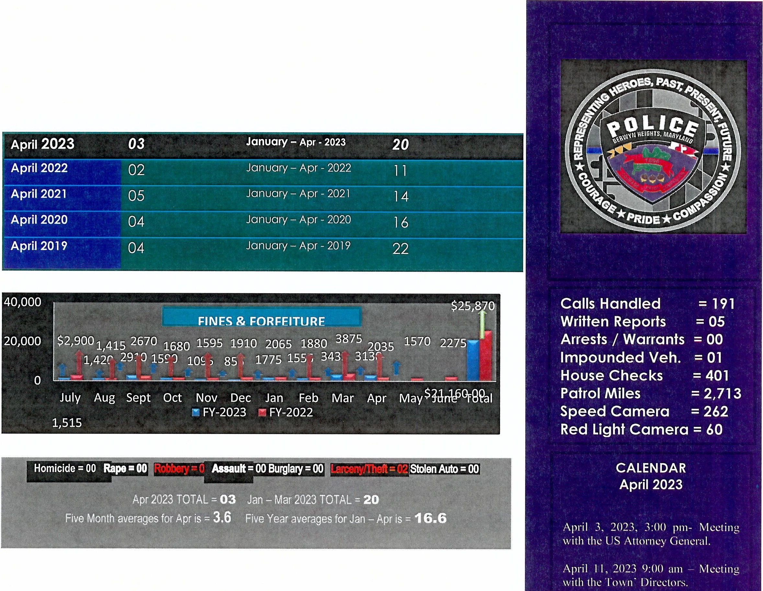

April 12, 202-' r11 11 :30 a111
MUNICIPAL & STATE INFRACTIONS
lli
 |  | -
 |  | .■J;;----
 |  |  | I  I!;;- | IL- | I
 |  | Jan | Feb | Mar | Apr | May | June | July | Aug | Sep | Oct | Nov | Dec
 | lriiilTOTAL | 98 | 137 | 136 | 117
 | PARKING | 36 | 70 | 59 | 62
 | WARNINGS | 45 | 41 | so | 42
 | Iii STATE | 12 | 21 | 19 | 11
 | SERO | 5 | 5 | 8 | 2

Mo:o:ting with tho: MD l11spo:.:1or Gmo:ral.

April 13, 2023 111 I 0:30 a111
IVk.:ting with tho: Spo:o:d Ca1110:ras Vrndor.

April 14, 2023 (11 I I :00 am
-
Mo:o:ting with tho: Town Manago:r about Spo:o:d Hu111ps.

April 25, 2023 111 I I :00 a111 -
So:niors Mo:o:ting.

April 27, 2023 111 I0:00 am
1\1.:.:ting with Town ro:sido:nt about Hat.: lncidmts.

April 28, 2023 la (J:00 am with staff about 111itigatio11s.
Mo:o:ting

April 29, 2023 (11 5:00 pm I'S;\
Awards o:vo:nt at Mt. Rainio:r.

Berwyn Heights Police Department
Compiled by Chief Kenneth K. Gattis-Antolik

Five
Month
Four Month Five Year

=18 = 83
1 Town of Berwyn Heights, MD
Last Month for March
08
1

UCR Part One (1)
I April 2023 03 January April- 2023 20
·

April 2022 April 2021 April 2020 April 2019
January - April - 2022 11
January -April - 2021 January -April - 2020 January -April - 2019
02
05
04
04
14
16
22

- 1
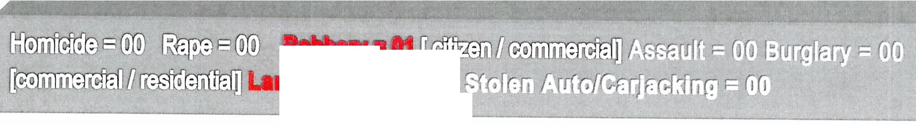
IO .. ,
I
rceny/Theft • 02 ....................................,,,1--".-..' t·J
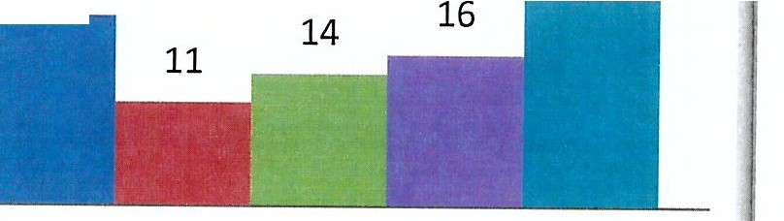
Notes:
The five-month averages for April= 3.6 [we had 3.0]
The five-year averages for January - April = 16.6 [we had 20.0]
30
20
22
20

10
3
2
5
4
4
0
April
April -5 Month
■ Apr-23 ■April-2022 ■Apr-21 ■Apr-20 ■ Apr-19

Chief's Signature: 6/. t!jf-11-4=/-1.1- Date: May 2, 2023

Prince George's County, Maryland _

BERWYN HEIGHTS POLICE DEPARTMENT
Monthly Snapshot for April 2023

AUTOMATED SPEEDCAMERA

April 2023
Edmonston Road 150
Greenbelt Road 112
Red Light I 58th@193 60
TOTAL=:=
..
··-
..
.
.. • .. 1 .:-

□2023 ■2022 □2021 □2020 ■2019

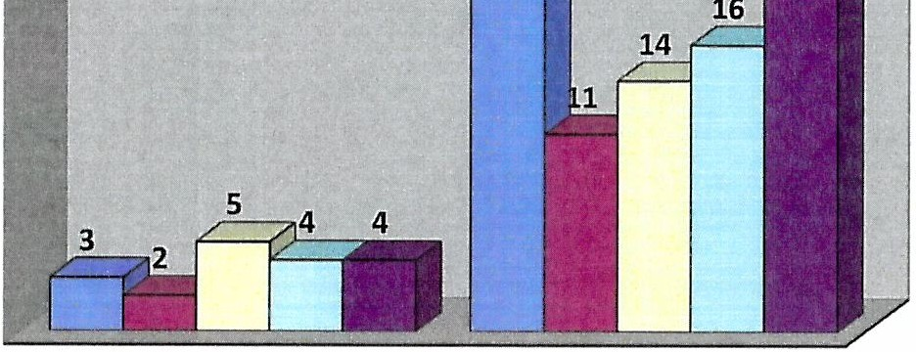25
April - 2022 = 02
April - 2023 = 03
UP by 1.0

20

15

10

5

0
April April 5 Mnts

0
s
zVl
iJ
...I
ii:
Q.
ct
MUNICIPAL & STATE INFRACTIONS
1ii11.c=1
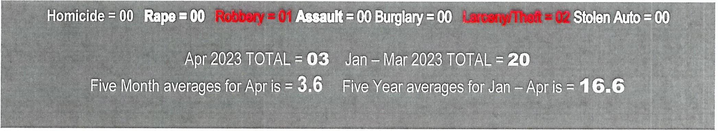

 | Jan | Feb | Mar | Apr | May | June | July | Aug | Sep | Oct | Nov | Dec
liilTOTAL | 98 | 137 | 136 | 117
Iii PARKING | 36 | 70 | 59 | 62
WARNINGS | 45 | 41 | 50 | 42
liil STATE | 12 | 21 | 19 | 11
SERO | 5 | 5 | 8 | 2
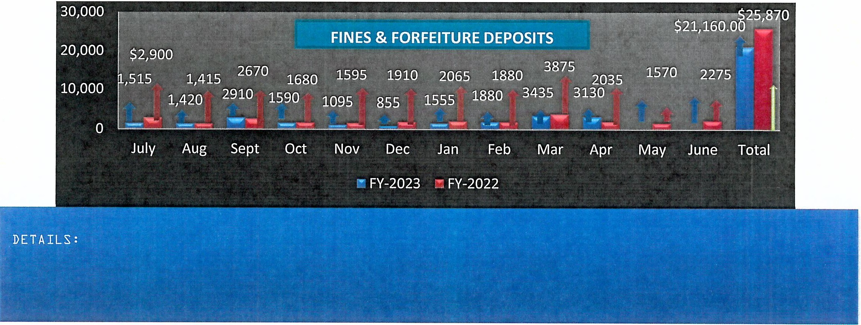
64

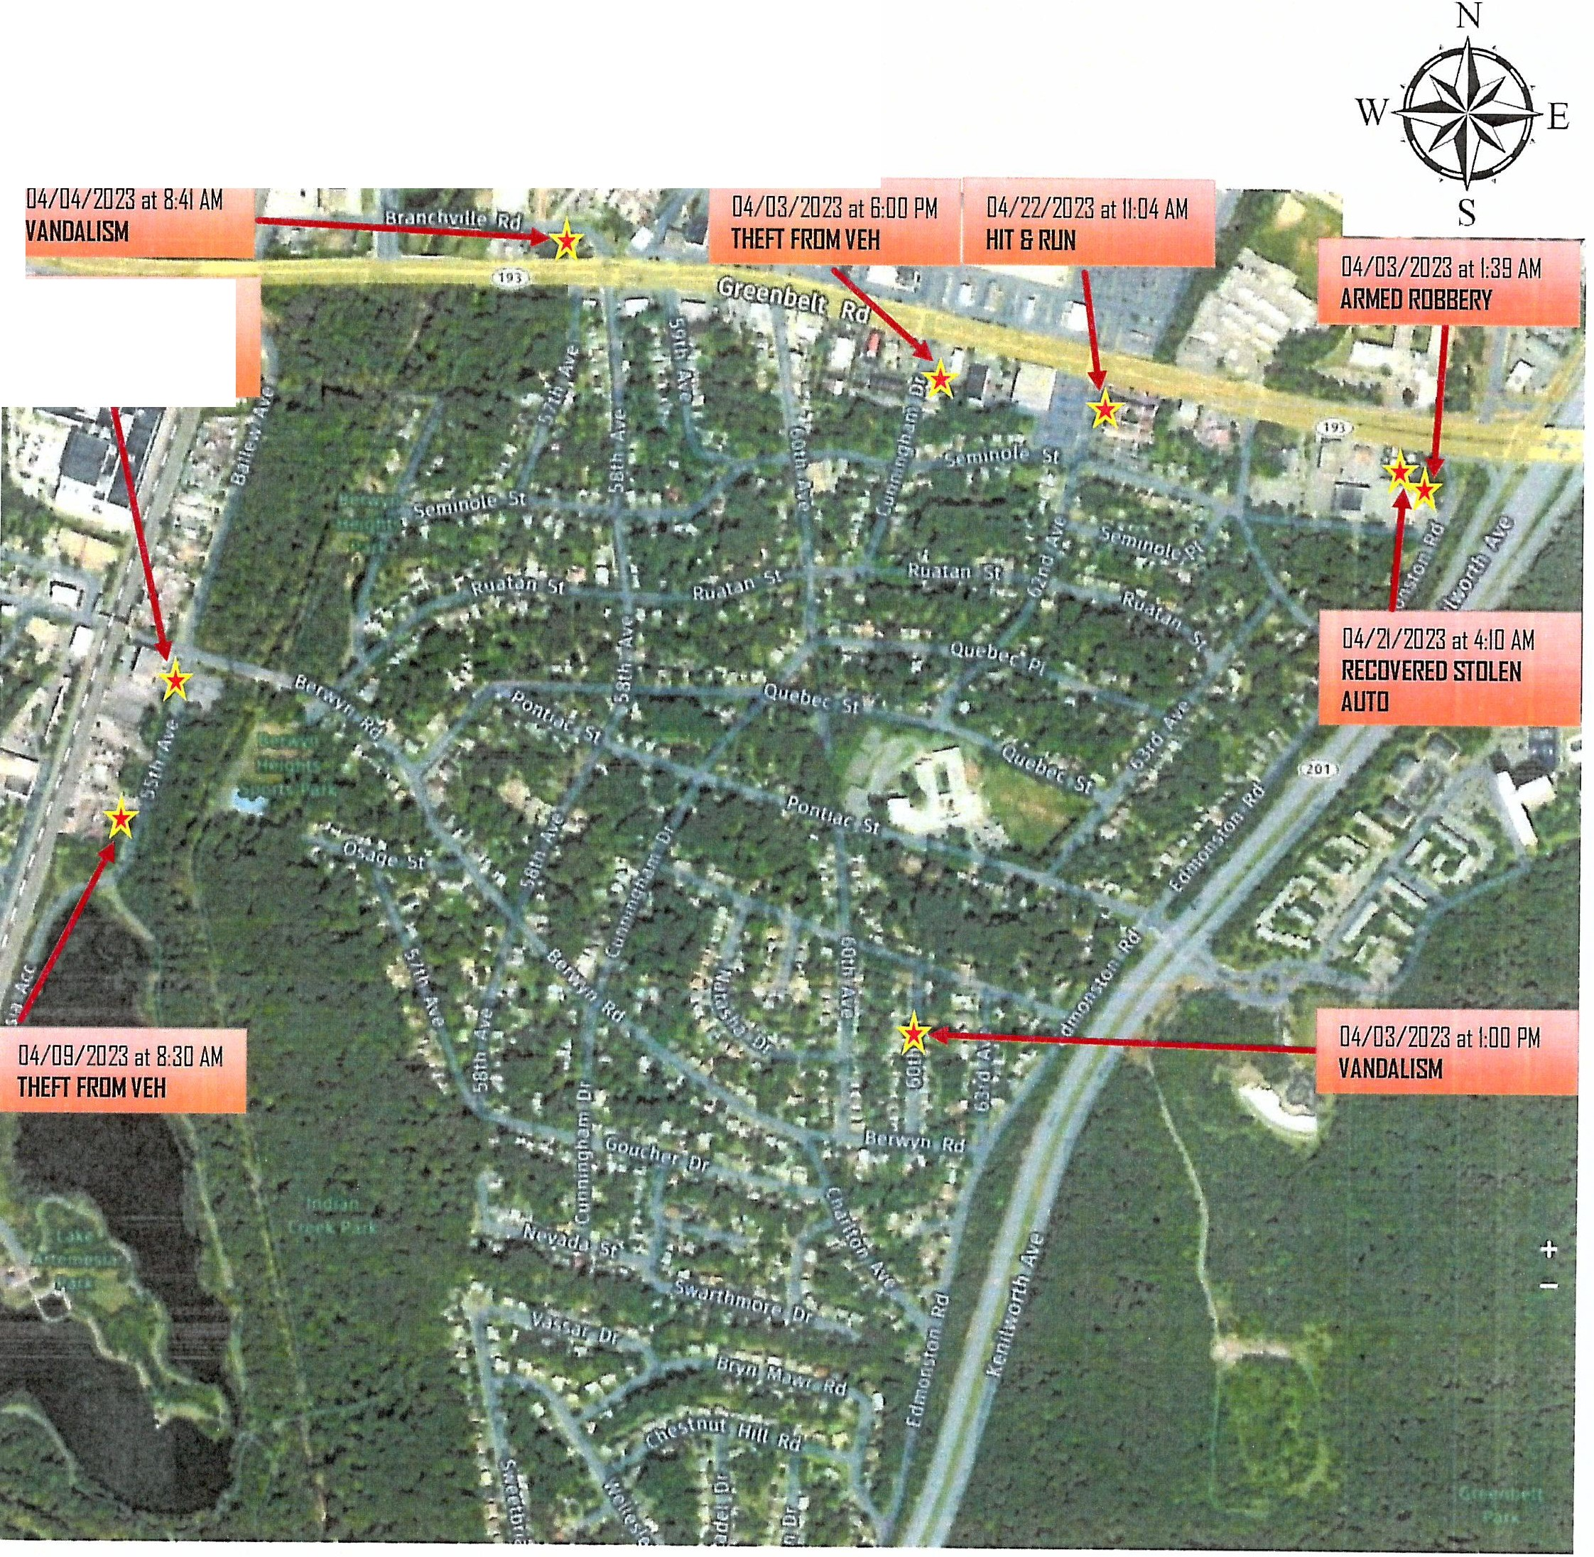

BHPD WEEKLY
•••

04/27/2023 at l□:00AM STATION REPORT-HATE BIAS

YOU CAN MAKE A DIFFERENCE IN YOUR COMMUNITY. If you have information about an unsolved crime call, text, or submit your tip online, and we'll take it from there. Anonymous Tip Line:
1-866-411-TIPS (8477) ~ Calls are answered 24 hours a day, seven days a week.
**NEW Crime Solvers Mobile App** The FREE "P3 Tips" mobile app, available for iOS and Android, will allow tipsters to send ANONYMOUSLY messages that have no length limitations, photos, videos and documents with the tip!
- All calls are completely anonymous
  - Your identity is secret
  - You will not be asked to give your name
  - You will not have to appear in court
  - We do not use caller ID
- Berwyn Heights Maryland Police Department 301-474-6554

2

EIRsWVN HE GHfS MJAIR{VIL.ANJll) l?J<cMJtE ll)El?JAIRsfMJENf
l?JUJ l!Jt SAlrEfV Alll)E AWAIR{ll)S 2@23 A rrfil 2W,J2@23 Mt,IR{ fi fi@Jtr,JM rrwl d

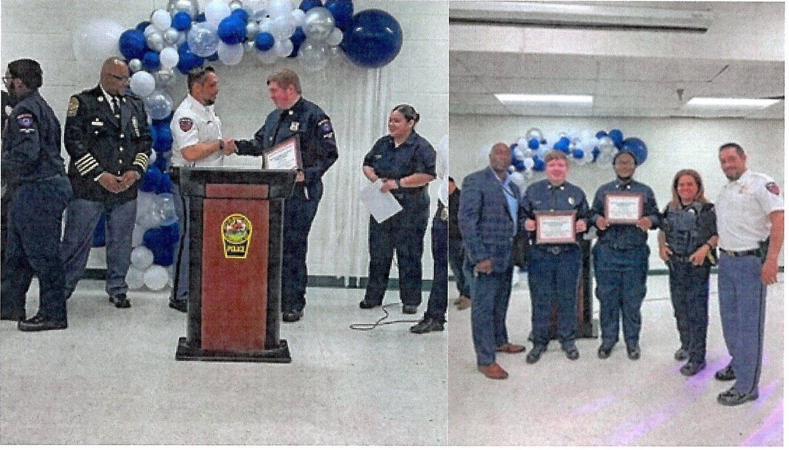
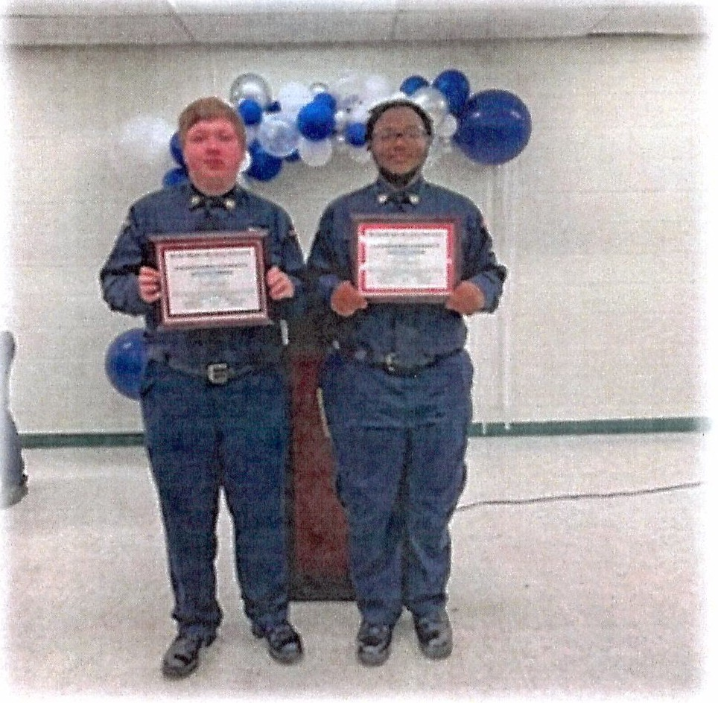

CONGRATULATIONS To PSA. Jacob Gohr and PSA. Ari Freeman for receiving the 2023 Distinguished Community Service Award from the BHPD.

Berwyn Heights Police Department
24 Hour Calls-for-Service Report
APRIL 2023

Date | Time | Incident Type | Location | Location Name | Disp | Case No. | Unit ID | Comments
04/01/2023 | 02:27 | PREMISE CHECK | Edmonston Rd / Pontiac St |  | 300 | 0211 | 1810 | 300
04/01/2023 | 11:46 | MISC POLICE INCIDENT | 85■5Bth Ave |  | NR | 0210 |  | NO REPORT
04/01/2023 | 12:32 | T - Traffic Stop | Quebec St/ 58th Ave |  | 576 | 0210 | BH102 | Traffic Stop Citation
04/01/2023 | 12:55 | 911 DISCONNECT | 8400 Ballew Ave |  | CE | 0210 |  | CLOSED AT ENTRY
04/01/2023 | 14:48 | 911 DISCONNECT | 6215 Greenbelt Rd Eb |  | CE | 0211 |  | CLOSED AT ENTRY
04/01/2023 | 15:19 | MISC POLICE INCIDENT | 76■Charlton Ave |  | cc | 0211 |  | CANCELED BY CALLER
04/01/2023 | 17:52 | DISORDERLY | 8904 62nd Ave | DOMINO'S PIZZA | 300 | 0211 | BH103 | 300
04/01/2023 | 18:43 | PREMISE CHECK | Greenbelt Rd Eb / Branchville Rd |  | 318 | 0210 |  | Premise Check - No Report
04/01/2023 | 20:37 | DOMESTIC | 56■Osage St |  | 371 | 0210 | BH103 | 371
04/02/2023 | 02:18 | DISORDERLY | 6219 Greenbelt Rd Eb | MCDONALDS - GREENBELT | 300 | 0211 | 187 | 300
04/02/2023 | 03:22 | CHECK WELFARE | 6219 Greenbelt Rd Eb | MCDONALDS - GREENBELT | 300 | 0211 | 187 | 300
04/02/2023 | 10:07 | 911 DISCONNECT | 52■Berwyn Rd |  | CE | 0210 |  | CLOSED AT ENTRY
04/02/2023 | 14:02 | 911 DISCONNECT | 6215 Greenbelt Rd Eb |  | CE | 0211 |  | CLOSED AT ENTRY
04/02/2023 | 16:53 | HOLD UP ALARM | 8904 62nd Ave |  | 300 | 0211 | BH103 | 300
04/02/2023 | 17:54 | 911 DISCONNECT | 6215 Greenbelt Rd Eb |  | NR | 0211 |  | NO REPORT
04/02/2023 | 19:51 | ASSAULT | 84■57th Ave |  | 300 | 0210 | BH109 | 300
04/03/2023 | 01:39 | REPORTED T/A  0ncu:::u:0v | 8900 Edmonston Rd | 711 COLLEGE PARK | 584C | 0211 | 1B7 | 584C
04/03/2023 | 11:46 | HOLD UP ALARM | 8900 Edmonston Rd |  | 378C | 0211 | BH102 | Premise Alarm - Commercial
04/03/2023 | 13:07 | DOMESTIC | 85■5Bth Ave |  | 300 | 0210 | BH102 | 300
04/03/2023 | 15:04 | VANDALISM | 85■60th Pl |  | 500 | 0211 | BH102 | Misc. Report
04/03/2023 | 15:41 | 911 DISCONNECT | 59■Osage St |  | CE | 0211 |  | CLOSED AT ENTRY
04/03/2023 | 17:39 | 911 DISCONNECT | 6215 Greenbelt Rd Eb |  | CE | 0211 |  | CLOSED AT ENTRY
04/03/2023 | 18:06 | THEFT FROM AUTO | 6101 Greenbelt Rd Eb | KFC - GREENBELT | 500 | 0211 | BH103 | Misc. Report
04/03/2023 | 19':49 | CHECK WELFARE | 87■Edmonston Rd |  | cc | 0211 |  | CANCELED BY CALLER
04/03/2023 | 20:02 | PREMISE CHECK | 63■Seminole St |  | 318 | 0211 | R13 | Premise Check - No Report
04/04/2023 | 02:15 | UNKNOWN TROUBLE | 85■63rd Ave |  | CE | 0211 |  | CLOSED AT ENTRY
04/04/2023 | 02:48 | PREMISE CHECK | 8900 Edmonston Rd | 711 COLLEGE PARK | 318 | 0211 |  | Premise Check - No Report
04/04/2023 | 02:53 | RESIDENTIAL ALARM | BB■Edmonston Rd |  | 378R | 0211 | 185 | Premise Alarm - Residential
04/04/2023 | 08:36 | VANDALISM | 5600 Greenbelt Rd Wb | TRUISTBANK | 500 | 0210 | BH105 | Misc. Report
04/04/2023 | 10:21 | DOMESTIC | 85■5Bth Ave |  | 300 | 0210 | BH105 | 300
04/04/2023 | 11:56 | DOMESTIC | 85■5Bth Ave |  | 300 | 0210 | BH105 | 300
04/04/2023 | 16:46 | HIT AND RUN | 6201 Greenbelt Rd Eb | ACTIVE PHYSICAL THERAPY | 300 | 0211 | BH106 | 300
04/04/2023 | 17:21 | 911 DISCONNECT | 6215 Greenbelt Rd Eb |  | NR | 0211 |  | NO REPORT
04/04/2023 | 19:40 | ANIMAL COMPLAINT | Greenbelt Rd Eb / Greenbelt Station Pkwv |  | 300 | 0210 | BH106 | 300
04/05/2023 | 02:39 | PREMISE CHECK | 8900 Edmonston Rd | 711 COLLEGE PARK | 318 | 0211 | 185 | Premise Check - No Report
04/05/2023 | 09:24 | DISORDERLY | 5815 Greenbelt Rd Eb | 711 | 300 | 0210 | BH105 | 300
04/05/2023 | 09:46 | 911 DISCONNECT | 8400 Ballew Ave |  | CE | 0210 |  | CLOSED AT ENTRY
04/05/2023 | 11:47 | DOMESTIC | 87■Cunningham Dr |  | 300 | 0210 | BH105 | 300
04/05/2023 | 12:39 | UNKNOWN TROUBLE | 85■Cunningham Dr |  | CE | 0210 |  | CLOSED AT ENTRY  67
5/2/2023 7:27:49 AM Disposition Types: NR-No Report RP-Report CE-Closed at Entry CC- 1 of 5 Paqes

04/05/2023 | 13:40 | UNKNOWN TROUBLE | 56■Berwyn Rd |  | CE | 0210 |  | CLOSED AT ENTRY
04/05/2023 | 14:39 | 911 DISCONNECT | 52■Berwyn Rd |  | cc | 0210 |  | CANCELED BY CALLER
04/05/2023 | 21:08 | SUSPICIOUS PERSON | 6327 Greenbelt Rd Eb |  | 300 | 0211 | BH106 | 300
04/05/2023 | 21:32 | PREMISE CHECK | 6327 Greenbelt Rd Eb |  | 318 | 0211 | BH106 | Premise Check - No Report
04/05/2023 | 22:40 | PROPERTY ALARM COMMERCIAL | 6105 Greenbelt Rd Eb |  | 378C | 0211 | BH106 | Premise Alarm - Commercial
04/05/2023 | 23:49 | DOMESTIC W/ WEAPON | 84■Cunningham Dr |  | 371 | 0211 | BH106 | 371
04/06/2023 | 13:48 | TACKUP | 89■56th Ave |  | SERV | 0210 | SC320 | PAPER SERVED
04/06/2023 | 14:17 | DISORDERLY | 5600 Greenbelt Rd Wb | TRUIST | 300 | 0210 | BH105 | 300
04/06/2023 | 14:28 | ANIMAL COMPLAINT | 62■Seminole St |  | cc | 0211 |  | CANCELED BY CALLER
04/06/2023 | 18:23 | SUSPICIOUS OCC AUTO | 57■Pontiac St |  | 300 | 0210 | BH106 | 300
04/06/2023 | 18:32 | PREMISE CHECK | 5700 (blk)pontiac St |  | 318 | 0210 | BH106 | Premise Check - No Report
04/07/2023 | 00:48 | PROPERTY ALARM COMMERCIAL | 6101 Greenbelt Rd Eb | KFC - GREENBELT | 378C | 0211 | BH106 | Premise Alarm - Commercial
04/07/2023 | 02:01 | PREMISE CHECK | 8900 Edmonston Rd | 711 COLLEGE PARK | 318 | 0211 | 1B10 | Premise Check - No Report
04/07/2023 | 15:33 | UNKNOWN TROUBLE | 8400 Ballew Ave |  | CE | 0210 |  | CLOSED AT ENTRY
04/07/2023 | 16:32 | UNKNOWN TROUBLE | 52■Berwyn Rd |  | CE | 0210 |  | CLOSED AT ENTRY
04/08/2023 | 03:33 | DISORDERLY | 89■57th Ave |  | cc | 0210 |  | CANCELED BY CALLER
04/08/2023 | 23:57 | CHECK WELFARE COMBINED | 83■55th Ave |  | 300 | 0210 | BH103 | 300
04/09/2023 | 04:10 | PREMISE CHECK | 8900 Edmonston Rd | 711 COLLEGE PARK | 318 | 0211 |  | Premise Check - No Report
04/09/2023 | 08:30 | THEFT FROM AUTO | 5411 Berwyn Rd | BERWYN HEIGHTS POLICE  nt=OllRTA.At=I\IT | 563V | 0210 | BH102 | 563V
04/09/2023 | 17:45 | ANIMAL COMPLAINT | Berwyn Rd / Lake Artemesia  T,J |  | CE | 0210 |  | CLOSED AT ENTRY
04/09/2023 | 19:34 | 911 DISCONNECT | 8400 Ballew Ave |  | CE | 0210 |  | CLOSED AT ENTRY
04/10/2023 | 00:10 | PREMISE CHECK | 6001(6000) Blk Greenbelt  Rn t=h |  | 318 | 0211 | 1B7 | Premise Check - No Report
04/10/2023 | 02:19 | PREMISE CHECK | 85■Edmonston Rd |  | 318 | 0211 | 1B7 | Premise Check - No Report
04/10/2023 | 11:32 | PAPER SERVICE | 59■Osage St |  | NOSERV | 0211 | DS18 | PAPER NOT SERVED
04/10/2023 | 17:03 | HOLD UP ALARM | 6201 Greenbelt Rd Eb Apt U  a | ORTHODONTICS | 378C | 0211 | BH103 | Premise Alarm - Commercial
04/10/2023 | 18:23 | UNKNOWN TROUBLE | 6215 Greenbelt Rd Eb |  | CE | 0211 |  | CLOSED AT ENTRY
04/10/2023 | 18:54 | CHECK WELFARE | 62nd Ave/ Greenbelt Rd Eb |  | 300 | 0211 | BH103 | 300
04/10/2023 | 19:17 | 911 DISCONNECT | 6215 Greenbelt Rd Eb |  | CE | 0211 |  | CLOSED AT ENTRY
04/11/2023 | 02:36 | PREMISE CHECK | 6001(6000) Blk Greenbelt  Rr{ t=h |  | 318 | 0211 | 1B6 | Premise Check - No Report
04/11/2023 | 05:28 | PROPERTY ALARM COMMERCIAL | 6105 Greenbelt Rd Eb |  | 378C | 0211 | 2B7 | Premise Alarm - Commercial
04/11/2023 | 18:21 | FIGHT | 8904 62nd Ave | TMOBILE | 300 | 0211 | BH106 | 300
04/12/2023 | 01:34 | PREMISE CHECK | 5800 Greenbelt Rd Wb |  | 318 | 0210 | 1B7 | Premise Check - No Report
04/12/2023 | 12:10 | TACKUP | 59■Berwyn Rd |  | SERV | 0211 | SC320 | PAPER SERVED
04/12/2023 | 14:09 | 911 DISCONNECT | 8400 Ballew Ave |  | CE | 0210 |  | CLOSED AT ENTRY
04/12/2023 | 16:02 | ACCIDENT | 5550 Greenbelt Rd Wb | BELTWAY PLAZA SHELL | 300 | 0210 | BH106 | 300
04/12/2023 | 17:11 | HIT AND RUN | 87■Edmonston Rd |  | 300 | 0211 | BH106 | 300
04/12/2023 | 18:17 | THEFT REPORT | 6051 Greenbelt Rd Eb | CHECKERS-GREENBELT | 300 | 0211 | BH106 | 300
04/12/2023 | 19:31 | CHECK WELFARE | 8904 Edmonston Rd | 7 ELEVEN | cc | 0211 |  | CANCELED BY CALLER
04/12/2023 | 23:59 | FAMILY DISPUTE | 83■Cunningham Dr |  | 300 | 0211 | 1B7 | 300
04/13/2023 | 00:42 | PREMISE CHECK | 5700 Branchville Rd | PRINCE GEORGES SCRAP | 318 | 0210 | 1B6 | Premise Check - No Report
04/13/2023 | 17:04 | ACCIDENT | Greenbelt Rd Eb 162nd Ave |  | 300 | 0211 | BH106 | 300
04/13/2023 | 17:32 | ACCIDENT | 5919 Greenbelt Rd Eb |  | CD | 0210 |  | CANCELED BY DUPLICATE

5/2/2023 7:27:49 AM Disposition Types: NR-No Report RP-Report CE-Closed at Entry CC-
68 2 of 5 Paqes

04/13/2023 | 17:32 | ACCIDENT | 60th Ave/ Greenbelt Rd Eb |  | CD | 0210 |  | CANCELED BY DUPLICATE
04/13/2023 | 18:05 | VEHICLE ACCIDENT COMBINED | Greenbelt Rd Eb/ 60th Ave |  | ACRS | 0210 | BH106 | ACRS REPORT
04/13/2023 | 21:11 | SUSPICIOUS OCC AUTO | 8904 62nd Ave | TMOBILE | 300 | 0211 | 3B10 | 300
04/13/2023 | 23:07 | PREMISE CHECK | 6101(6100) Blk Greenbelt  D t:h |  | 318 | 0211 | 3B10 | Premise Check - No Report
04/14/2023 | 04:17 | NOISE COMPLAINT | 87■63rd Ave |  | 300 | 0211 | 1B6 | 300
04/14/2023 | 09:34 | RESIDENTIAL ALARM | 89■57th Ave |  | 378R | 0210 | BH102 | Premise Alarm - Residential
04/14/2023 | 11:01 | HIT AND RUN | Greenbelt Rd Wb / Cherrywood Ln | MATTRESS WAREHOUSE | TR | 0210 |  | TRANSFERRED TO OTHER AGENCY
04/14/2023 | 11:27 | 911 DISCONNECT | 6201 Greenbelt Rd Eb | EXPRESS HEALTHCARE | CE | 0211 |  | CLOSED AT ENTRY
04/14/2023 | 11:29 | UNKNOWN TROUBLE | 6201 Greenbelt Rd Eb |  | cc | 0211 |  | CANCELED BY CALLER
04/14/2023 | 12:07 | SUSPICIOUS PERSON | 6200-bl Ruatan St |  | 507 | 0211 | BH102 | 507
04/14/2023 | 12:43 | SUSPICIOUS PERSON | 87■Edmonston Rd |  | 5761 | 0211 | BH102 | 5761
04/14/2023 | 12:50 | 911 DISCONNECT | 6215 Greenbelt Rd Eb |  | cc | 0211 |  | CANCELED BY CALLER
04/14/2023 | 13:03 | UNKNOWN TROUBLE | 6215 Greenbelt Rd Eb |  | CE | 0211 |  | CLOSED AT ENTRY
04/14/2023 | 13:12 | CHECK WELFARE COMBINED | 6301 Greenbelt Rd Eb | BERWYN PRESBYTERIAN  f'l--1111::::,("1,..J | 300 | 0211 | BH102 | 300
04/14/2023 | 13:31 | LOCKOUT | 5915 Greenbelt Rd Eb | PARKED BY THE 7 ELEVEN | 300 | 0210 | BH102 | 300
04/14/2023 | 19:08 | SUSPICIOUS PERSON | 61■Seminole St |  | 300 | 0211 | BH106 | 300
04/14/2023 | 19:48 | PREMISE CHECK | 6014(6100) Blk Berwyn Rd |  | 318 | 0211 | B51 | Premise Check - No Report
04/14/2023 | 22:36 | 911 DISCONNECT | 58■Berwyn Rd |  | CE | 0210 |  | CLOSED AT ENTRY
04/14/2023 | 23:22 | UNKNOWN TROUBLE | 6215 Greenbelt Rd Eb |  | CE | 0211 |  | CLOSED AT ENTRY
04/15/2023 | 10:39 | BREAK IN IN PROGRESS | 6201 Greenbelt Rd Eb Apt | PREMIER MEDICAL CENTER | 378C | 0211 | BH102 | Premise Alarm - Commercial
04/15/2023 | 16:13 | HOLD UP ALARM | ""  8904 62nd Ave |  | 300 | 0211 | BH102 | 300
04/15/2023 | 21:13 | NOISE COMPLAINT | 89■59th Ave |  | 300 | 0210 | BH109 | 300
04/15/2023 | 22:50 | 911 DISCONNECT | 8400 Ballew Ave |  | cc | 0210 |  | CANCELED BY CALLER
04/16/2023 | 02:32 | DOMESTIC | 6327 Greenbelt Rd Eb | SHELL | 300 | 0211 | 1B6 | 300
04/16/2023 | 02:56 | DOMESTIC | 5815 Greenbelt Rd Eb |  | 300 | 0210 | 1B6 | 300
04/16/2023 | 10:26 | UNKNOWN TROUBLE | 85■58th Ave |  | CE | 0210 |  | CLOSED AT ENTRY
04/16/2023 | 12:35 | UNKNOWN TROUBLE | 6215 Greenbelt Rd Eb |  | CE | 0211 |  | CLOSED AT ENTRY
04/16/2023 | 19:47 | MISC POLICE INCIDENT | 6215 Greenbelt Rd Eb |  | cc | 0211 |  | CANCELED BY CALLER
04/17/2023 | 10:35 | SUSPICIOUS AUTO | 6219 Greenbelt Rd Eb | MCDONALDS - GREENBELT | 300 | 0211 | BH105 | 300
04/17/2023 | 12:55 | ASSIST FIRE EMS | 6215 Greenbelt Rd Eb | NEAR MCDONALDS -  r-ot=t=t..u: t:1 T | 300 | 0211 | BH105 | 300
04/17/2023 | 13:19 | MISC POLICE INCIDENT | 86■57th Ave |  | CE | 0210 |  | CLOSED AT ENTRY
04/17/2023 | 18:44 | PROPERTY ALARM COMMERCIAL | 6011 Greenbelt Rd Eb |  | 378C | 0211 | BH109 | Premise Alarm - Commercial
04/17/2023 | 20:20 | 911 DISCONNECT | 59■Tecumseh St |  | CE | 0210 |  | CLOSED AT ENTRY
04/18/2023 | 03:09 | PREMISE CHECK | 5700 (blk)branchville Rd |  | 318 | 0210 | 1B8 | Premise Check - No Report
04/18/2023 | 07:51 | 911 DISCONNECT | 8400 Ballew Ave |  | CE | 0210 |  | CLOSED AT ENTRY
04/18/2023 | 12:08 | EVICTION | 89■56th Ave |  | SERV | 0210 | SC565 | PAPER SERVED
04/18/2023 | 12:31 | UNKNOWN TROUBLE | 86■63rd Ave |  | CE | 0211 |  | CLOSED AT ENTRY
04/19/2023 | 01:09 | PREMISE CHECK | 5800 (blk)greenbelt Rd Wb |  | 318 | 0210 | 1B7 | Premise Check - No Report
04/19/2023 | 08:07 | SUSPICIOUS OCC AUTO | 5600 Greenbelt Rd Wb | TRUIST BANK | 300 | 0210 | BH106 | 300
04/20/2023 | 11:17 | 911 DISCONNECT | 8404 Ballew Ave |  | CE | 0210 |  | CLOSED AT ENTRY
04/20/2023 | 13:02 | CROSSING GUARD ASSIGNMENT | 62nd Ave/ Quebec St Bldg Berwvn Hts Es |  | 300 | 0211 |  | 300
04/20/2023 | 14:39 | PAPER SERVICE | 89■59th Ave |  | NOSERV | 0210 | SC505 | PAPER NOT SERVED

5/2/2023 7:27:49 AM Disposition Types: NR-No Report RP-Report CE-Closed at Entry CC-
69 3 of 5 Paqes

04/20/2023 | 18:10 | 911 DISCONNECT | 89■62nd Ave |  | CE | 0211 |  | CLOSED AT ENTRY
04/20/2023 | 19:58 | UNKNOWN TROUBLE | 88■63rd Ave |  | CE | 0211 |  | CLOSED AT ENTRY
04/21/2023 | 04:07 | SUSPICIOUS AUTO | 6327 Greenbelt Rd Eb |  | 505S | 0211 | 1B6 | Stolen Vehicle - Report
04/21/2023 | 04:08 | ASSIST | 6327 Greenbelt Rd Eb |  | 300 | 0211 |  | 300
04/21/2023 | 13:36 | UNKNOWN TROUBLE | 63■Pontiac St |  | CE | 0211 |  | CLOSED AT ENTRY
04/21/2023 | 15:02 | UNKNOWN TROUBLE | 6215 Greenbelt Rd Eb |  | CE | 0211 |  | CLOSED AT ENTRY
04/21/2023 | 18:06 | CHECK WELFARE | 59■Berwyn Rd |  | 300 | 0211 | BH103 | 300
04/21/2023 | 18:30 | FRAUD | 58■Seminole St |  | CE | 0210 |  | CLOSED AT ENTRY
04/21/2023 | 20:59 | DISORDERLY | 86■60th Ave |  | 300 | 0211 | BH109 | 300
04/21/2023 | 21:56 | ACCIDENT | Greenbelt Rd Eb/  Rr-::inr-hHillO Rn |  | 300 | 0210 | BH103 | 300
04/22/2023 | 02:20 | UNKNOWN TROUBLE | 60■Berwyn Rd |  | 300 | 0211 | 1B6 | 300
04/22/2023 | 11:04 | HIT AND RUN | 6201 Greenbelt Rd Eb | EXPRESS HEALTHCARE | 500 | 0211 | BH105 | Misc. Report
04/22/2023 | 16:20 | OVERDOSE ALS COMBINED | 89■59th Ave |  | 300 | 0210 | BH103 | 300
04/22/2023 | 18:22 | UNKNOWN TROUBLE | 5600 Greenbelt Rd Wb | SUNTRUST BANK -  r-:s::>t:t:P\lt:H:::1 T | 300 | 0210 | BH103 | 300
04/22/2023 | 20:02 | DISORDERLY | 56■Goucher Dr |  | 300 | 0210 | BH109 | 300
04/22/2023 | 21:45 | 911 DISCONNECT | 84■57th Ave |  | CE | 0210 |  | CLOSED AT ENTRY
04/23/2023 | 08:56 | 911 DISCONNECT | 61■Ruatan St |  | CE | 0211 |  | CLOSED AT ENTRY
04/23/2023 | 10:23 | 911 DISCONNECT | 6215 Greenbelt Rd Eb |  | CE | 0211 |  | CLOSED AT ENTRY
04/23/2023 | 16:13 | PROPERTY ALARM COMMERCIAL | 6105 Greenbelt Rd Eb |  | 378R | 0211 | BH105 | Premise Alarm - Residential
04/23/2023 | 17:00 | 911 DISCONNECT | 6215 Greenbelt Rd Eb |  | CE | 0211 |  | CLOSED AT ENTRY
04/23/2023 | 20:51 | UNKNOWN TROUBLE | 8400 Ballew Ave |  | CE | 0210 |  | CLOSED AT ENTRY
04/23/2023 | 23:28 | DOMESTIC | 56■Berwyn Rd |  | 371 | 0210 | BH103 | 371
04/24/2023 | 04:06 | DOMESTIC | 56■Ruatan St |  | 371 | 0210 | 1B6 | 371
04/24/2023 | 12:33 | 911 DISCONNECT | 6219 Greenbelt Rd Eb | MCDONALDS - GREENBELT | CE | 0211 |  | CLOSED AT ENTRY
04/24/2023 | 16:51 | FIGHT | 6219 Greenbelt Rd Eb | MCDONALDS - GREENBELT | 300 | 0211 | BH103 | 300
04/24/2023 | 17:49 | DISORDERLY | 6101 Greenbelt Rd Eb | KFC - GREENBELT | 300 | 0211 | BH109 | 300
04/24/2023 | 19:27 | 911 DISCONNECT | 6175 Greenbelt Rd Eb |  | CE | 0211 |  | CLOSED AT ENTRY
04/25/2023 | 00:26 | GUNSHOTS | 56■Ruatan St |  | CD | 0210 |  | CANCELED BY DUPLICATE
04/25/2023 | 01:11 | PREMISE CHECK | 5500-bl Greenbelt Rd Wb |  | 318 | 0210 | 1B9 | Premise Check - No Report
04/25/2023 | 17:26 | MISC POLICE INCIDENT | 8904 62nd Ave | STAPLES - BERWYN HEIGHTS | CE | 0211 |  | CLOSED AT ENTRY
04/25/2023 | 21:55 | PROPERTY ALARM COMMERCIAL | 6011 Greenbelt Rd Eb |  | 378C | 0211 | BH102 | Premise Alarm - Commercial
04/26/2023 | 00:09 | PREMISE CHECK | 5800 {blk)greenbelt Rd Wb |  | 318 | 0210 | 1B7 | Premise Check - No Report
04/26/2023 | 02:51 | GUNSHOTS | 56■Ruatan St |  | 300 | 0210 | 1B7 | 300
04/26/2023 | 03:31 | GUNSHOTS | 56■Ruatan St |  | 300 | 0210 | 1B6 | 300
04/26/2023 | 04:29 | UNKNOWN TROUBLE | 87■Cunningham Dr |  | CE | 0210 |  | CLOSED AT ENTRY
04/26/2023 | 11:56 | HOLD UP ALARM | 8904 62nd Ave |  | 378C | 0211 | BH106 | Premise Alarm - Commercial
04/26/2023 | 13:34 | CW18 | 8900 Edmonston Rd | 711 COLLEGE PARK | 318 | 0211 | 2B9 | Premise Check - No Report
04/26/2023 | 18:14 | 911 DISCONNECT | 89■58th Ave |  | CE | 0210 |  | CLOSED AT ENTRY
04/26/2023 | 19:29 | PAPER SERVICE | 56■Osage St |  | SERV | 0210 | SC605 | PAPER SERVED
04/26/2023 | 19:34 | DISORDERLY | 6327 Greenbelt Rd Eb | GREENBELT SHELL | 300 | 0211 | BH102 | 300
04/27/2023 | 01:56 | PREMISE CHECK | 6001(6000) Blk Greenbelt  on l="h |  | 318 | 0211 |  | Premise Check - No Report
04/27/2023 | 13:49 | 911 DISCONNECT | 6215 Greenbelt Rd Eb |  | CE | 0211 |  | CLOSED AT ENTRY

04/27/2023 | 15:08 | UNKNOWN TROUBLE | 6215 Greenbelt Rd Eb |  | 300 | 0211 | BH102 | 300
04/27/2023 | 16:17 | SUSPICIOUS PERSON | 5550 Greenbelt Rd Wb | BELTWAY PLAZA SHELL | 300 | 0210 | BH106 | 300
04/27/2023 | 19:56 | 911 DISCONNECT | 6215 Greenbelt Rd Eb |  | CE | 0211 |  | CLOSED AT ENTRY
04/27/2023 | 21:41 | UNKNOWN TROUBLE | 6215 Greenbelt Rd Eb |  | cc | 0211 |  | CANCELED BY CALLER
04/27/2023 | 23:06 | 911 DISCONNECT | 60■Berwyn Rd |  | CE | 0211 |  | CLOSED AT ENTRY
04/28/2023 | 05:51 | CROSSING GUARD ASSIGNMENT | 62nd Ave / Quebec St Bldg Berwvn Hts Es |  | 300 | 0211 | BH105 | 300
04/28/2023 | 09:22 | CW18 | 8900 Edmonston Rd | 711 COLLEGE PARK | 318 | 0211 | 2B10 | Premise Check - No Report
04/28/2023 | 15:47 | ACCIDENT | 62nd Ave/ Quebec St |  | 309 | 0211 | BH102 | 309
04/28/2023 | 16:12 | 911 DISCONNECT | 6201 Greenbelt Rd Eb | EXPRESS HEALTHCARE | 300 | 0211 | BH103 | 300
04/28/2023 | 17:27 | PREMISE CHECK | 6200 Pontiac St | BERWYN HEIGHTS  C:I C:UC:f\.lT/lRV | 318 | 0211 | L146 | Premise Check - No Report
04/29/2023 | 08:36 | 911 DISCONNECT | 6215 Greenbelt Rd Eb |  | CE | 0211 |  | CLOSED AT ENTRY
04/29/2023 | 10:03 | T - Traffic Stop | Greenbelt Rd Eb/ 57th Ave |  | 576 | 0210 | B206 | Traffic Stop Citation
04/29/2023 | 17:51 | UNKNOWN TROUBLE | 59■Osage St |  | CE | 0211 |  | CLOSED AT ENTRY
04/29/2023 | 19:56 | LOUD MUSIC COMPLAINT | 62■Pontiac St |  | 300 | 0211 | BH103 | 300
04/29/2023 | 20:11 | LOUD MUSIC COMPLAINT | Ruatan St/ 58th Ave |  | CD | 0210 |  | CANCELED BY DUPLICATE
04/29/2023 | 20:14 | LOUD MUSIC COMPLAINT | 56■Ruatan St |  | CD | 0210 |  | CANCELED BY DUPLICATE
04/29/2023 | 20:21 | NOISE COMPLAINT | 57■Nevada St |  | CD | 0210 |  | CANCELED BY DUPLICATE
04/29/2023 | 21:28 | LOUD MUSIC COMPLAINT | Villanova Rd / Swarthmore  n, |  | 300 | 0211 | BH103 | 300
04/29/2023 | 21:57 | NOISE COMPLAINT | Seminole St/ 58th Ave |  | 300 | 0210 | BH109 | 300
04/29/2023 | 22:29 | LOUD MUSIC COMPLAINT | 62■Pontiac St |  | 300 | 0211 | BH109 | 300
04/29/2023 | 22:49 | LOUD MUSIC COMPLAINT | 57■Pontiac St |  | CD | 0210 |  | CANCELED BY DUPLICATE
04/29/2023 | 22:51 | LOUD MUSIC COMPLAINT | Pontiac St/ 60th Ave |  | CD | 0211 |  | CANCELED BY DUPLICATE
04/29/2023 | 22:54 | PARTY COMPLAINT | 89■60th Ave |  | 100 | 0210 |  | 100
04/29/2023 | 23:40 | PARTY COMPLAINT | 89■60th Ave |  | 300 | 0210 | BH109 | 300
04/30/2023 | 19:59 | 911 DISCONNECT | 8400 Ballew Ave |  | CE | 0210 |  | CLOSED AT ENTRY
04/30/2023 | 20:45 | SUSPICIOUS AUTO | 8200 Blk 55th Ave |  | 500 | 0210 | BH103 | Misc. Report
Total Calls: 191
BERWYN HEIGHTS POLICE DEPARTMENT
CASE REPORT WORKFLOW STAGE

4/1/2023 To 4/30/2023

Case No. | Workflow Stage | Submittal QRI | Subject | Disposition | Entered Date | ID# | Reported On | Juv | PGCAgency
23-0019732-  001 | Work-Complete | Berwyn Heights Police | VANDALISM | Active | 04/03/2023 | 1454 | 04/03/2023 | N | BERWYN HEIGHTS POLICE DEPARTMENT
23-0019772-  001 | Work-Complete | Berwyn Heights Police | Recovered Property | Not a Crime/Other Service | 04/03/2023 | 1445 | 04/03/2023 | N | BERWYN HEIGHTS POLICE DEPARTMENT
23-0019864-  001 | Work-Complete | Berwyn Heights Police | VANDALISM | Active | 04/04/2023 | 1449 | 04/04/2023 | N | BERWYN HEIGHTS POLICE DEPARTMENT
23-0020905-  001 | Work-Complete | Berwyn Heights Police | THEFT FROM AUTO | Active | 04/09/2023 | 1454 | 04/09/2023 | N | BERWYN HEIGHTS POLICE DEPARTMENT
23-0023802-  001 | Linx | Berwyn Heights Police | property damage auto | Active | 04/22/2023 | 1449 | 04/22/2023 | N | BERWYN HEIGHTS POLICE DEPARTMENT
Total Reports --> |  |  |  |  |  |  |  |  | 5

Berwyn Heights Police Department

Self-Generated Activities APRIL 2023

·
Lt. Unger |  |  |  | 00 | NOTE:
Sgt. Roberson |  |  |  | 00
Det. Krouse |  |  |  | 00
Cpl. Hollowell |  |  |  | 00
Cpl. Rufino |  |  |  | 00
Cpl. Duck |  |  |  | 00
Pvt. Lowndes |  |  |  | 00
Pvt. Herriott |  |  |  | 00
S/O. Portillo |  |  |  | 00
Juvenile Arrests: 00 |  | Warrants = 00 I Summons = 00 I EPS =00 |  |  |  |  | Total Arrests  :00 | 00 Adult(s) ARREST 00WARRANT
OFFICER |  | STATE |  |  |  |  | WARNING | S.lR.O.
Lt. Unger | = |  | 00 |  |  | 00 |  | 00
Sgt. Roberson 1445 = 00 |  |  |  |  |  | 00 |  | 00
Det. Krouse 1447 | = |  | 00 |  |  | 00 |  | 00
Cpl. Hollowell 1449 = 00 |  |  |  |  |  | 01 |  | 00
Cpl. Rufino 1451 | = |  | 07 |  |  | 07 |  | 00
Cpl. Duck 1448 | = |  | 03 |  |  | 04 |  | 00
Pvt. Lowndes 1456 = 01 |  |  |  |  |  | 10 |  | 00
Pvt. Herriott 1454 | = |  | 00 |  |  | 20 |  | 02
S/O Portillo | = |  | 00 |  |  | 00 |  | 00
TOWN CITATION |  |  |  |  |  | TOTAL
Lt. Unger = 00 |  |  |  |  |  | .0..0. |  | State = 11
Sgt. Roberson = 23 |  |  |  |  |  | 23 |  | SERO = 02
Det. Krouse = 00 |  |  |  |  |  | .0..0. |  | Town Citations = 62
Cpl. Hollowell = 12 |  |  |  |  |  | 13. |  | Warnings =42
Cpl. Rufino = 17 |  |  |  |  |  | .3.1. |  | Total Citations = 117
Cpl. Duck = 00 |  |  |  |  |  | o..z
S/O Portillo = 00 |  |  |  |  |  | .0..0.
Pvt. Herriott = 02 |  |  |  |  |  | 2.4
Pvt. Lowndes = 08 |  |  |  |  |  | 19.

72

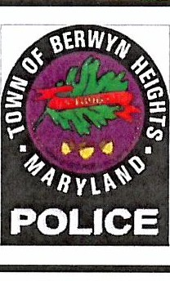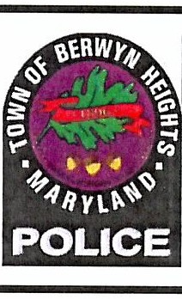

BERWYN HEIGHTS POLICE DEPARTMENT
MONTHLY REPORT OF CITATION TYPES
. A_PR_I_L .I I 2023
State Citations
IAll Others
IFailure to Stop at Stop Sigr IOther Driver's License Violations ITraffic Control Device Violations IVehicle Registration Violations
1 I
41
3 I
1 I
21
Total State Citations:
Warning Notices

IFailure to Stop at Stop Sigr
Ispeeding
ITraffic Control Device Violations
Ivehicle Registration Violations
20
9
2

9
2
Total Warnings:
Park'mg c·,tat,ons
 | 27
Double Parkin | 2
On or Overtop of a Curb | 1
On Park Property After Hours | 1
Parked in Fire Lane | 4
Parked in Travel Portion of Roac | 1
Parked Left Wheels To Curt | 4
Parked on the Grass | 2
Parked Over 12" From The Curt | 1
Signs Where Prohibitec | 19
Total Parking Citations:

Safety Equipment Repair Orders
IRepair Orders I
rotal SERO'S: I

Total Moving Violations: I 551 Total Parking Citations: Total Citations Issued: I 1111

05/02/2023 Page 1 of 1

73

CITATIONS BY MONTH
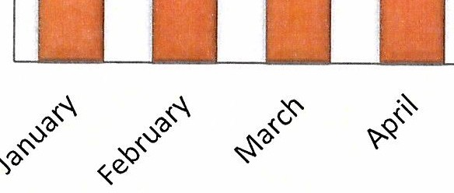
160
140
137
136
120
117
100
98
80

60
40

20
0
2023

OFFICERS TRAFIC STATISTIC
-
APRIL 2023
LOWNDES HERIOTT PORTILLO
DUCK RUFINO HOLLOWELL
KROUSE ROBERSON
UNGER
I
--
.,
0
5
10
15
20
25
30
35
I
r
I
- -
---
[=-·
-
,
I
----
--------

 | UNGER | ROBERSON | KROUSE | HOLLOWEL  L | RUFINO | DUCK | PORTILLO | HERIOTT | LOWNDES
I Seriesl | 0 | 23 | 0 | 13 | 31 | 7 | 0 | 24 | 19

74

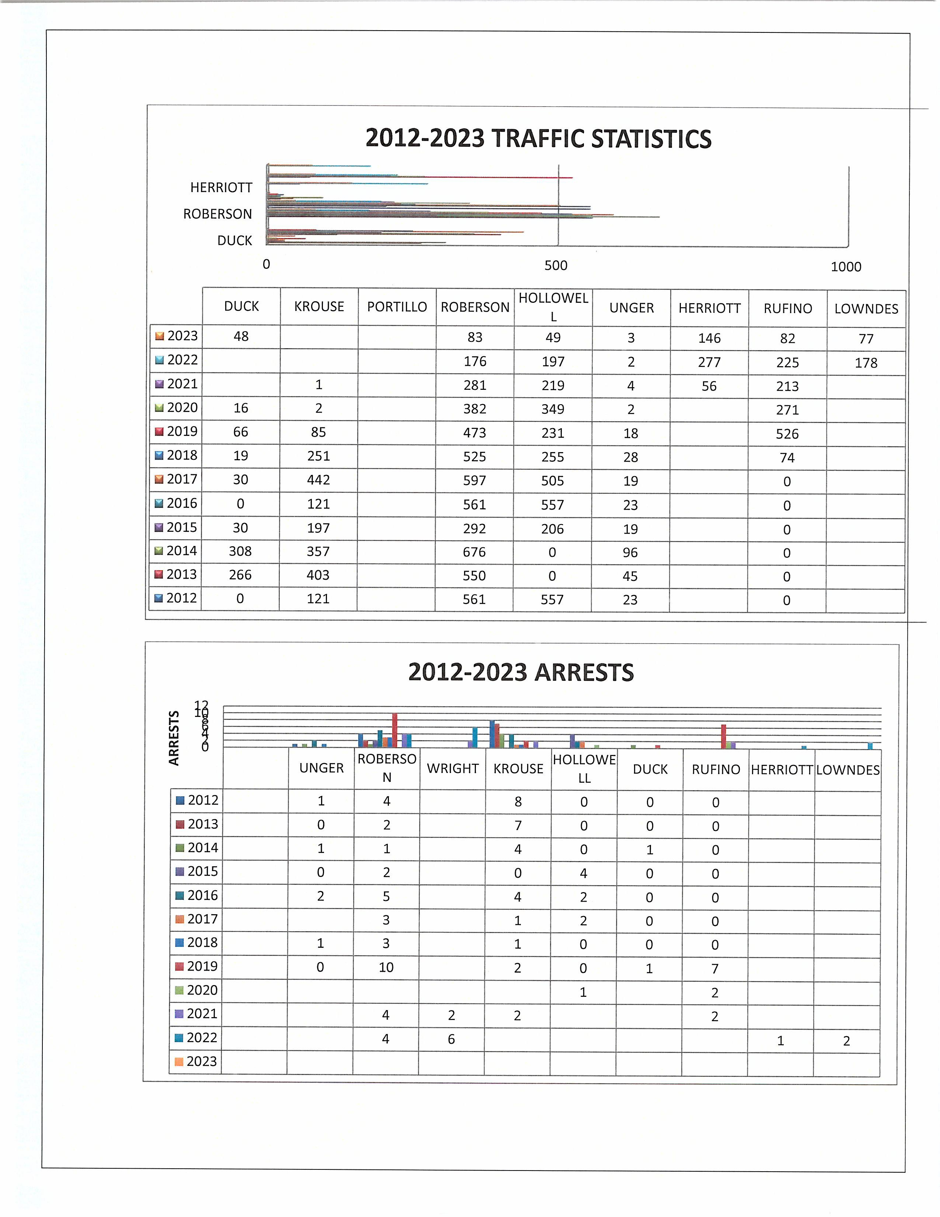

75

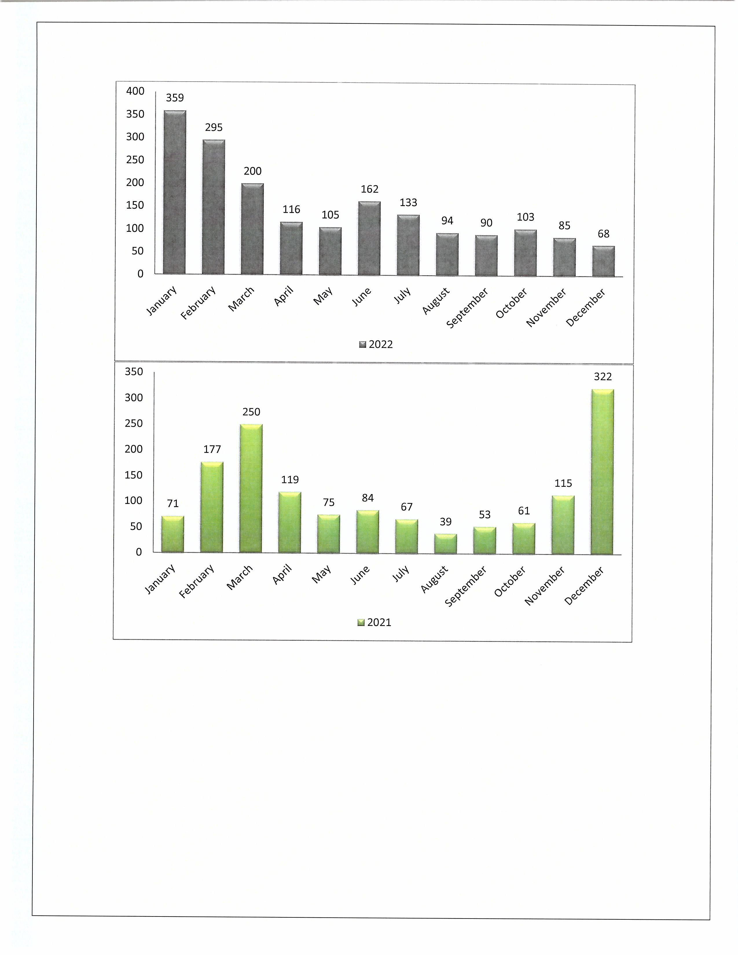

76

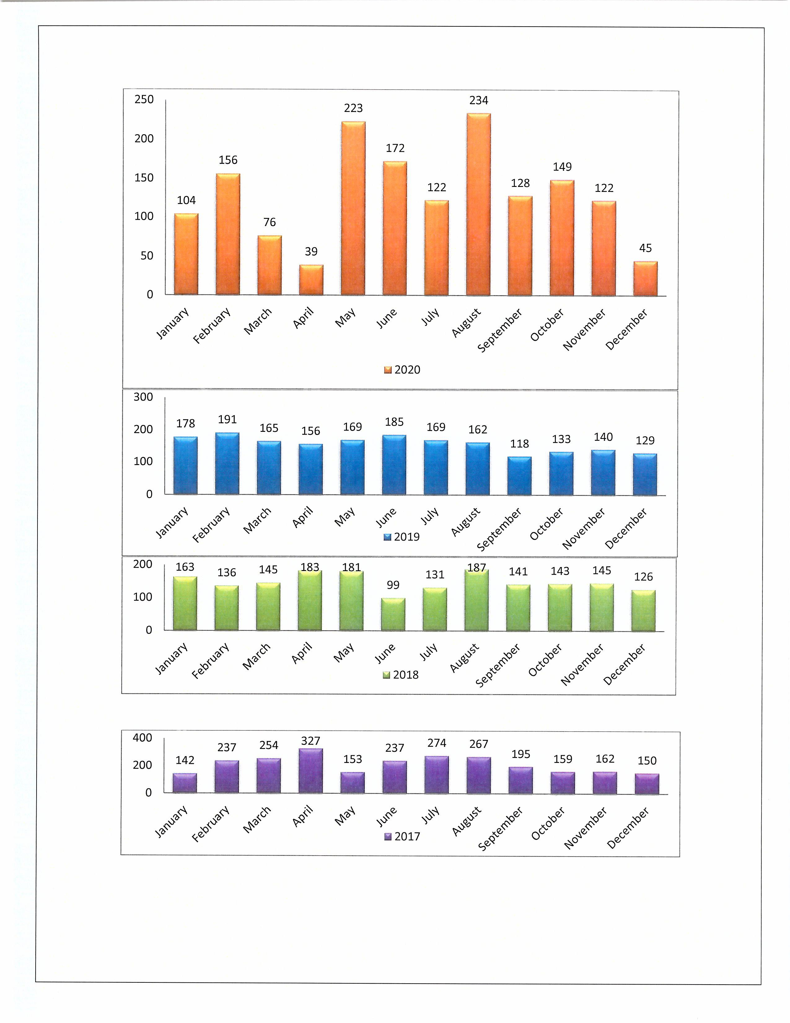

77

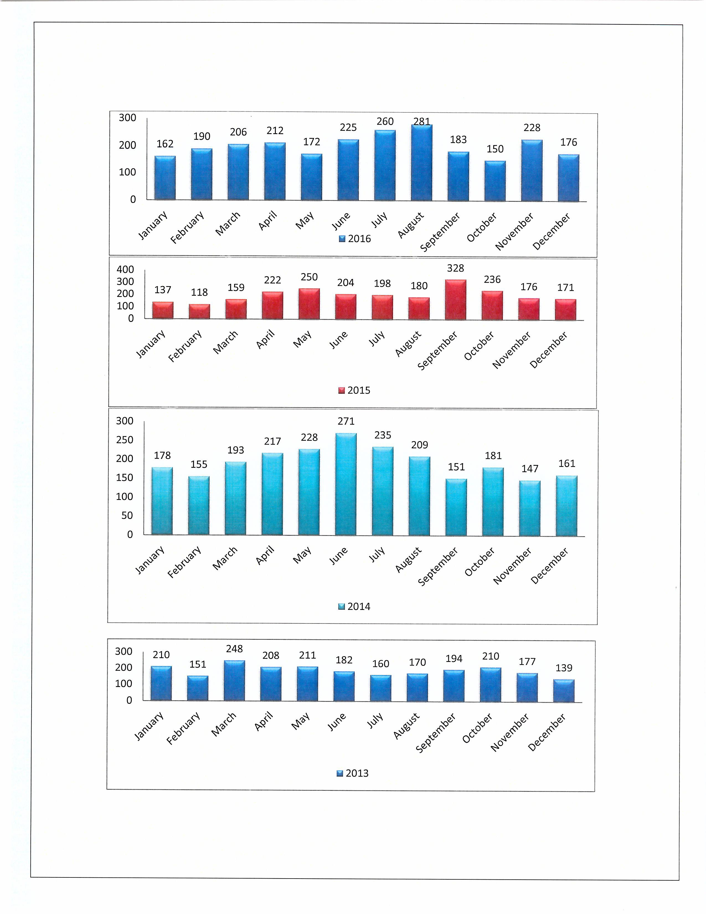

78

DEPARTMENT OF PUBLIC WORKS

Monthly Report: April 2023
Prepared by Brad Pudner, Public Works Director
PUBLIC WORKS NEWS

Countdown to Berwyn Heights Day!

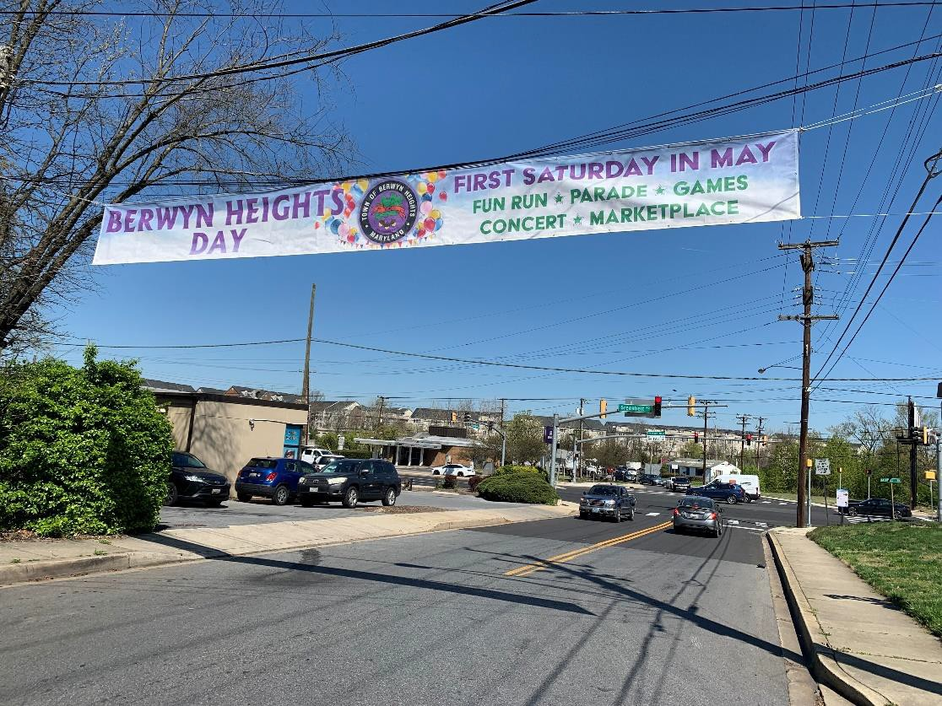
Over the month of April, Public Works has been busy preparing for the big event on May 6th. On April 4th, we installed the Berwyn Heights Day banners at 58th Avenue at Greenbelt Road, and Pontiac Street at Edmonston Road.

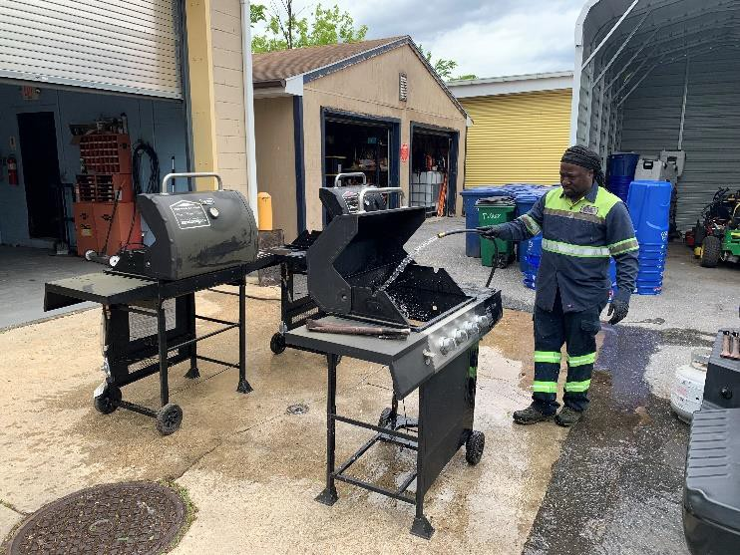
After inventorying supplies for Berwyn Heights Day, we washed items like the grills in this photo. We also checked the generators to make sure they are running, built new stands for the Fun Run finish line banner, purchased tent weights to hold the tents in place in case of light to moderate wind, and checked to make sure tent canopies, picnic tables, coolers, and other supplies are ready. Over the first week of May the final preparations will be made.

April Projects: Town Hall Parking Lot Painting, Before and After
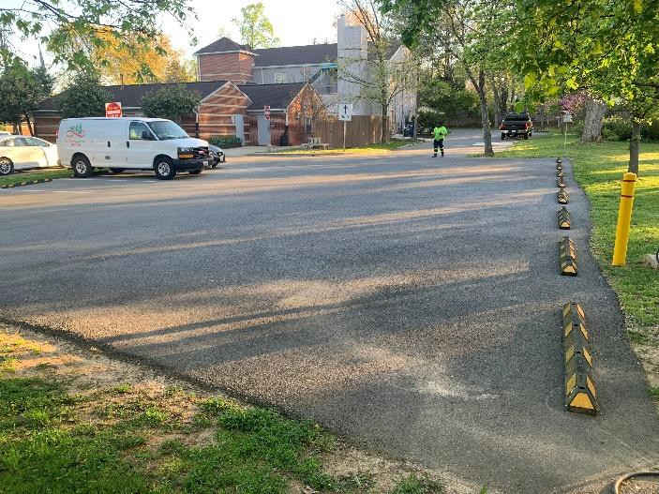
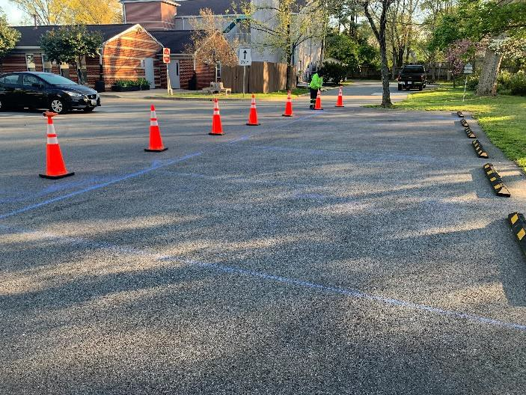
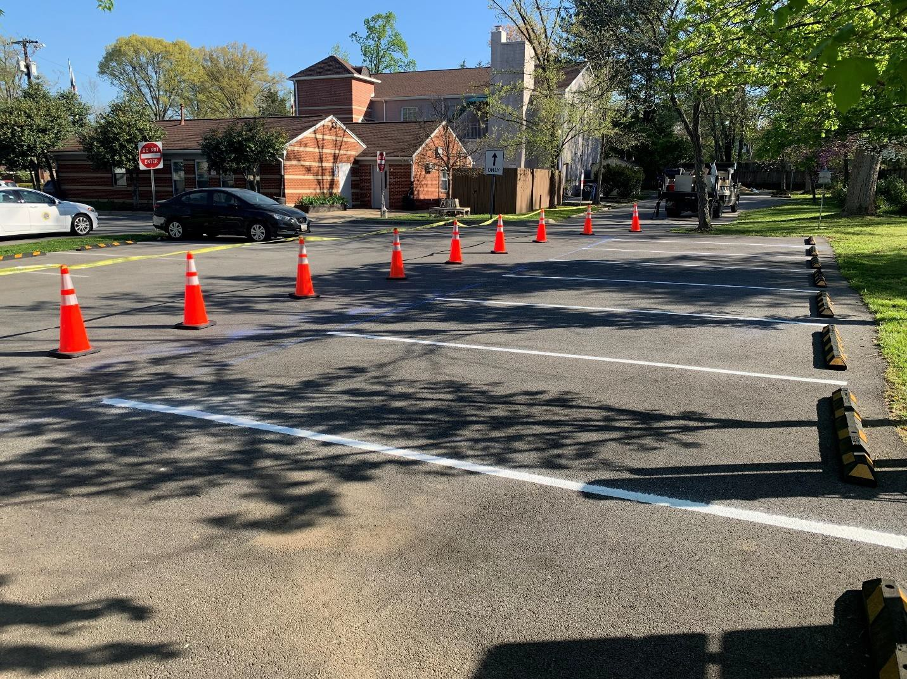

April Projects: Curb Painting- Before and After
During April, Public Works began repainting worn yellow curbs to more clearly denote “No Parking” areas. We started on Pontiac Street and as time permits, we will continue through the rest of Town.
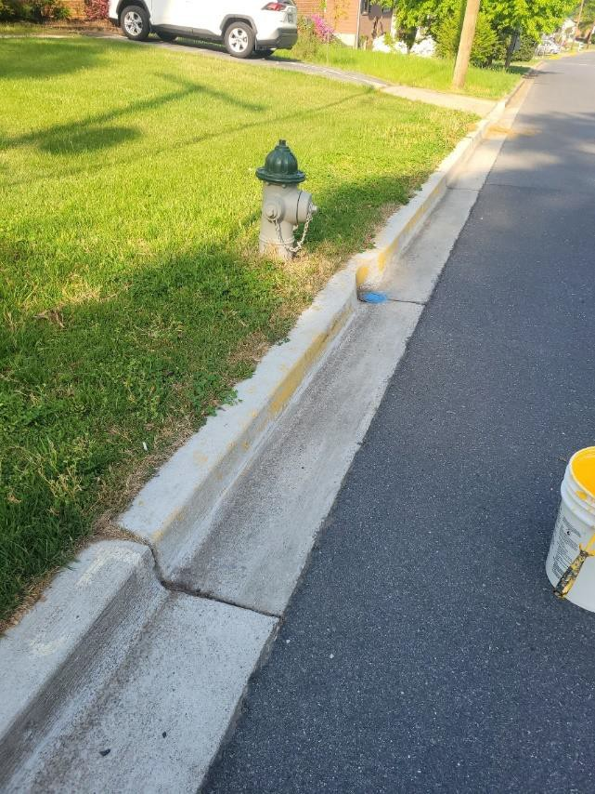
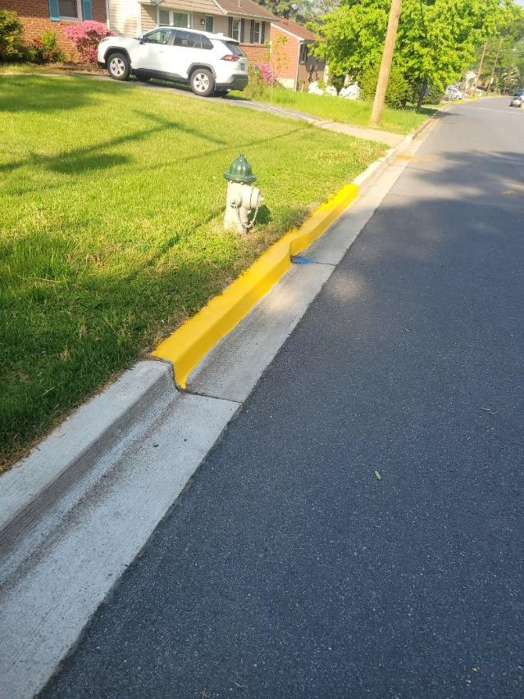
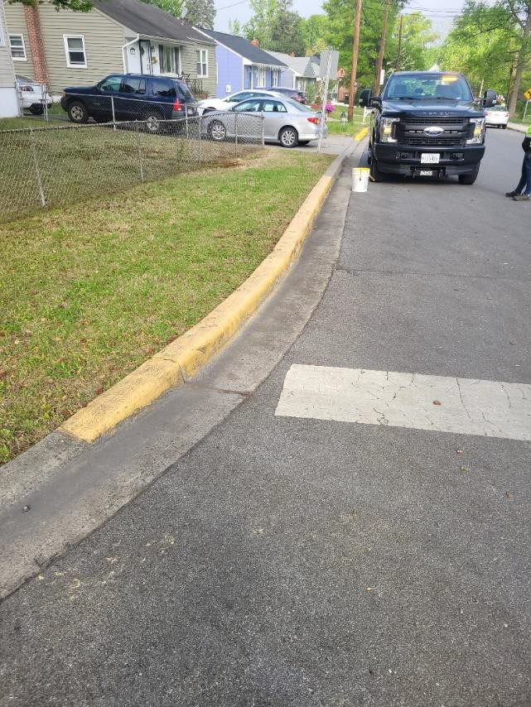
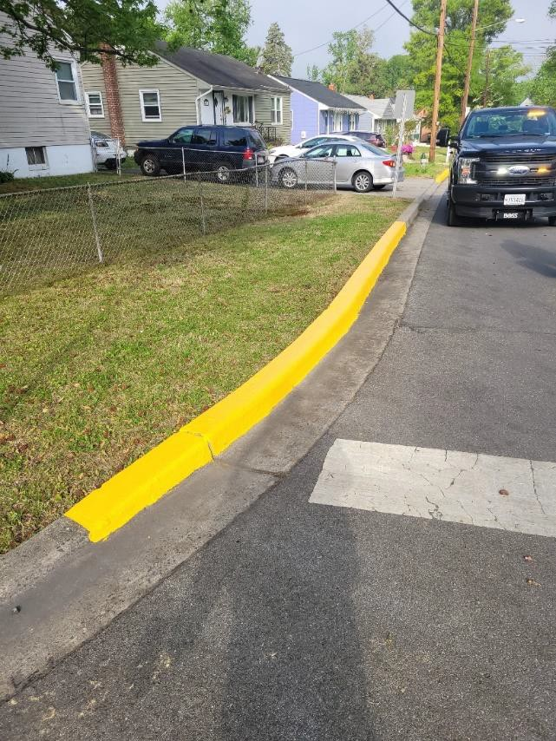

Trash Truck #24 Decals
The new trash truck has received its final preparations with the installation of its decorative decals. We highlighted the Town’s status as a Tree City USA and Bee City USA to showcase our dedication to sustainability and encourage recycling. Truck #24 will make its grand debut in the Berwyn Heights Day parade, and then it will officially begin its tour of duty on the trash and recycling routes.

Other Public Works News
Mowing
Grass in Town-maintained areas has begun growing vigorously with the arrival of Spring, and this will become a large part of Public Works’ schedule aside from the trash routes in the coming summer months. To improve this mowing season, we purchased a new commercial grade 48” walk-behind mower that will help improve mowing on hilly areas like the School Hill Right-of-Way on Quebec Street.

WSSC Edmonston Road Project and Road Repaving
WSSC informed the Town that they have been able to obtain a new contractor after the original one failed to complete the job, so work on Edmonston Road can finally resume. There is still some pipe work that needs to be completed, and then the road will be repaved.

Trash & Recycling Monthly Statistics

April 2023 Trash & Recycling Statistics
 | Tons | Price/ton | Revenue | Expense | Percent
Mixed Solid Waste | 93.5 | $ 70.00 |  | $ 6,545.00 | 64.1%
Recycling | 22.8 | $ 27.00 |  | $ 614.25 | 15.6%
Yard Waste/Food  Compost | 27.8 | $ 25.00 |  | $ 695.00 | 19.1%
Scrap Metal | 1.8 |  | $ 205.40 |  | 1.2%
TOTALS | 145.8 |  | $ 205.40 | $ 7,854.25 | 100.0%

12 Month Trash, Recycling, Yard Waste, Scrap Metals & Leaf Collection Volumes
 | Mixed Solid  Waste | Recycling | Yard Waste | Scrap Metals | Leaf Collection
May 2022 | 116.48 | 26.42 | 28.17 | 1.94
June 2022 | 112.43 | 29.83 | 19.28 | 1.77
July 2022 | 108.63 | 27.14 | 130.2 | 1.32
August 2022 | 137.34 | 30.99 | 56.65 | 2.1
September 2022 | 105.26 | 23.54 | 33.33 | 1.32
October 2022 | 97.54 | 23.06 | 20.41 | 0.88
November 2022 | 93.76 | 29.77 | 48.82 | 1.23 | 236.25
December 2022 | 87.44 | 25 | 13.28 | 0.68 | 87.5
January 2023 | 113.93 | 24.7 | 31.76 | 0.8 | 21
February 2023 | 84.6 | 22.3 | 12.4 | 0.9
March 2023 | 90.6 | 26 | 14.7 | 0.5
April 2023 | 93.5 | 22.8 | 27.8 | 1.8
TOTALS (TONS) | 1241.51 | 311.55 | 436.8 | 15.24 | 344.75
% of Totals | 48% | 12% | 17% | 1% | 13%

Town of Berwyn Heights
5700 Berwyn Road Berwyn Heights, MD 20740
Tel. (301) 474-5000
Fax (301) 474-5002
MAYOR
Jodie Kulpa-Eddy
COUNCIL MEMBERS
Christopher Brittan-Powell (Mayor Pro Tem) Shinita Hemby
Faustino Menjivar Jason W. Papanikolas

Resolution 03-2023
Adopting an updated Comprehensive Fees and Fines Schedule
Whereas, Chapter IV of the Charter of the Town of Berwyn Heights vests the Town Council with authority to establish and enact fees and fines; and

Whereas, Section 602 of the Town Charter requires the Town Council to retain a balance between proposed expenditures and anticipated revenues in the annual operating budget; and

Whereas, various sections of the Town Ordinances establish fees to cover the cost of services and fines as penalties for violations; and

Whereas, on August 14, 2019 the Town Council adopted Ordinance 179 establishing a comprehensive fee and fine schedule to be listed in the appendix of the codified ordinances of the Town and to transfer all specific dollar amounts of fees and fines found in various sections of the Town ordinances to the newly established fees and fines schedule; and

Whereas, with the adoption of Ordinance 179, it was established that the fees and fines charged by the Town shall be reviewed and readopted annually by Resolution to reflect any changes; and

Whereas, it was determined by the Council to:
- Increase the fines from $40 to $50 for the following traffic and parking violations under Ordinance 119: for illegally parked commercial or recreational vehicles, blocking a private driveway without consent, illegally placed signs prohibiting parking, parking on a bridge or elevated structure, double parking, parking on the travel portion of the roadway, obstructing a private or public driveway (partially in the road), parked more than 12 inches from the curb, parked left wheel to the curb, stop, stand or park any Class FA, FB, FD, EPF, E, Dump or Class E registered truck or vehicle over 20,000 on a public street, and Operate any Class FA, FB, FD, EPF, E, Dump or Class E registered truck or vehicle over 20,000 pound on a public street.
- Ordinance 114: Increased the fine from $50/$100 to $100/$200 for any violation under this “Peace, Order and Nuisances” Ordinance

NOW, THEREFORE, BE IT RESOLVED, that the Comprehensive Fees and Fines Schedule, as attached, is hereby established with immediate effect.
RESOLVED:

ATTEST:

Jodie A. Kulpa-Eddy, Mayor

Melanie Friesen

Resolution 03-2023 Comprehensive Fees Schedule

Section of Code | Type of Fee | Amount of Fee ($)
Ordinance 104 Building & Inspection
104.8 | Residential building permit | $75 for value of construction under $25,000
104.8 | Residential building permit | $125 for value of construction over $25,000
104 | Commercial building permit | $25 + $3 per $1,000 of construction to $1,500  max. Every increment of $1,000 goes up $3
104 | Deck permit | 25.00
104 | Fence permit | 25.00
104 | New home permit | 250.00
104 | Raze permit | 100.00
104.6 | Roll-off (Dumpster) permit | $25 for every 15 days of portion thereof
104.8 | Portable temporary storage unit permit | $50 for every 30 days of portion thereof
104.8 | Building, roll-off or storage unit damage  deposit | up to $1,000 (for potential damage to Town ROW
Ordinance 105 Business Licenses
104.4 | Banks & financial institutions | $250 per year
104.4 | Peddler, solicitors | $25 per year
104.4 | Professional services - Each professional | $50 per year
104.4 | Real estate & insurance - Each agent | $35 per year
104.4 | Coin operated vending machines - each | $10 per year
Gross receipts fee schedule:
104.7 | Gross receipts under $25,000 | $40 per year
 | Gross receipts $25,000 - $100,000 | $75 per year
 | Gross receipts $100,000 - $500,000 | $125 per year
 | Gross receipts $500,000 - $750,000 | $185 per year
 | Gross receipts $750,000 or greater | $250 per year
Ordinance 106 - Cable TV, Comcast
106.5.a | Franchise application filing fee | 5,000.00
Ordinance 117 - Refuse Collection
Resolution 2-2010 Refuse Collection Fees
A | Appliances | $25 prior to collection
B | Building & construction debris | Fee determined by Public Works if over 3 cubic  yards
C a | Bulk refuse | No fee if under 3 yards
C b | Bulk refuse | Fee determined by Public Works if over 3 cubic  yards
D | Clean outs | Fee determined by Public Works - any amount
E | Electronic or electronic recyclables | Fee determined by Town Council
F | Hazardous waste | Not accepted
G a | Household refuse - first roll-out container | No fee
G b | Household refuse - add'l roll-out container | Fee determined by Town Council
H | Imported waste | Not accepted
I | Loose leaves | No fee
J | Motor vehicles & parts | Fee determined by Public Works
K | Pressured containers | Not accepted
L | Recyclable materials | Fee collected on tax bill
M | Special collection material | Fee determined by Public Works
N | Tires | $5 each prior to collection
O a | Yard waste | No fee under 3 yards
O b | Yard waste | Fee determined by Public Works if over 3 cubic  yards
Ordinance 118 Road & Public Rights-of-Way
Resolution 05-2019
Permit application fee
 | Value of work up to $4,999 | 40.00
 | Value of work $5,000 to $25,000 | 100.00
 | Value of work greater than $25,000 | 1,000.00
Permit fee
 | Value of construction up to $250,000 | 10% of the value of construction/work

Resolution 03-2023 Comprehensive Fees Schedule

Value of construction $250,000 or greater | 8% of the value of construction/work
Driveway apron (residential only) | 40.00
Permit renewal fee | 25% of original fee

Ordinance 119 Traffic & Parking
Resolution 03-2015
Accident report - resident | 10.00
Accident report - non-resident | 20.00
Police report - resident | No charge
Police report - non-resident | 15.00
Fingerprinting (per card) Residents only | 10.00
Returned check | 35.00
Vehicle impound release | 75.00

Ordinance 120 Rental Housing
Resolution 02-2017
Rental license application fee | 300.00

Ordinance 125 Small Cell Facilities
Resolution 06-2019
Application fee - up to 5 | 500.00
Each additional | 100.00
Each new pole | 1,000.00
Plan review cost, if in excess of set fees
Access fee | 270.00 per small cell facility per year

Administration and  Police Department | Notary fee | 4.00 per page notarized

Resolution 03-2023 Comprehensive Fines Schedule

Section in Code Section Name Fine for Initial Offense Fine for Repeat or Continuous Violation
Ordinance 104 - Building & Inspection Violations
Section 8 | Residential building permit - late filing violation | $25 per calendar day
Section 3 D 3  Section 8 | Working under 'Stop Work Order  Commercial building permit - late filing violation Roll-off container permit fine | $1,000 per calendar day  $100 per calendar day | $15
Section 8 | Portable storage unit permit fine |  | $25
Section 8 | Portable storage unit - violation for unapproved extension | $100 per week
Section 8 | Unpaid damages to Town property 10 days after notification | Recorded as lien against property
Ordinance 105 - Business License Violations

Resolution 05-2006
Section 3 - Annual Renewal of Licenses Application not filed and/or fees not paid within 30 days $50
Application not filed and/or fees not paid - each additional month or partial month beyond first 30 days
Section 8 - Violation Violation of any provision of Ordinance 105 $50

$50

Violation of any provision of Ordinance 105 not corrected in 30 days $50
Ordinance 107 - Clean Lot Violations
Resolution 02-2015
A 1 Imminent threat violation - (Immediate) $25 per day $50 per day
A 2 Hazardous violation (Time sensitive) $100 $200
A 3 Non-hazardous violation (Regular order) $100 $200
B Tall grass & weeds violation (Time sensitive) $100 $200
C Invasive species & bamboo violation (Regular order) $100 $200
D Discarded vehicle violation (Immediate) $100 $200
E Vehicle condition & storage violation (Regular order) $100 $200
F Motor vehicle parts violation (Time sensitive) $100 $200
G Building materials violation (Time sensitive) $100 $200
H Improper wood storage violation - (Regular order) $100 $200
I High vegetation violation (Regular order) $100 $200
J Parking surfaces violation (Immediate) $25 per incident $25
K Building security violation (Time sensitive) $100 $200
L Accessory structures violation (Structural) $100 $200
M Premises indentification violation (Regular order) $100 $200

Section 6 Notice of Violation of Standards A 5 b Violations not fully corrected within the timeframe, as specifed in 6 E of this
Ordinance
Failure to pay fine will result in the amount of any fine(s) imposed to be collected in the same manner as delinquent Town taxes
Not to exceed $1,000 Lien

Ordinance 110 - Ethics Violations
Section 8 - Enforcement a 1 Late fine for failure to timely file a financial disclosure statement $2 per day up to $250

Resolution 03-2023 Comprehensive Fines Schedule

a 2 Late fine for failure to file timely lobbyist registration/lobbyist report | $10 per day up to $250
a C The Commission may impose a fine for any violation of ORD 110 | $5,000 per day | $5,000 each additional day
Ordinance 111 - Municipal Infractions Violations
Section 2 General Penalties
- Infraction $100 Not to exceed $200

- Misdemeanor - each day to be considered a separate offense Not to exceed $100 and possible
imprisonment not to exceed 30 days
Not to exceed $100 and imprisonment not to exceed 30 days

Ordinance 112 - Parks & Public Pro Property Violations
Any violation of Ordinance 112 |  | $5 to $100 and possible  imprisonment not to exceed 30 days
Ordinance 114 - Peace, Order & Nuisance Violations
Any violation of Ordinance 114 |  | $100 |  | $200
Ordinance 117 - Refuse Collection Violations
Resolution 02-2010
Section 5 Refuse categories fines
 | Imported waste fine | Up to $1,000
 | Pressured containers fine | fines may apply
Section 4
A | Improper disposal of A. Appliances, B. Bamboo, D. Bulk waste F. composting, H. Fish/Animal carcasses, J. Household refuse L. Leaves, N. Motor vehicle parts/accessories, O. Pressured containers, P. Recyclable materials, Q Special buld refuse, collection, R. Tires, S. Yard waste, and T. Corrugated cardboard boxes & recycling bins/containers:
 | a) first violation in a calendar year |  | $15
 | b) second violation in a calendar year |  |  | $25
 | c) third violation in a calendar year |  |  | $35
 | d) repeat violation in subsequent calendar year |  |  | $50
B | Improper disposal of C. Building, construction, and remodeling materials and waste, E. Clean-outs, I. Hazardous materials or waste, and M. Litter:
 | a) first violation in a calendar year |  | $50
 | b) second violation in a calendar year |  |  | $75
 | c) third violation in a calendar year |  |  | $100
C | Improper disposal of materials into storm drains
 | a) first violation in a calendar year |  | $50
 | b) second violation in a calendar year |  |  | $75
 | c) third violation in a calendar year |  |  | $100

Section 3
Resolution 03-2023 Comprehensive Fines Schedule

Imported waste Up to $1,000 per violation per day

Section 4 - ORD117 Section 6 | Safeguards for collectors
 | a) first violation in a calendar year | $25
 | b) second violation in a calendar year |  | $50
Section 4 - ORD117 Section 7 | Accessibility of items placed for collection
 | a) first violation in a calendar year | $25
 | b) second violation in a calendar year |  | $50
Ordinance 118 - Roads & Public Rights-of-Way Violations
Working under 'Stop Work Order' $1,000 per day
Missed construction inspection $125 per inspection
Ordinance 119 - Traffic & Parking Violations
Section 4
A | Vehicle parked in excess of 72 hours | $60
B | Illegally parked commercial or recreational vehicles | $50
C | Abandoned vehicle | $100
D | Illegally placed construction equipment or materials | $100
E | Conducting vehicle repairs on street | $60
F 1 | Blocking private driveway without consent | $50
F 2 | Parking in front of/blocking fire hydrant | $100
F 3 | Blocking crosswalk | $60
F 4 | Illegally placed traffic control devices | $60
F 5 | Illegally placed signs prohibiting parking | $50
F 6 | Parking in a handicap zone | $250
F 7 | Parking on any sidewalk | $60
F 8 | Parking in a fire lane | $100
F 9 | Parking on a bridge or elevated structure | $50
F 10 | Double parking | $50
F 11 | Parking on the travel portion of the roadway | $50
F11 A | Obstructing any portion of an intersection | $75
F 12 | Obstructing private or public driveway (partially in the road) | $50
G 1 | Parked more than 12 inches from curb | $50
G 2 | Parked left wheel to curb | $50
H 1 | Stop, stand, or park any Class FA, FB, FD, EPF, E, Dump or Class E registered truck or vehicle over 20,000 pounds on public street | $50
H 2 | Operated any Class FA, FB, FD, EPF, E, Dump or Class E registered truck  or vehicle over 20,000 pounds on public street | $50
I | Parking on private property without permission | $60
J | Unattended motor vehicle violation (motor running) | $75
K | Failure to attach vehicle registration plates in front and rear | $60
Ordinance 120 - Rental Housing Violations

 | Resolution 03-2023 Comprehensive Fines Schedule
Resolution 02-2017
 | Failure to apply for or renew a rental license | $400
 | Continued failure to apply for or renew a rental license |  | Up to double for each 20 business days
 | Failure to provide all required rental license application info. | $200
 | Continued failure to provide rental license application info. |  | Up to double for each 20 business days
 | Missed scheduled inspection or reinspection:
 | a) First missed appointment in a calendar year | $50
 | b) Second missed appointment in a calendar year |  | $75
 | c) Third and each successive missed appointment in a calendar year |  | $100
Public Nuisance Violations | Creating, encouraging, inviting, permitting or continuing to allow a public nuisance - fined to owner:
 | a) First violation in a calendar year | $200
 | b) Second violation in a calendar year |  | $400
 | c) Third and each successive violation in a calendar year |  | $600
Remedial Violations | Failure to correct remedial violation within 20 days of first notice | $200
 | Failure to correct remedial violation within 20 days of second notice |  | $250
 | Failure to correct remedial violation each additional 10 business days |  | $250
 | Failure to contact for inspection or reinspection within 10 days business days of first Notice of Violation | $200
 | Failure to contact for inspection or reinspection within 10 days business  days of second Notice of Violation |  | $250
 | Failure to contact for inspection or reinspection each 10 business days  thereafter |  | $300
All Other Violations | Failure to correct violation with 20 business days of first notice | $200
 | Failure to correct violation with 20 business days of second notice |  | $250
 | Failure to correct violation each additional 10 business days |  | $250
 | Failure to contact for inspection or reinspection within 10 business days of first notice of violation |  | $200
 | Failure to contact for inspection or reinspection within 10 business days of  second notice of violation |  | $250
 | Failure to contact for inspection or reinspection within 10 for each  additional business day thereafter |  | $300
Liens | Failure to pay any fine(s) set forth for violations of Ordinance 120 will result in the amount of any fine(s) and fee(s) imposed being recorded as a lien against the property and will be collected in the same manner as  delinquent Town taxes
License or renewal revocation or denial | The Town reserves the right to either revoke or deny the renewal of rental housing license for any violation(s) of Ordinance 120

Resolution 03-2023 Comprehensive Fines Schedule
Ordinance 125 Small Cell Facilities
Resolution 06-2019
Violation fines $100 per day

Ordinance 134 - Commercial Clean | Lot Violations
Resolution 07-2015
A. Condition of Exterior  A 1 | Imminent threat (Immediate) - 24 hours to correct |  | $400 |  | $800
A 2 | Hazardous (Regular order) - 7 days to correct |  | $300 |  | $600
A 3 | Non-hazardous (Regular order) - 7 days to correct |  | $200 |  | $400
B | Tall grass & weeds (Regular order) - 7 days to correct |  | $200 |  | $400
C | Invasive species & bamboo (Regular order) - 7 days to correct |  | $200 |  | $400
D | Discarded vehicle (Immediate) - 24 hours to correct |  | $300 |  | $600
E | Vehicle condition & storage (Structural) - 30 days to correct |  | $300 |  | $600
F | Vegetation (Structural) - 30 days to correct |  | $200 |  | $400
G | Plantings in the Right-of-Way (Regular order) - 7 days to correct |  | $200 |  | $400
H | Parking surfaces (Immediate) - 24 hours to correct |  | $200 |  | $400
I | Building materials (Regular order) - 7 days to correct |  | $200 |  | $400
J | Motor vehicle parts (Regular order) - 7 days to correct |  | $300 |  | $600
K | Wood storage (Regular order) - 7 days to correct |  | $200 |  | $600
L | Conditions of public amenities (Structural) - 30 days to correct |  | $200 |  | $400
M | Structures & accessory structures (Structural) - 30 days to correct |  | $200 |  | $400
N | Building security (Immediate)- 24 hours to correct |  | $200 |  | $400
N | Building security (Structural) - 30 days to correct |  | $200 |  | $400
O | Premises grading (Structural) - 30 days to correct |  | $200 |  | $400
P | Compliance w/ County Zoning Ordinance (Regular) - 7 days to correct |  | $200 |  | $400
Q | Premises identification (Regular order) - 7 days to correct |  | $200 |  | $400
R | Construction safety (Regular order) - 7 days to correct |  | $200 |  | $400
Ordinance 149 - Red Light Camera
Red Light Camera Violation |  |  | $75
Ordinance 153 - Noise Violations
Resolution 01-2011
 | 10 Decibels or less over noise limit:  - first offense  - second offense  - third offense | Warning |  | Warning or $25 | $50
 | d) fourth and subsequent offenses |  |  |  | $100

Resolution 03-2023 Comprehensive Fines Schedule

More than 10 decibels over noise limit:
a) first offense | Warning
b) second offense |  | Warning or $50
c) third offense |  |  | $100
d) fourth and subsequent offenses |  |  | $100
Noise violation at prohibited times:
a) first offense | Warning
b) second offense |  |  | $50
c) third offense |  |  | $100
d) fourth and subsequent offenses |  |  | $150
Frequent and sustained noise by domestic animals:
a) first offense | Warning
b) second offense |  |  | $15
c) third offense |  |  | $30
d) fourth and subsequent offenses |  |  | $45
Failure of an owner to pay a noise violation fine will result in the |  | Lien
amount of the fine being recorded as a lien against the property and
collection in the same manner as delinquent Town taxes

