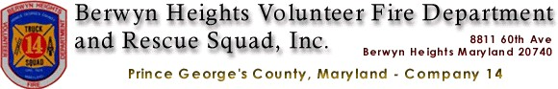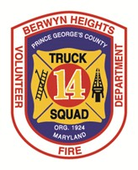

www.bhvfd14.com 301-474-7886

Mayor & Town Council Town of Berwyn Heights 5700 Berwyn-Road Berwyn Heights, MD 20740

RE: Fiscal Year 2024 Funding Support Request

Mayor & Council,

Fax: 301-220-2476

Friday March 10th, 2023

2022 was a very busy and eventful year for our Town and our Department. Together we faced and responded to multiple storms that produced devastating wind damage and dangerous flooding over the summer. There were also good times during community events such as Berwyn Heights Day, National Night Out, Santa on a Firetruck, and much more. Again, this year, thanks to the dedication of our volunteer members, Station 14 remained fully staffed 24/7 without missing a single call for service. We are grateful for all the support and partnerships we have built with the Town over the past decade, not all volunteer corporations in the County have a municipality they can partner with.

FY 2024 Assistance Requests
Below are our requests for the Town to consider when formulating the FY2024 Budget:

Standard $10,000 Contribution: This annual contribution assists us with day-to-day operations such as tools and equipment purchasing.

Assistance with replacing our Utility Truck: This year, we are asking that the Town consider partnering with us to replace our 2008 Ford Utility Truck with a new pick-up truck with a utility body. We are also asking that the Town consider utilizing some of its ARPA Funding to support this purchase, as the vehicle is instrumental in responding to weather and area trail emergencies due to its 4x4 wheel drive and being more maneuverable than our larger fire apparatus. This particular vehicle has proven especially essential during the devastating storms we witnessed this past summer.

Challenges
Staffing remains our largest concern coming into 2023. The volunteer system County-wide is at its lowest point in history, and the County Fire/EMS career staff does not have the numbers to handle the existing call volume, let alone cover the volunteer gaps. This has led to the County paying out millions of dollars of overtime a month. Fortunately, the Berwyn Heights VFD is one

of the few County stations that managed to maintain 24/7 staffing again through 2022 and has not missed a single call for service. However, our volunteer levels are not immune to the volunteer shortage. The COVID-19 pandemic devastated our recruiting abilities for nearly two years, and the lack of new members has placed a strain on our bunkroom and riding members. The call volume of our Ambulance is also a large burden, with members taking dozens of calls a day and sitting at area hospitals sometimes for hours waiting on a bed for their patients. Our ambulance is also frequently handling calls further outside our response area in Laurel, Bowie, Lanham, and Riverdale, handling other stations’ call volume.

The County’s career firefighter staffing shortages is so bad it has led to several high-level conversations of them removing the 6 “daywork” personnel assigned to Company 14 Monday thru Friday from 7am - 3pm that gives our volunteers a much-needed break and staffs the station when our members are at work or school. If the County were to pull career staffing from our station, we would not be able to staff the station during the day on weekdays when the career staff currently cover.

We ask the Town to continue to work closely with the County leadership to stress the importance of maintaining daywork career staffing at our Station.

Looking Ahead
Below are some of the major projects we have planned over the next 5 years:

Refurbishment of our 2009 Seagrave Ladder Truck: After thousands of calls, our ladder truck is starting to show its age. We are working with the manufacturer with plans to ship the ladder truck back out to Wisconsin to undergo a full refurbishment. This refurbishment is expected to cost nearly as much as when we purchased the unit new, about $850,000. After being refurbished, the unit is expected to remain a front-line apparatus for another 10 years. We are hoping to utilize a county reserve ladder truck during the refurbishment.

Ambulance Replacement/refurbishment: Our 2015 Ford Ambulance is reaching the end of its service life. Over the next 2-3 years, we will be looking to either fully replace it, or rechassis it by refurbishing the patient transport “box” and placing it onto a new truck chassis.

Fire Station Renovation & Expansion: Our current station was initially built in 1968 and expanded in 1992. Though there have been some upgrades made over the past 30 years, it is time to begin the process of a full renovation and expansion to better meet the current and future needs of our community. A new firehouse would cost upwards of $15 million, with a renovation of the current facility estimated between $3 and $8 million. The County’s 2023 CIP Budget projects a $3.6 million renovation “Beyond 6 Years” (Line item 3.51.0016). Per the County CIP - “This station is unable to adequately serve the current and anticipated staffing needs, male/female staffing accommodation and ADA compliance. Additional improvements such as energy efficiency improvements, security improvements, disaster resilience and technologies to improve response time will be included. We are hoping to partner with the Town, County, and State to fund this renovation.

100 Year Anniversary: In 2024, our department will be celebrating 100 years of continuous volunteer service to the community. The Berwyn Volunteer Fire Department was organized in 1919, and the Department split in 1924 creating the Branchville Volunteer Fire Company and the

Berwyn Heights Volunteer Fire Department. A multi-day celebration is being planned for 2024 to celebrate this achievement.

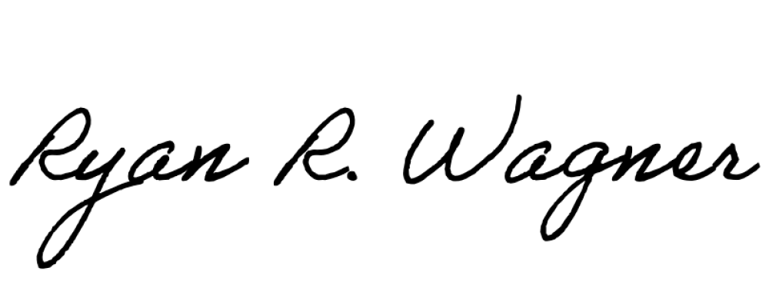
Please feel free to reach out if you have any questions or concerns, we are always willing to attend a budget work session to discuss these items further.
Sincerely,
Ryan Wagner President
Berwyn Heights VFD

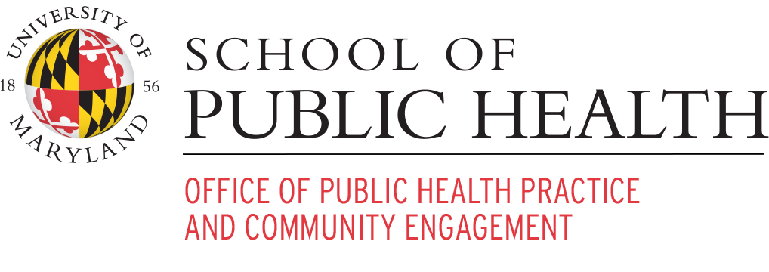

Proposed Work Plan with the Town of Berwyn Heights

Purpose:
The purpose of this project is for the Town of Berwyn Heights to identify and understand what it means to be part of the community of Berwyn Heights. A once self-proclaimed Mayberry of the DMV is experiencing community member shifts and is interested in identifying what community means to them in order to tackle the community’s grand challenges together. The Berwyn Heights Town Council has invited the University of Maryland (UMD) School of Public Health (SPH) Office of Public Health Practice & Community Engagement (OPHPCE) to participate in a community-driven approach to defining the ‘new’ community of Berwyn Heights. The OPHPCE will provide student, faculty, and staff support to the Berwyn Heights community around three primary goals: re-defining and re-establishing a sense of community in the Town of Berwyn Heights, re-invigorating volunteerism in the Town of Berwyn Heights, and coming up with community-driven and evidence-based approaches to stormwater flooding prevention.

Methodology:
The OPHPCE strongly believes in a community-driven approach. The topic areas of inquiry have been identified by Berwyn Heights community members. OPHPCE will provide coordination support that ensures power is centered within the community. The proposed scope of work below aims to spend a great deal of time in the listening and data collection phase to ensure that all proposed strategies for strengthening the sense of community come from the community itself. The OPHPCE will utilize the processes developed and findings as a model for better practices that can be disseminated for knowledge building, education, and training and applied in practice with other communities.

Timeline:
A project proposal will be presented to the Mayor by April 28, 2023 with proposed implementation plans through 2026.

Why public health?
The American Public Health Association defines public health as that which promotes and protects the health of people and the communities where they live, learn, work and play. Promoting and protecting health is multi-faceted and layered and involves the buy-in of a multitude of partners. Public health is the convener of all aspects of an individual’s life because ultimately, without health, nothing else can exist. The UMD SPH has students, faculty, and staff that have dedicated their lives to understanding and promoting the health and well-being of individuals and communities through a wide range of approaches and topic areas.

4200 Valley Drive, College Park, MD 20742-2611 | sph-phpce@umd.edu | sph.umd.edu/phpce @UMDPublicHealth | UMD.SPH | @umdpublichealth

Scope of work:
The OPHPCE proposes the following scope of work to address these three key priority areas for the Town of Berwyn Heights:
Identifying and creating a sense of community among residents
Promoting a culture of volunteerism in the community
Identifying best practices for and
preventing fu g
ture floodin
in the town

The OPHPCE shall:
- Create a Community Advisory Team (CAT) of 5-10 community members that represent a diverse set of residents. Nominations for CAT members will be solicited via the town bulletin and identified with the Town Council. This CAT will work with OPHPCE to:
  - Co-create, review, and approve the community assessment plan
  - Identify what to assess and best approaches (i.e. partner with schools at back to school night) for gathering information as well as any additional key priority areas to be focused on in the assessment.
  - Co-create, review, and approve a formal timeline for the assessment
  - Co-create, review, and approve all assessment tools including interview and focus group guides.
- Assist in the planning and implementation of a community assessment plan. This plan will be co-created, reviewed, and approved by the CAT. The following are suggestions for community assessment plan activities:
  - Conduct a Social Network Analysis of the Town of Berwyn Heights to identify important leverage points and existing connections for information gathering and spread and general sense of connection among residents.
  - Conduct semi-structured interviews & focus groups with Berwyn Heights residents to get a better understanding of their definition and sense of community in the Town.
- Conduct two community landscape assessments utilizing knowledge from the CAT and online searches to establish a list of existing facilitators and barriers to reaching the identified priority areas in this project plan.
- Provide student support to the implementation of the community assessment plan including:
  - Students in Fall 2023 courses including HLTH 292, HLTH 391 or HLTH 780,
  - OPHPCE undergraduate interns, and/or
  - OPHPCE graduate interns.
- Ensure any tools co-created for the community assessment are pilot tested with community members prior to their official use and revisions are included after testing.

4200 Valley Drive, College Park, MD 20742-2611 | sph-phpce@umd.edu | sph.umd.edu/phpce @UMDPublicHealth | UMD.SPH | @umdpublichealth

- Synthesize and analyze the results from the community assessment and present the draft results to the CAT for initial review.
- Host town hall-style meetings to present the findings from the community assessment and member check them for accuracy.
- Utilize the results of the community assessment to co-create a Community Action Plan for addressing the key priority areas for the Town of Berwyn Heights moving forward.

Proposed Timeline:

July-August 2023
September 2023
October-November 2023
December 2023
January-February 2024
March-April 2024
May 2024

- Assemble advisory team and conduct initial meetings

- Deliver final co-created community assessment plan to course instructors and identify & assemble student teams

- Students begin collecting data in coordination with the advisory team

- Synthesis and analysis of results

- Member checking the results with CAT and community members

- Begin co-creating the community action plan

- Final Community Action Plan delivered and presented to Berwyn Heights

Budget:
A more detailed budget will be co-created with the CAT, however, the OPHPCE foresees the following budget items for this project:
Item: OPHPCE: Berwyn Heights:
UMD Faculty Support | In kind
UMD Student Support | In kind
UMD team travel to Berwyn Heights | In kind
Software for community assessment tools  and analysis | In kind
Printing costs for interviews and focus  groups | In kind
Stipends for CAT members |  | Recommend:  $250/month/CAT member
Incentives for interview & focus group  participants |  | Recommend:  $75/interview
Space for focus groups and CAT meetings |  | In kind

4200 Valley Drive, College Park, MD 20742-2611 | sph-phpce@umd.edu | sph.umd.edu/phpce @UMDPublicHealth | UMD.SPH | @umdpublichealth

Budgetary Guidelines for ARPA 18-month Budget
The Berwyn Heights Town Council proposes to use the remaining ARPA funds for the following purposes:
- Stormwater management is considered a priority need, and improvement projects, to include stormwater mitigation efforts on affected private property, preservation of open space and tree canopy, and demonstration projects on Town-owned properties (where practical) will be supported.
- Supportfor the mental and physical health of residents, and community public health, including aging in place.
- Improving social, cultural, and educational programming for the Town's residents, including assisting community organizations that provide these activities.
- To empower and facilitate greater inclusion into all facets of community life of the Town's Latino, immigrant, and other diverse members.
- Provide financial and housing security assistance to residents and
businesses affected by COVID and the resulting economic disruption.
- Provide needed financial assistance to the Town government to compensate for the economic disruption that occurred subsequent to COVID.
In all cases, Berwyn Heights will work with stakeholders and County, State and Federal agencies to identify and procure other funds necessary to supplement projects approved in this budget. The goal should be to make ARPA funds stretch as much as possible to get the biggest bang for our buck!

Review and Proposed Process for Remaining Alloca�ons of Berwyn Heights’ ARPA Funds
In response to the deleterious impacts of COVID, the Federal Government ini�ated the American Rescue Plan Act (ARPA). The funds associated with ARPA were largely channeled through the State, which used a formula for their distribu�on to various governing en��es (e.g., states, coun�es, municipali�es). The State of Maryland allocated, by applying its formula�on of federal direc�ves, a set amount to go to municipali�es – a.k.a., Non-En�tlement-Units (NEUs). This formula�on was largely inﬂuence by municipali�es/NEUs popula�on sizes and the sizes of their annual budgets. These funds were restricted in allowed uses in that they were not (with certain excep�ons) not to serve to replace what would have been normally obtained through the regular budget.
Typically, there were two distribu�ons (a.k.a., tranchets) of ARPA funds. Together these two distribu�ons make up all the funds that an NEU like Berwyn Heights would get. In general, in Maryland, the governmental en��es that contain communi�es such as Berwyn Heights – and also received ARPA funds for its residents – include the municipality itself (e.g., Berwyn Heights), the County it is in (Prince Georges), and the State (Maryland). As the governing body of Berwyn Heights, our Town Council, has the responsibility of following Federal Guidelines, and those we developed ourselves in alloca�ng these funds. As the requirements of the Federal Guidelines are all maintained by those recently adopted by the Town Council, we may focus on our own adopted guidelines as we move forward in determining how to direct all remaining alloca�ons. There are two key aspects involved, possibili�es and process.
The possibili�es will be obtained through the process we follow. These should be aligned with more general goals, essen�ally being concrete expressions of those goals. To date, the Council has explored many possibili�es and enacted a few. These possibili�es were largely informed by our residents during many outreach eﬀorts. A summary of these is atached.
The process of making these determina�ons for the remaining ARPA funds itself needs to be determined and conducted by the Town Council. Some discussion has already occurred in this regard and we will certainly desire more. As the Council already has a set of rules that guides its behavior, some applica�on of these seems reasonable. However, speciﬁc rules surrounding ARPA funds, such as seen in the recently adopted guidelines, may facilitate the overall process. In addi�on, those put forth previously for considera�on, such as at the May 1st mee�ng, ought to be given considera�on. Each councilmember is asked to inform Council during our May 25th mee�ng of the guidelines they desire to be considered. Our delibera�ons as a team can then give shaped to par�cular procedures associated with this overall process.
Goals → Process → Procedures → Possibili�es
In sum, from our broad set of guidelines/goals we will use the process we decide on to direct out decision making procedures through which we iden�fy and select the possibili�es we believe will help achieve such goals. We are not star�ng from scratch and have already developed much of the above. But in ﬁrming up the above, we will be able to reduce misunderstandings.

Town of Berwyn Heights

AMERICAN RESCUE PLAN ACT (ARPA)
(Based upon “Draft Budgetary Guidelines for ARPA 18-month Budget”)
BALANCE (Per 3/31/2023) - $2,533,462

FY2024+ INITIATIVES Amounts COMMENTS

Stormwater Management/Capital1

- Stormwater (Concept Design of a stormwater drainage system) $75,000 (NTE)
- Final Design/Permitting (Est. design fees of engineering consultant) $300,000 (Approximately)
- Hydrology/Hydraulic Study (with concept designs) $25,000 (NTE) 25% match with the USA Corps of Engineers
- Construction Costs $1,000,000
- Stormwater Consultant/Engineer/Administrator $150,000 FTE; 18 mos.; salary + benefits
Subtotal (Stormwater/Capital) $1,550,000

1 Estimates for stormwater “Concept Design”, “Final Design”, “Hydrology” and “Construction Costs” are based upon numbers provided by the Prince George’s County Department of Public Works & Transportation.

- Demonstration Projects
  - (Rainwater) Cisterns (Pricing varies on size: 300-1,000 gal.) $25,000 10 cisterns/shipping x $2,500 (max.)/each
  - Mitigation Ponds TBD Should be funded by the County/State/M-NCPPC

- Stormwater mitigation (residential) $165,000 Assistance NTE $7,500 per approval
- Floodgates (residential) $ 10,000

Sub-Total (Stormwater Management) $1,750,000

NON-STORMWATER PROJECTS

Mental & Physical Health Support

- Grant support to local non-profits for MH $10,000
- “Aging In Place” (Partnership with City of Greenbelt & UMD) $50,000 Need to confirm estimate and programming

Emergency Assistance

- Resident & business relief $ 51,751
- Local non-profits (housing, food assistance) $10,000

Educational Growth Support

- Local non-profits providing education support $16,500

Employee Health & Safety

- Carry-over from FY23 (in case it’s needed) $ 7,500

Administration

- ArcGIS Software $ 25,000

- UMD/School of Public Health $ 50,000
- Community Outreach Worker $ 97,500 18 mos.; $50-$55k/salary/annual + benefits

Police Department

- Police Vehicles (2) $121,600 $60,800 each

Public Works Department

- Pick-Up Truck $ 80,000
- Dingo $ 50,000

Subtotal (Non-Stormwater Projects) $569,851

TOTAL – ARPA FY2024+ $2,319,851

Expenditures TBD $213,611

TOWN OF BERWYN HEIGHTS POSITION DESCRIPTION

TITLE: STORMWATER CONSULTANT/ENGINEER
PAY GRADE: Contractual
DEPARTMENT: Town Administration (ARPA)
STATUS: Non-exempt REPORTS TO: Town Manager CREATION DATE: May 2023

Purpose Of Position: This position is the lead and “subject matter expert” for the government of the Town of Berwyn Heights concerning stormwater-related matters. One of the principal responsibilities of this position is to review stormwater engineering reports, analyses and designs, as well as monitor and comment on municipal drainage and stormwater infrastructure improvement projects within the Town of Berwyn Heights (or “Town”). The position is responsible for analyzing and interpreting engineering data, reviewing and designing (when applicable) and filing related engineering information and plans, providing to the Council his/her analysis and recommendations vis-à-vis potential stormwater-related and other water drainage projects. This position shall provide guidance in response to project inquiries and concerns from residents and elected officials and shall take the lead role in reviewing and approving resident Stormwater Mitigation Reimbursement grant applications.

Tangentially, the Stormwater Consultant/Engineer informally inspects project workmanship for quality, quantities, and adherence to approved plans and specifications including, but not limited to, the inspection of storm drain projects, sewer construction/replacement, construction excavation, booster pumping stations (if applicable) and related infrastructure projects within the Town’s legal boundaries and public right of way.

Additional duties include drafting special and periodic reports for the Town Council and community, and addressing citizen complaints.

Essential Functions

  - The successful candidate will apply engineering practices and stormwater management (“SWM”) concepts/regulations in conducting SWM plan review, ensuring that stormwater runoff is managed in compliance with State and County Code.
  - Reviews flooding and drainage studies/reports, construction plans, specifications and cost estimates for water drainage and stormwater infrastructure improvement projects.
  - Monitors (and be able to report to the community and Council on) stormwater engineering activities, such as inspecting project sites, recording project progress, and attending status meetings.
  - Reviews, evaluates (to include providing feedback) and files appropriate engineering reports and other information such as project work orders, invoices, proposals, grant applications, and/or permits.
  - Conducts limited site plan and/or stormwater management (SWM) model reviews on proposed new construction and redevelopment efforts (knowledge of hydrology, hydraulics and general drainage concepts preferred).
  - Interacts with the various parties involved; observes compliance with federal, state and county requirements.

  - Investigates and responds to inquiries and concerns from contractors, Town staff and elected officials, the general public, and public or institutional agencies.
  - When requested, participates in the rain assessment procedure(s) to document flooding during certain rain events.
  - Takes a lead role in the Town government’s efforts to mitigate stormwater runoff (for instance, utilizing cisterns).
  - Creates/maintains communication (via phone calls, e-mail and meetings) and maintains relationships with stormwater partners involved with SWM issues within the Town, including (but not limited to) Prince George’s County (Department of Public Works and Transportation and the Department of the Environment), the U.S. Army Corps of Engineers, the Washington Suburban Sanitary Commission, the University of Maryland College Park, consultant(s), and any relevant State of Maryland agencies.
  - Takes a lead role in reviewing and approving resident Stormwater Mitigation Reimbursement grant applications.
  - Facilitates or attends staff meetings to exchange information.
  - Identifies and attends stormwater management training and classes, seminars, or conferences, to enhance professional skills.
  - Actively seeks funding opportunities by finding and responding to grant opportunities.
  - Takes the lead role in organizing and facilitating a Town-endorsed stormwater committee.
  - Takes on related/other duties as assigned.

The successful candidate will excel in areas such as communication (both orally and in writing), customer-focused service, dependability, flexibility, interpersonal skills, planning and organization, reasoning and problem solving, and is expected to establish and maintain effective relationships with fellow employees, County officials, contractors, elected officials and the general public.

Educational/Vocational Requirements: Requires a Bachelor’s degree in Civil Engineering or a closely related field from a four-year college or university accredited by the Accreditation Board for Engineering and Technologies. Knowledge in sediment control procedures (certification), water and sanitary sewer safety regulations, OSHA/MOSHA regulations, compaction techniques, methods of surveying and the testing of construction materials is highly desired.
Experience Requirement: A minimum of two years of stormwater (FTE) experience is preferred, or an equivalent combination of education, training, and related experience.
Certifications And Licenses: A Professional Engineer (PE) license or enrollment as an Engineer-In-Training (EIT) is desired. A State of Maryland and/or Prince George’s County certification(s) may be required.

Special Requirements: This position is not guaranteed a permanent desk at the Berwyn Heights government office building; therefore, working from home and through videoconference, e-mail, cellphone and attending occasional meetings is anticipated.
Work is often performed outdoors. Note: During forecasted adverse (i.e., potential flooding) weather, this position shall be “on-call”, to include weekends, evenings, and holidays. When warranted, this position will be expected to work hours in excess of their normal scheduled hours (for instance, during flooding events).

Work-Related Equipment Knowledge/Experience:

  - Laptop Computer
  - Cellphone
  - Protective Equipment Required (for occasional field visits):
    - Hard Hat
    - Safety Shoes
    - Safety Vest
  - Calculator
  - Drafting Instruments

Compensation: This is a full-time salaried position; the annual salary range is $70,000 -
$80,000, depending upon credentials and experience. The successful applicant will sign a term contract that will expire December 31, 2024. Benefits shall include:

- Health Insurance (Medical, Dental, Vision, Long and Short-Term Disability and Life)
- Paid Leave including Vacation, Sick, Family Sick, Personal, Bereavement and 12 Holidays
- Maryland State 401(a) Matching Plan and 457 Deferred Compensation Plans
- Employee Assistance Program

The Town of Berwyn Heights is an Equal Opportunity Employer (EOE). In compliance with the Americans with Disabilities Act (ADA), the Town will provide reasonable accommodations to qualified individuals with disabilities.

Goals & Elible Uses
General Standards & Eligible Use of Funds within Each Standard and BH Identified Projects

Public Health Negative Econ Impacts Asst to Small Businesses Aid to Impacted Communities Public Sector Capacity and Workforce Needed Investments in Water, Sewer, or Broadband Infrastructure

Goal: Support Community health, well being and safety.
Retain UMD SPH Experts
Conduct Professional Assessments
Retain Town Outreach Coordinator / Program specialist
Design and Dev Outreach program and appropriate interventions Run/Host Mental Health Events
Grant/Agreements to Mental Health Agencies Aging in Place
Inclusion Program Food Security Housing Security
FT - Director of PRECA
Green Efforts - Adopting practices, Trees, Mitigation practices

Storm Water Management SWM Gates Program Backflow Prevention
Neighborhood SWM Plan & Implementation TownWide Watershed SWM Plan & Implementation

Infrastructure
Purchase/Obtain MNCCP BH Community Center building and outside space Dog Park - with Bark Social Type Potential
Performance Center
Enhance Capacity of 2nd Fl of Town Center - Twist n Shout for music video, performances
Latino Center

Implement Pop's Park Design Implement WBBH Implement Safe Streets
Additional Traffic Safety Features
Historical Society - Improvements and Programs Development of MiniParks

Infrastructure Continued

Services to Disproportionately Impacted Communities
Free Town-Wide Broadband
Robust outreach program for minority and migrant community(ies) Aging in Place Programs
Promoting Homeownership Programs Renter Protection Programs Outreach to, and Empowerment of, Code Improvement

Latino Center - Language Courses NA & AA

Aid to Impacted Communities
Martgage, Utility, Rent Bills Aging in Place Programs Ethnic and Racial Minorities

Aid to Impacted Industries Premium Pay
Revenue Replacement
Done

Principles: Areas in Need, Low % of Budget, Direct Comm Impact

